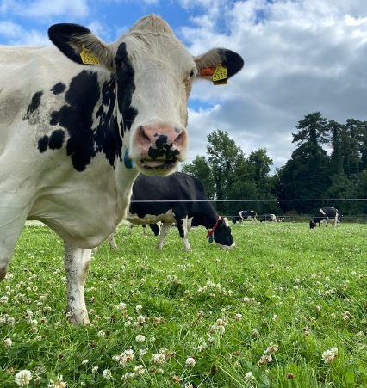
Project Objectives

- To develop a sustainable high-output grass-based spring milk production system
- To incorporate the most recent advances in grassland management for dairy farms into a high- output system
- Use a type of dairy cow that has good genetic indices for both milk production and fertility
- Employ the best practices from nutrition research and dairy cow husbandry
- Incorporate nutritional studies into a high-output system
- To incorporate management technologies and system attributes that enhance the sustainability of dairy production
Farm Details Week 2nd– 8st Oct 2023
Stocking rate on MP (LU/ha) | 3.16
Farm Cover (kg of DM/ha) | 613
Growth Rate (kg of DM/ha/day) | 35
Demand (kg of DM/ha/day) | 19
Average grass DM (%) | 12.4
Average Concentrate fed (kg/day) | 4
Average DIM | 231
Cow Details Week 2nd -8th Oct 2023
Yield (kg/cow/day) | 20.3
Fat (%) | 4.88
Protein (%) | 3.76
MS (kg/day) | 1.77
SCC | 76,400

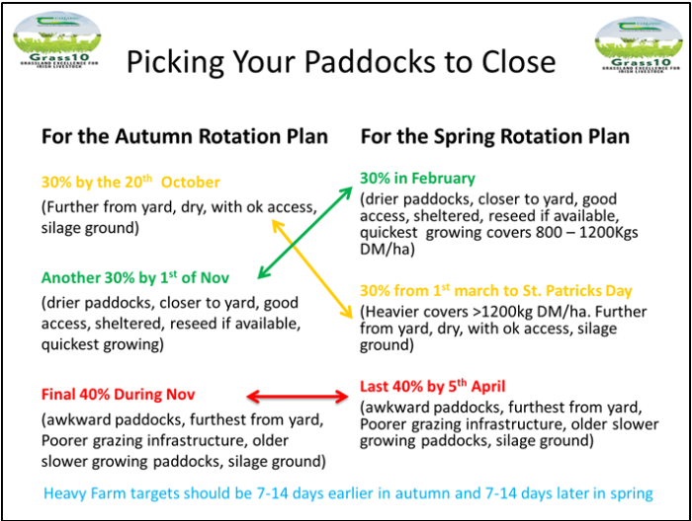
Grassland Management:
Grass quality is excellent for the time of year. Ground conditions are good allowing for good cleanouts of paddocks ahead of closing. We will start to close paddocks on Monday the 9th following the 30/30/40 rule, selecting paddocks strategically on location on the platform and ground conditions both now and in the spring.

Cows are being offered 10kgDM of 64% DMD silage, 6 kgDM grass and 4 kg of Concentrate in the parlour.

Figure 1 Teagasc grass10
Comments:
From the same period last year, milk production was 18.57 kg/cow at 5.07 % fat, 4.08 % protein (1.7 kg MS) and SCC was 61,000. BCS will be monitored closely with dry off approximately 90 days away. Now is the time to take action if needed to alter condition on cows and reach a target BCS of 2.75-3 at dry off.

