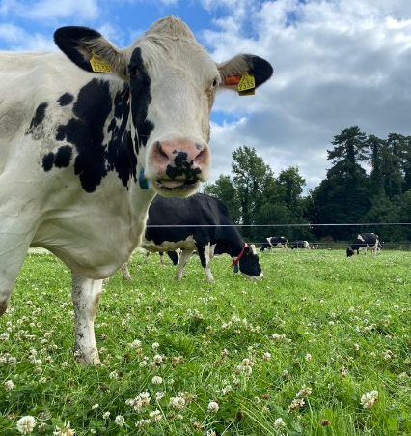
Project Objectives

- To develop a sustainable high-output grass-based spring milk production system
- To incorporate the most recent advances in grassland management for dairy farms into a high- output system
- Use a type of dairy cow that has good genetic indices for both milk production and fertility
- Employ the best practices from nutrition research and dairy cow husbandry
- Incorporate nutritional studies into a high-output system
- To incorporate management technologies and system attributes that enhance the sustainability of dairy production
Farm Details Week 11th– 17th Sept 2023
Stocking rate on MP (LU/ha) | 3.16
Farm Cover (kg of DM/ha) | 644
Growth Rate (kg of DM/ha/day) | 40
Demand (kg of DM/ha/day) | 38
Average grass DM (%) | 14.6
Average Concentrate fed (kg/day) | 3
Average DIM | 210
Cow Details Week 11th – 17th Sept 2023
Yield (kg/cow/day) | 22.6
Fat (%) | 4.91
Protein (%) | 3.92
MS (kg/day) | 2.00
SCC | 68,545

Grassland Management:
As farm cover is low, 3kg DM/cow/day of silage has been added to the diet since the 12th of September to reduce demand for grass and extend the grazing season. Target farm cover for mid-September is approximately 1100-1200kg DM/Ha. The proportion of silage in the diet will increase this week to reduce grass demand, which will aid in building covers.

Comments:
Ground conditions have held up well, however heavy rain fall over the weekend means silage is now being offered at the feed barrier in the shed pre-milking instead of under the fence lines.

