Persons completing this assessment should refer to the UCD Chemical Safety Manual, the associated chemical safety guides as necessary, and must review the SDS for the chemicals under assessment.

1. General Information

Name of Person(s) involved in the Process and their Position
Principal Investigator / Supervisor
(Person responsible for ensuring safety)
Date of Assessment
Location of Works
Frequency of Process / Chemical in use

2. Title and Details of the Process Involving the use of Hazardous Agents – give details of the process(es) in question - if necessary, attach a written procedure. Please describe the entire lifecycle of chemical usage from delivery to disposal. Include details of any hazardous reaction products or wastes generated and how these are to be managed.

Title of Process:
Details:

3. Hazardous Agent(s) to be used

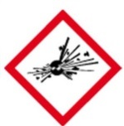  GHS01 | 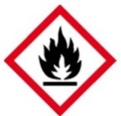  GHS02 | 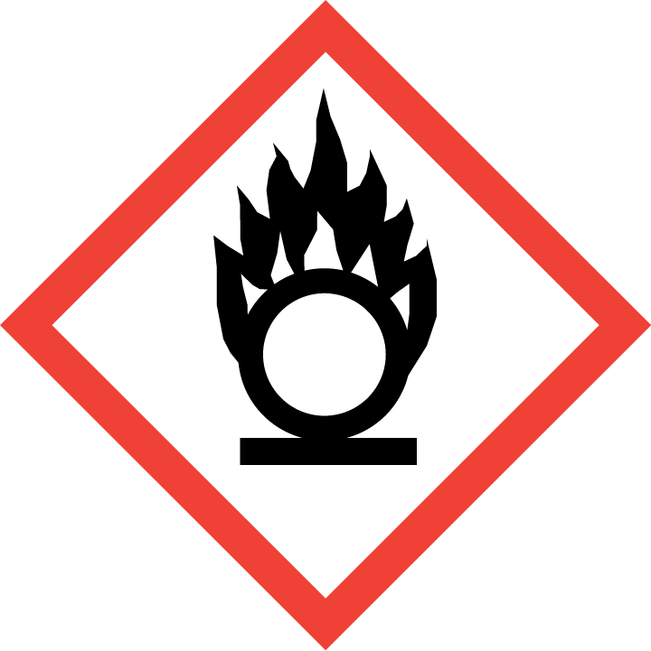  GHS03 |  | GHS04 |  | 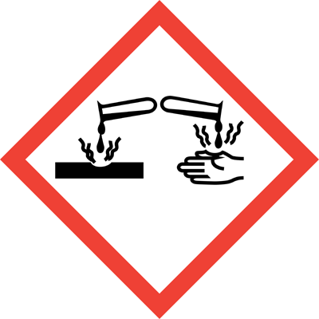  GHS05 | 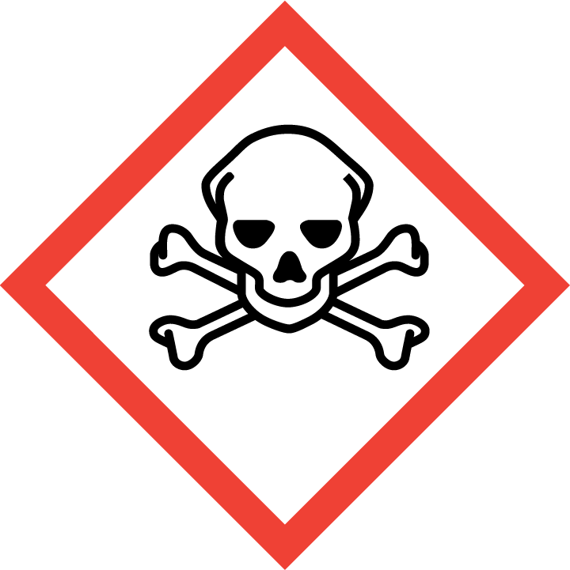  GHS06 | GHS07 |  | 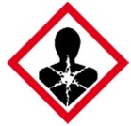  GHS08 | GHS09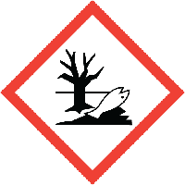
☐ | ☐ | ☐ |  |  | ☐ | ☐ | ☐ | ☐ |  | ☐ | ☐
Chemical name (or formula where no name) |  |  |  |  |  | Hazard Statements
Hazard Class
Signal Word |  |  |  |  |  | Precautionary Statements
Amount
Form
(Add additional tables as required)

Has a safer alternative(s) been considered for all chemicals (give details)?
____________________________________________________________________________________________________________________________________________________________________

Provide scientific justification for the use of chemicals classed as Carcinogen, Mutagen or Reproductive Toxin
____________________________________________________________________________________________________________________________________________________________________

Are any of the chemicals in use incompatible and likely to give rise to a potentially dangerous reaction or generate hazardous reaction products (give details): __________________________________________________________________________________
Check potential reactions with the Chemical Reactivity Worksheet

Location of SDS for each Chemical: _____________________________________________________

4. Potential Experimental / Reaction Outcomes (give details where applicable)

Exothermic: ☐ Explosive: ☐ Release of gas / vapours: ☐ Pressurisation: ☐
Generation of unstable compounds: ☐ Effects on normal atmospheric conditions: ☐
Other: ☐ ____________________________________________________________________________________________________________________________________________________________________

5. Reaction Products & Waste
If possible list the reaction products generated and indicate their hazards -
Reaction Products

GHS01 | GHS02 | GHS03 | GHS04 |  | GHS05 | GHS06 | GHS07 | GHS08 | GHS09
☐ | ☐ | ☐ |  | ☐ | ☐ | ☐ | ☐ | ☐ | ☐
(Add additional tables as required)

If possible list the wastes generated and indicate their hazards -
Wastes Generated

GHS01 | GHS02 | GHS03 | GHS04 |  | GHS05 | GHS06 | GHS07 | GHS08 | GHS09
☐ | ☐ | ☐ |  | ☐ | ☐ | ☐ | ☐ | ☐ | ☐
(Add additional tables as required)

6. Potential Exposure*

- Who (and how many) could potentially be exposed to these chemicals. Consider all stages of the chemicals’ lifecycle from delivery through to disposal.
- Is there a part of the process which could lead to a release of the chemical into the air or onto a surface (give details)?
What controls are in place to prevent this?
- What are the potential routes of exposure? (Inhalation, ingestion, dermal, transplacental, sharps)
- What steps have you taken to minimise or eliminate the potential routes of exposure identified?
- What is the chance of the exposure occurring? (Unlikely, Likely, Very Likely)
- Concentration / intensity, duration and frequency of exposure
* for carcinogens, mutagens and reproductive toxins the objective should be to eliminate exposure

7. Controls in Place
- PPE in use | Lab Coat: ☐ Safety Glasses: ☐  Safety Goggles: ☐ Face Shield: ☐ Gloves: ☐ (indicate type)____________  Other: ☐ (give details) _____________
- Engineering controls | Fume hood: ☐ Other: : ☐  * LEV / Desk Exhaust: : ☐  * only suitable for low risk activities involving low risk materials.
- Other controls
- Storage arrangements(ensure incompatibles are separated)
- Waste disposal procedure

8. Further Risk Control Measures These additional risk control measures should be designed to tackle the hazards identified in Sections 3, 4, 5, and 6 above. All questions must be answered.
- Can any of the hazardous agents be replaced with less hazardous materials? (give details)
- Can the amount of chemical in use be reduced?
- Can the duration / intensity of exposure / numbers of persons exposed be reduced?
- Are further safety / hygiene facilities required?
- Is warning signage required?
- Are transport or storage arrangements contributing to risk?
- Is appropriate first aid equipment / antidotes available?
- Is additional safety equipment required?
- In the case of carcinogens, mutagens and reproductive toxins are storage and labelling provisions adequate?
- In the case of carcinogens, mutagens and reproductive toxins can a sealed working system be used?
- In the case of carcinogens, mutagens and reproductive toxins does the working area require demarcation?
- In the case of carcinogens, mutagens and reproductive toxins do the users require medical surveillance?
- Can the process be modified to reduce exposure risks?
- Is further training for personnel required?
- Can different equipment be used to control risk?
- Is further PPE required?
- Can engineering controls be put into place?
- Is the product of the process creating a high risk that can be reduced?
- Does the working area require demarcation?
- Are safe handling procedures in place?
- Is occupational exposure monitoring required?
- Do ignition sources require isolation?
- Can the emergency responses be improved?
- Is health surveillance required?

9. Emergency Responses (Consult relevant SDS for further information)

 | Response Measures | Location of kits / specialist or response equipment
- Fire
- First Aid
- Accidental Release / Spill Response

10. Risk Rating

 | Severity
Likelihood |  | Low ☐ | Medium ☐ | High ☐
 | Low ☐ | Trivial | Acceptable | Moderate
 | Medium ☐ | Acceptable | Moderate | Substantial
 | High ☐ | Moderate | Substantial | Intolerable

Assessment of likelihood and Severity

 | Severity of Outcome | Likelihood of Exposure
Low | Slightly Harmful | Unlikely
Medium | Harmful | Likely
High | Very Harmful | Very Likely

Severity | Likelihood | Risk Rating

- Trivial Risk: No further action needed
- Acceptable Risk: No additional risk control measures required
- Moderate Risk: Implement further risk control measures if possible
- Substantial Risk: Further control measures must be implemented. If this is not possible then work must be strictly managed to ensure safety.
- Intolerable: Work must be prohibited until further control measures are implemented.

Is the risk rating acceptable: Yes: ☐ No: ☐
If yes sign and date below and ensure all risk control measures have been implemented.
If no identify further control measures and reassess risk. If the risk cannot be reduced to an acceptable level then the process cannot be carried out.

Is this work suitable for lone working: Yes: ☐ No: ☐

Signed: Date: Position:

________________ __________ ________________

Signed: Date: Position:
________________ ___________ ________________
This document must be signed by the person carrying out the assessment and their academic supervisor / manager (person responsible for ensuring safety).

