Principles & Practice of Clinical & Translational Research Course 2012
This course aims to equip participants with the essential knowledge, skills and competencies necessary to undertake effective programmes of clinical investigation and translational research.

Date: 12th – 14th September 2012
Venue: Tutorial Rooms 1 and 2, 2nd Floor, Catherine McAuley Centre, Nelson Street, Dublin 7.
Fee: €100 (Certificates of verified GCP Training and Course Attendance included)
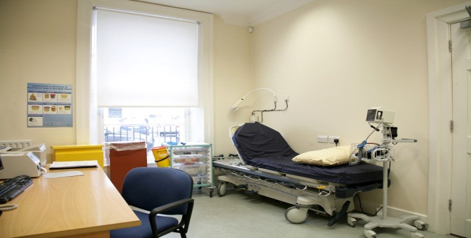
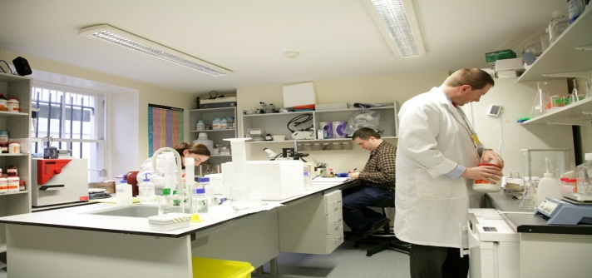
Registration and Further Information: helen.campion@ucd.ie

Course Agenda
Wednesday 12st September 2012
09.30 – 10.00 | Introduction, Overview and Welcome | Prof. Patrick Murray
10.00 – 11.00 | Introduction to Experimental Medicine | Dr. Peter Doran
11.00 – 11.30 | Break
11.30 – 12.30 | Scientific Writing and Figure Production | Dr.Eoin Cotter
12.30 – 13.30 | Cellular and Molecular Therapeutics | Dr. Debbie Wallace
13.30 – 14.30 | Lunch
14.30 – 17.00 | Cell Biology Practical
Thursday 13th September, 2012
08.15 – 09.15 | Clinical Trials | Prof. Patrick Murray
09.15 - 10.30 | Investigator Initiated Clinical Trials | Dr. Peter Doran
10.30 – 11.00 | Break
11.00 – 13.00 | Clinical Trials Practical
13.00 – 14.00 | Lunch
14.00 – 15.00 | Animal Models of disease | Prof Ml Keane
15.00 – 16.00 | Translational Research | Prof Doug Veale
16.00 – 17.00 | Clinical Trials in HIV | Dr. Jack Lambert
Friday 14th September, 2012
09.00 – 10.00 | Medical Device Studies | Dr. Niall McAleenan
10.00 – 11.00 | New Medical Device Frontiers in Respiratory Medicine | Prof. Jim Egan
11.00 – 11.30 | Break
11.30 – 13.00 | Introduction to Good Clinical Practice‐ ICH‐GCP | Ms. Siobhan Gaynor
13.00 -14.00 | Lunch
14.00 – 16.00 | Introduction to Good Clinical Practice‐ ICH‐GCP | Ms Siobhan Gaynor

