Maps, mapping data and data visualisation
  - A short course in geolocated data and your use of digital map technologies

Wednesday, February 28th 2018, 9.30am-4.30pm.

Map Library, School of Geography, JH Newman Building, UCD

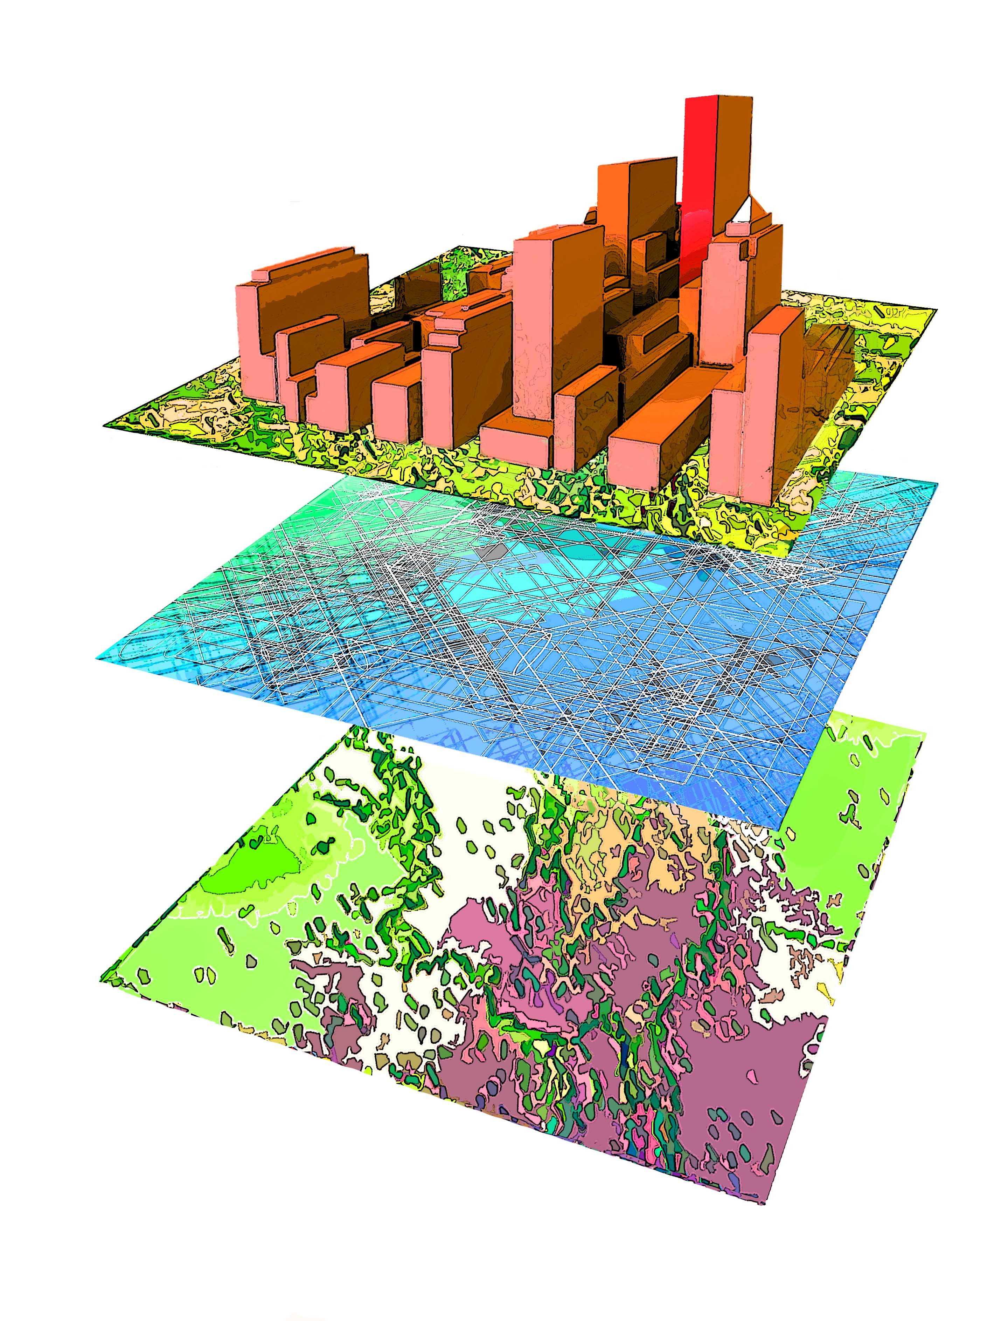
Maps and data are everywhere: we carry them around with us and we generate massive volumes of data by interacting every day. There is talk of ‘big data’, GIS and smart cities. But what are the tools we can use to make sense of these geolocated data? How are maps and data linked? In what ways can you use these tools to enhance your work? This free short course is offered by the School of Geography. The aim is to introduce you to maps, mapping data and basic data visualisation techniques.

Over the course of a one-day workshop, the School of Geography, in its interactive map library environment, will present the following:

- How geographers use geolocated data to make sense of the world
- Online sources of data
- Creating basic maps with data
- Using your data to create the maps you want
- Outputting maps for your reports
- Next steps in GIS and data visualisation technologies

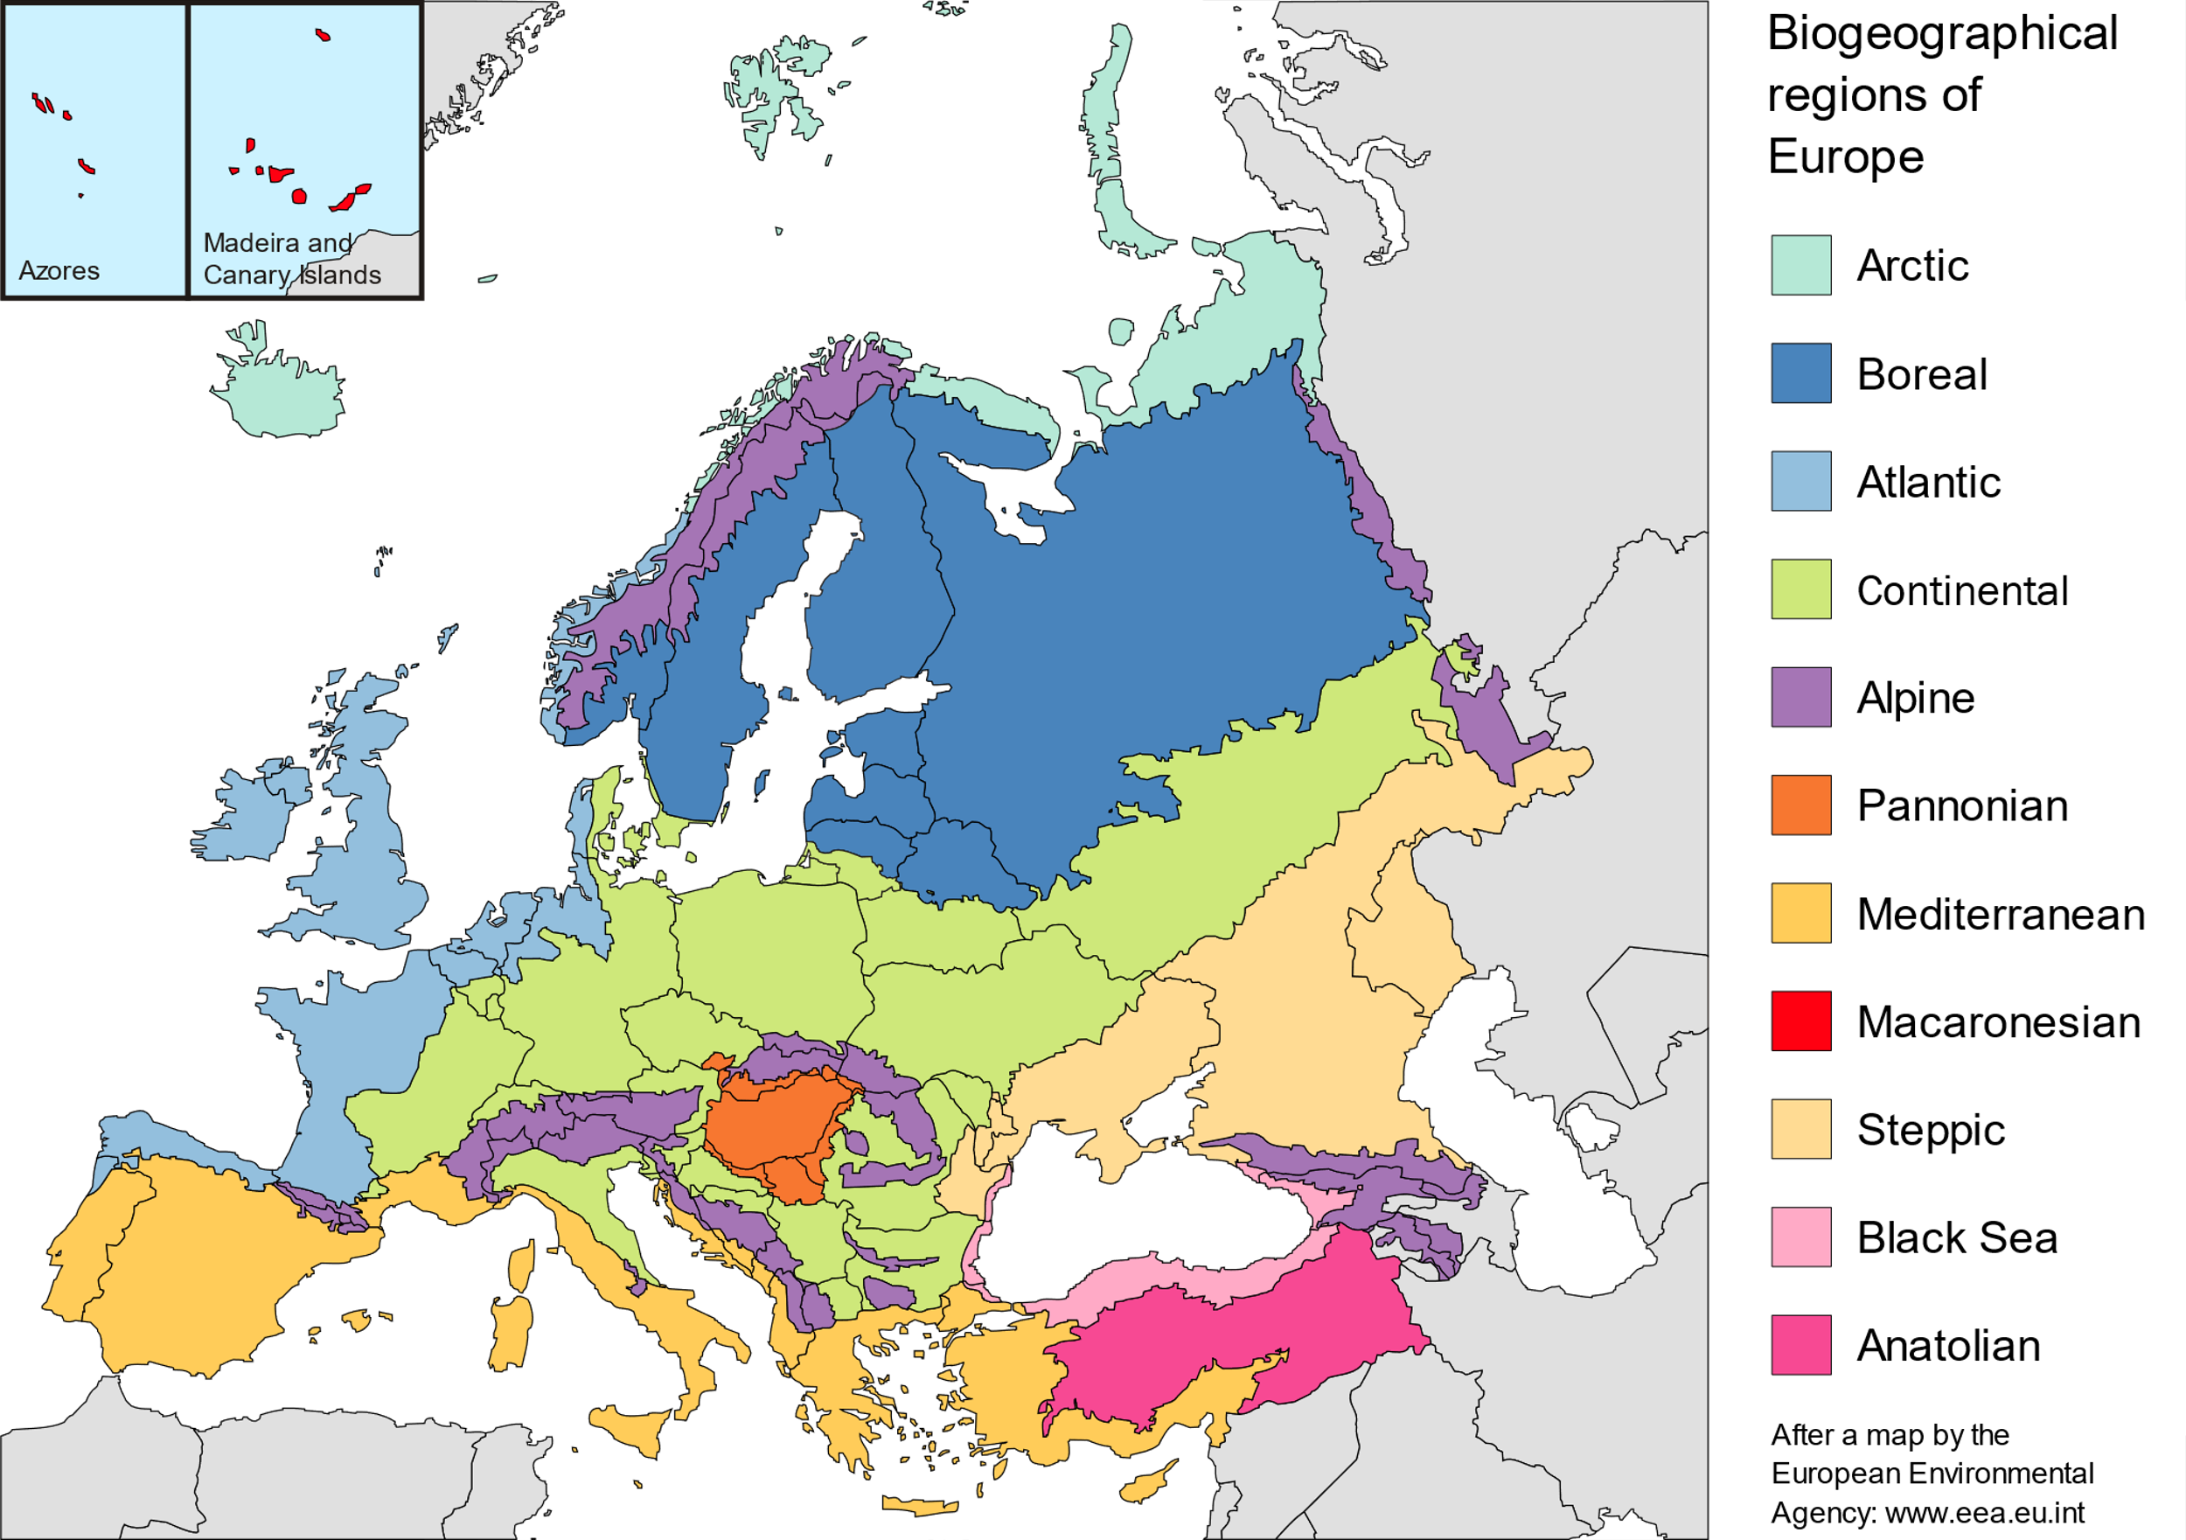
This short course is for anyone who wants to find out more about geolocated data and its usage in everyday life. It is a free, not-for-credit but certified foundation course for other modules we offer in the School of Geography.

Dr. Eoin O’Mahony
Teaching Fellow, School of Geography.

