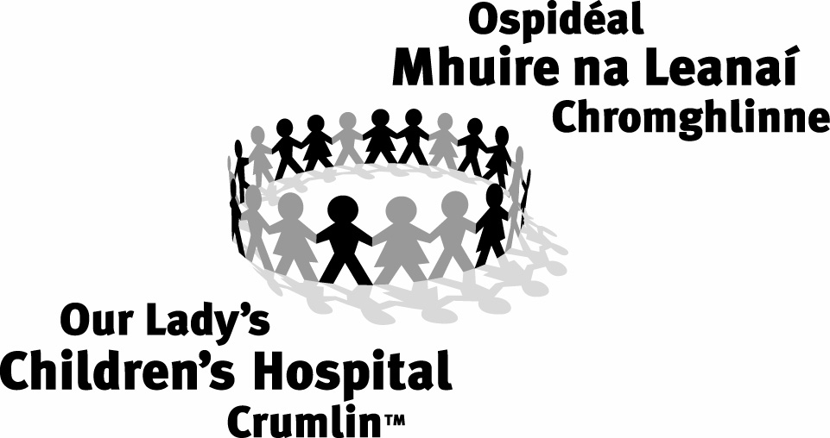 Nursing Practice Development Unit
Our Lady’s Children’s Hospital, Crumlin, Dublin 12
TELEPHONE Direct dial: +353 1 4558111 Bleep 8648
practice.development@olhsc.ie

Guidelines for Specialist Paediatric Placement
BSc Nursing
(General, Psychiatry, Intellectual Disability)

Welcome to Our Lady’s Children’s Hospital, Crumlin (OLCHC). We hope that you enjoy your placement with us. These guidelines are to support seconded students during their paediatric specialist placement at Our Lady’s Children’s Hospital.

Contacts
Allocations Liaison Officer (ALO) | Janet Coldrick | 01-4092693 | Bleep 8595
Clinical Placement Co-Ordinator (CPC) | Amanda Scott | 01-4282707 | Bleep 8596
Clinical Placement Co-Ordinator (CPC) | Naomi Bartley | 01-4282707 | Bleep 8597
Clinical Placement Co-Ordinator (CPC) | Elaine Harris | 01-4282707 | Bleep 8599
HDNS Course Co-Ordinator | Carmel Gallagher | 01-4096373 | Bleep 8598
Practice Development Co-ordinator (NPDC) | Carol Hilliard / Fionnuala O Neill | 01-4092284 01-4096637 | Bleep 8648  Bleep 8638

Ist Day
- A four hour orientation commences at 8.00 on the first morning. Please go to the Centre for Children’s Nurse Education where a member of the NPDU will meet you. You will be introduced to your clinical area during the orientation programme.
- Depending on your placement you may be in clinical placement on the first day. Please bring uniform in case.
- Lockers are available please bring a padlock for your locker. Your locker must be emptied and left unlocked on your last day.
- There is limited overnight accommodation. Rooms must be booked in advance by contacting Margaret ext 6370 between 08.00-10.00 Monday - Friday. Outside these hours leave voicemail with requirements and contact details. She will phone you back. Payment is made on return of key.

Hours of Duty
- All off duty is at the discretion of the Clinical Ward Manager
- 35 hours per week. Rostered from Monday-Friday only.
- 7 ½ hours for Bank Holidays.

Off Duty (2 week placement) Ward Areas | Meal Breaks
Day 1 = Orientation = 08.00-12.00

6 shifts (3 per week) = 07.30-19.45 | Lunch = 40 minutes Tea = 30 minutes

Off Duty (2 week placement) Day Units | Meal Breaks
4 shifts per week  08.00-17.30 (includes orientation on Day 1) | Lunch = 45 minutes  15 minutes coffee break x 2

Attendance Record
- Each student has responsibility to ensure the attendance record is signed daily by preceptor/Clinical Nurse Manager.
- Any absence is accrued in hours and must be paid back following discussion with 3rd level institution.
- It is mandatory to have been screened for MRSA in advance of placement. Please address any concerns with ALO/CPC at orientation.
Sick Leave
- If you are unfit for duty, it is essential that you contact the relevant Ward/Department directly. It is also essential that you contact your parent hospital/third level institution immediately.
- Please refer to attached list of phone numbers
- Failure to notify relevant ward of return to work will result in additional/cumulative hours of sick leave.
Specific Requests
- If leave is required for a particular reason, this must be arranged with your parent hospital/Third level institution. Our Lady’s Children’s Hospital must be notified and advised of this arrangement in advance.
- Off duty requests must be made in advance directly with the Clinical Nurse Manager.

Uniform
- Please bring uniform in on first day as clinical placements may commence following the orientation programme.
- Students must comply with local uniform guidelines while on secondment in OLCHC. Please refer to uniform guidelines available in all clinical areas. Specific points:
  - Long hair must be tied up neatly
  - No wristwatches, rings or jewellery (except plain wedding bands or gold/silver ear studs) are permitted
  - Students must not travel home in their uniform at the end of the shift
Parking
- Staff car parking spaces are limited and can be difficult to obtain. The public car park has an hourly/ daily charge and can be expensive. Please consider car-pooling or public transport. OLCHC has excellent public transport links including bus and Luas.
- Several bicycle sheds are located in the hospital grounds. Please note that spaces are limited.
Security/Safety
- Many entrances/exits may only be used with a OLCHC swipe card. These are not issued to you for your 2 week placement. Please enter the hospital by the main entrance.
- Please maintain an awareness of security at all times for the safety of our children and colleagues.
- You are strongly advised to leave all valuables at home.
- It is your responsibility to become familiar with local fire policy and major disaster plan.
- Please locate the emergency trolley and other emergency equipment in your area. Emergency number is 2222.

Support
  - If you have any concerns during your placement, please contact your base CPC / Link lecturer

Direct Dial Phone Numbers

Main Hospital; 01 4096100

St Annes: 01 4096521 / 01 4096522
Nazareth: 01 4096524/ 01 4096558
St Brigid’s: 01 4096473/ 01 4096555
St Theresa’s: 01 4096471 / 01 4096554
St Peter’s: 01 4096468 / 01 4096553
Our Lady’s: 01 4096475 / 01 4096556
St Josephs: 01 4096409 / 01 4096545
St Micheael’s: 01 4096405 / 01 4096543
Surgical Day Unit: 01 4282601 / 01 4282600
Medical Day Unit: 01 4096525 / 01 4096818
Nephro-Urology: 01 4096948 / 01 4096974
OPD: 01 4096347
Radiology 01 4096454

UNIFORM COLOUR CODE

Emerald Green | CNM 1&2
Blue | Staff Nurses
White with Red trim | Clinical Nurse Facilitators
Pink with Navy trim | Clinical Nurse Specialists
White with Blue trim | Undergraduate and post-registration nursing students
Red | Dieticians
Yellow Tee Shirts | Play Specialists
Lilac | Health Care Assistants
Light Green | Household staff
Novelty Tunics | St Annes, Emergency Department & IV team nurses
Navy Scrubs | ICU Nurses
Wine Scrubs | Radiology Nurses
Green scrubs | Theatre/ Recovery Nurses

