POSTGRADUATE SCHOLARSHIPS
MEDICAL SUBJECTS
Anatomy
Physiology
Medical Informatics

University College Dublin
School of Medicine & Medical Science

Join a vibrant and dynamic Biomedical Science community
University College Dublin is one of Europe’s leading research-intensive Universities where undergraduate and graduate education, research and innovation, and national leadership form a continuum.
Our Medical School has a long tradition of leadership in Irish Healthcare and is responsible for the education and training of over 1,400 medical students and 300 masters and doctoral students annually.
Our community and hospital-based clinical partners provide primary, secondary and tertiary healthcare for a catchment population of almost one million people in the greater Dublin area. Together with Mater Misericordiae University Hospital and St Vincent’s Healthcare Group, we are creating Ireland’s first academic medical centre, Dublin Academic Medical Centre. Both hospitals are regional and national referral centres for many clinical specialties.
Applications are now invited for full-time Medical Traineeships within the UCD School of Medicine & Medical Science in the areas of Anatomy, Physiology and Medical Informatics. The appointees will be expected to undertake a graduate research degree programme. They will join a vibrant and dynamic academic community and will have an opportunity to contribute to our teaching and research programmes.

Postgraduate Programme
The School delivers our innovative academic programmes through a blend of teaching methods including lecture, seminar, practical demonstrations and tutorials.
We aim to provide students in our Medicine, Biomedical Health and Life Sciences, Diagnostic Imaging, and Physiology courses with a rigorous scientific education and the skills to seek, synthesize and apply new knowledge which emerges throughout their medical careers. Our programmes are delivered through guided enquiry-based methods such that the student is at the centre of the learning experience.
Postgraduate Medical Scholars will receive education in and experience of demonstrating and small group teaching to undergraduate students in a variety of formats (including tutorials, problem solving and group project work).
Consistent with the School’s commitment to research and enquiry, our medical trainees are also expected to participate in knowledge discovery and to obtain a Postgraduate Research Degree.
The appointees will be expected to:
- Undertake a supervised graduate degree (MSc., MCh., MD., or PhD.) through research in an agreed area of biomedical or clinical research.
- Partake in a structured training course in small group educational techniques.
- Assist in the delivery of small group teaching (including tutorials, enquiry-based learning, group project assignments) under the supervision of academic staff in the areas of anatomy, physiology and/or medical informatics.

Selection Criteria
Mandatory
- Candidates should have good academic achievements to date including a degree in Medicine (or an Honours degree in a closely allied Life or Health Science).
- A high proficiency in ICT skills is required for traineeships in Medical Informatics.

Desirable
- Good computing skills including basic word processing, spreadsheet skills, computing graphics and experience of using PowerPoint.
- Ability to present medical and scientific topics to both undergraduate and expert audiences.

Summary of Appointment Particulars
College: | College of Health Sciences
School: | UCD School of Medicine & Medical Science
Academic Unit: | Biomedical Science Section
Post Type : | Trainee / Demonstrator Scholarship
Duration : | Initial appointment will be for a period of one year but may be renewed, subject to satisfactory progression to allow completion of a graduate degree.
Location : | UCD Health Science Centre, Belfield
Reports to : | Head of Subject  Prof James Jones, Anatomy  Prof Paul McLoughlin, Physiology  Dr Patrick Felle, Medical Informatics
Application Procedure: | - Letter of Application  - Detailed curriculum vitae including full postal address  - Names and addresses of three referees.
Apply to: | Applications should be submitted by email to  zoe.thompson@ucd.ie  Alternatively, applications can be sent by post to:  Ms Zoë Thompson  UCD School of Medicine and Medical Science  Room C209, 2nd Floor  UCD Health Sciences Centre  Belfield, Dublin 4, Ireland
email: zoe.thompson@ucd.ie
telephone: +353 1 716 6634
facsimile: +353 1 716 6649
Closing Date: | Anatomy: Friday, 15th March 2013  Medical Informatics: Friday, 15th March 2013  Physiology: Friday, 31st May 2013

About the University

University College Dublin
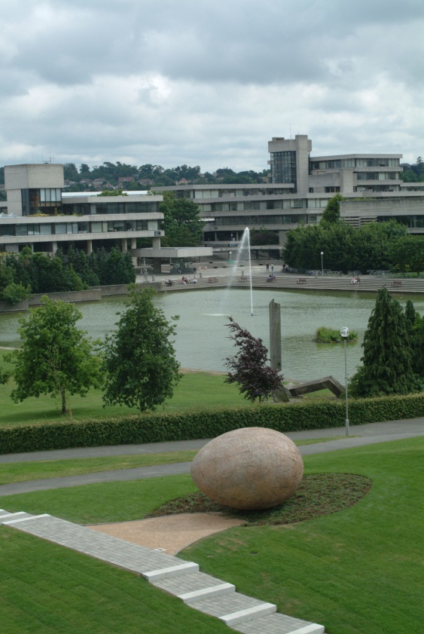
University College Dublin (UCD) is an internationally recognised research-intensive university that drives innovation and discovery within its community of world-class researchers.
Founded in 1854 by John Henry Newman, today UCD is Ireland’s largest university with almost 25,000 students. It is the most popular destination for Irish school-leavers and actively promotes university life as a journey of academic and personal discovery through its innovative and flexible UCD Horizons undergraduate curriculum.
UCD is Ireland’s leader in postgraduate education with almost 7,000 postgraduate students - representing approximately 28% of the UCD student population - and almost 2,000 PhD students. Over 50% of UCD undergraduates progress to postgraduate studies.
UCD is home to almost 5,000 international students and places great emphasis on the internationalisation of the Irish student experience – preparing all UCD students for future employment and life that crosses borders, boundaries and cultures.
The role of UCD within Irish higher education is underscored by the fact that UCD alone accounts for over 30% of international students, over 25% of all postgraduate students and almost 28% of all doctoral enrolments across the seven Irish universities.
www.ucd.ie

College of Health Science
The University is structured as a series of schools and research institutes within seven Colleges.
- UCD College of Agriculture, Food & Veterinary Medicine
- UCD College of Arts & Celtic Studies
- UCD College of Business & Law
- UCD College of Engineering & Architecture
- UCD College of Health Sciences
- UCD College of Human Sciences
- UCD College of Science
Schools comprise a number of subject groupings and represent the fundamental academic unit for resource management purposes within the University. Colleges are designed to promote cross- and multi-disciplinary interaction between academic subjects in both teaching and research. www.ucd.ie/chs

UCD School of Medicine & Medical Science
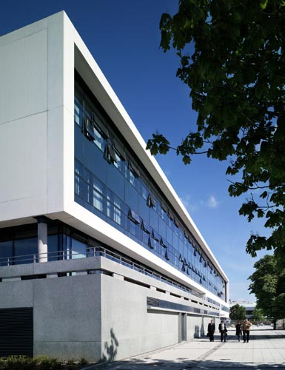
Undergraduate Programmes
Founded in 1855 and now one of Ireland’s leading medical schools, the UCD School of Medicine & Medical Science offers five undergraduate degree programmes in Medicine (direct entry and graduate entry), Physiology, Radiography and Biomedical Health & Life Sciences. Over 450 new students are recruited annually to a cohort of approximately 1,400 undergraduate students.
The School offers both direct school leaver entry and graduate entry to four, five and six year medicine programmes and provides Ireland’s only undergraduate training in diagnostic imaging through a four year Bachelor of Science (B.Sc.) degree in Radiography.
The School also offers a highly competitive four year B.Sc in Biomedical Health & Life Science which provides a thorough understanding of disease aetiology and pathogenesis and provides graduates with advanced biomedical research expertise. This programme is designed to fuel careers in biomedical and biopharmaceutical research either in academia or in industry and also serves as a strong research basis for those pursuing graduate entry routes to medicine.
The school is responsible for the delivery of Bachelor of Science (B.Sc.) degree in Physiology and our academic staff also contribute to other UCD Science degree programmes including pharmacology and neuroscience.
All our undergraduate programmes are modularised as part of the University’s Horizons initiative and each offers a range of student selected options including national and international research opportunities.
www.ucd.ie/medicine
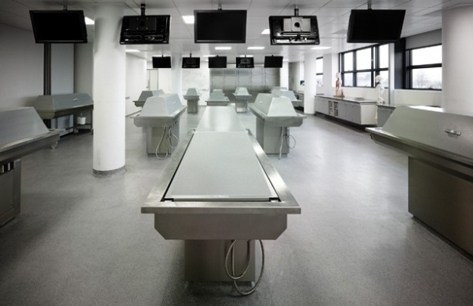
Modern lecture theatres State-of-Art Anatomy Dissection Room
Graduate Programmes
The School offers over twenty graduate taught programmes ranging from certificate to masters degree awards and a further twenty graduate research programmes at masters or doctoral level with over 400 graduate students.
Our portfolio of biomedical, clinical and translational research has over 75 principal investigators, 50 post-doctoral scientists and 250 doctoral students with grants under management worth approximately €35 million and an annual research income of approximately €7.5 million per annum.

Research Focus
Our translational research focus seeks through scientific enquiry to enhance our understanding of human diseases leading to advances in the diagnosis, treatment and prevention of human disease and improving human health.
Our research is focused on key thematic areas of
• Inflammation, Immunity and Infection
• Vascular Biology and Diabetes
• Biomarker Discovery & Biological Imaging
Approaches include cellular and molecular biology, bioinformatics and proteomics, through whole organism disease models to patient–based clinical and population studies. This multidisciplinary strength provides a stimulating environment in which scientists and clinicians can interact with relevant translational research.

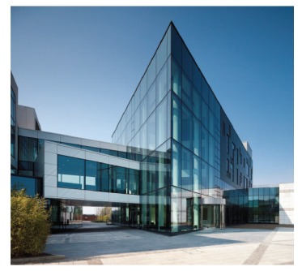
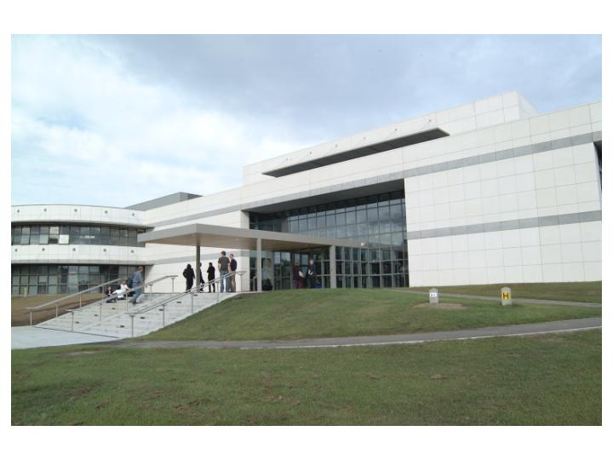
Research Institutes
The School is a principal stakeholder in Ireland's premier biomedical research institute, the UCD Conway Institute for Biomolecular & Biomedical Research.
In 2011, the School took ownership of the Charles Institute, an €18 million, 2,000 m² research facility which will see the creation of Ireland’s first academic institute focused on dermatology research and training. Research within the Charles Institute will address common skin disorders such as psoriasis, eczema, skin cancer and rare genetic skin diseases.
UCD Conway Institute
UCD Charles Institute

UCD Clinical Research Centre
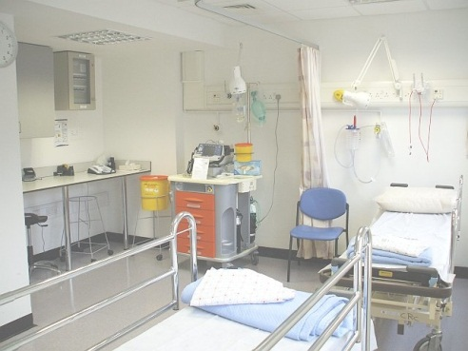
The School has built dedicated state-of-the-art clinical research units on two hospital sites (MMUH, SVUH) to provide an integrated infrastructure for clinical and translational research. This clinical research centre supports approximately 50 clinical trial, biocollection or observational studies annually with over 5,000 patient contacts. www.ucd.ie/crc

Clinical Leadership
Together with Mater Misericordiae University Hospital and St Vincent’s Healthcare Group, the School has established Ireland's first academic health centre, Dublin Academic Medical Centre. Our clinical training programmes are delivered at six major Dublin teaching hospitals and across the country through sixteen affiliated acute, general or specialist hospitals. The School also has a nationwide primary care clinical training network comprising over 100 general practitioners.
Our clinical faculty includes approximately 350 hospital consultants and over 300 junior doctors in training. Many of our hospital partners are recognised as regional and national centres of excellence for the treatment of specific diseases. Hence our students have access to best healthcare practitioners and are exposed to the practice of medicine in a variety of clinical settings.
More about DAMC

