Research & Innovation Chapter for the Self-Assessment Report
[This document provides a general template for the research & innovation chapter of a school level self-assessment report.]

[Note: The following template is provided for use with the University Quality Review Process. Text enclosed in square brackets and displayed in red italics is included to provide guidance to the author and should be deleted before publishing the document. Text enclosed in square brackets and displayed in black provide an example of what might be written for a specific section, this text should be modified or deleted before publishing]

[Suggested contents for the research & innovation chapter:]

1 Chapter Y - Research & Innovation 2
1.1 Introduction 2
1.2 Inputs 2
1.3 Activities 10
1.4 Outputs 11
1.5 Outcomes 15
1.6 Impacts 16
1.7 Conclusions and Recommendations 17

Chapter Y - Research & Innovation

[The purpose of this this chapter is to present a high-level picture of research & innovation activity within the school for the period under review.

Introduction
[The introduction provides an overview of the entire school’s research & innovation activities and how these are aligned with the strategy of the university.]
Examples
UCD School of Agriculture and Food Science, Periodic Quality Review, Self Assessment Report (October 2013)

[The UCD School of Agriculture and Food Science (SAFS) conducts interdisciplinary collaborative agriculture and food research in areas of national and international strategic importance by building on existing strengths while also valuing individual research activity. The School’s strategic research themes are aligned with those of the wider University as outlined in the UCD Strategic Plan to 2014 “Forming Global Minds”.
At present the School has a very active research programme comprising more than 100 researchers Principal Investigators and contract research staff, 155 graduate students and an operating research income of €47.9 million in the period from 2007 to 2011.]

Inputs

Research Strategy
[This section defines the direction in which research is headed at the school. It includes the research (& innovation) vision, mission, and objectives of the school.]

Vision
[A short statement outlining a desired future state. Can be aligned to a related strategic plan statement and timeline.]

Examples

The Hellman Lab, University of Notre Dame, Department of Biological Sciences
We envision a world abundant with biodiversity that sustains humanity. To help achieve this, we strive to:
- Understand ecological responses to climate and other environmental changes;
- Develop strategies to help people and ecosystems reverse or adapt to these changes;
- Engage in regular dialog with the public to implement such strategies.

Centre for Urban History, University of Leicester
The vision for the Centre for Urban History is to remain one of the world’s leading institutes for the study of the urban past. This implies deepening and extending our two-fold purpose of research and education. In the next ten years we shall strengthen our reputation with research councils, international agencies and policy-makers as a Centre for path-breaking research on urbanisation, urban cultures and the historic environment. And we are becoming a truly international Centre for training postgraduate students from across the world in the study of urban history, global cities and historic conservation. The result will be a vibrant Centre, influencing scholarship and policy-making at the highest levels in the understanding of how cities worked in the past and how they can be sustained in the future.

Mission
[Outlines what the unit does it terms of its present state or purpose. Identifies who benefits from its current activities and how this is achieved.]
Examples

Department of Computer Science, University of Texas at Austin
Computer science is at the intellectual forefront of the digital revolution that will define the 21st century.That revolution is in its infancy but is visible all around us. New scientific, economic and social paradigms are arising from computing science and being felt across all sectors of the economy and society at large.

The Department of Computer Science at the University of Texas at Austin is a recognized leader in the creation of scientific knowledge and practical technologies that are defining this historic transformation. Our mission is to supply the people and ideas that will shape this new frontier.

The jobs of tomorrow will use technologies not yet invented. Many of the software and hardware tools that enable these technologies are being invented by our faculty and students. Such innovation requires dedication to learning, in the classroom, in the research laboratory, and throughout one's professional career.
Scientific discovery and technological innovation require mastery of the fundamentals of computing science as well as mastery of practical technical skills.

At the Department of Computer Science, we offer a unique educational opportunity for students to achieve excellence in both through rigorous classes and participation in cutting edge research.

School of Business and Economics, Loughborough University
To develop elite performers capable of creating and leading high performing businesses and delivering value to society globally, through providing world-class research and education in business and economics, within an environment where the contributions of all members of the School community are valued.
In short, our mission is about:
- Developing Winners, Achieving Excellence, Delivering Value

Objectives
[Can be used to qualify the mission statement with a list of specific goals.]

Examples

UCD School of Agriculture and Food Science, Periodic Quality Review, Self Assessment Report (October 2013)
The School’s current research activities seek to:
- Advance efficient and sustainable animal and crop production to contribute to national targets and adhere to policy reform.
- Develop and evaluate sustainable land use.
- Advance the economic management and performance of the food chain and contribute to policies and programmes in rural and agricultural development.
- Optimise the quality of foods to enhance the health and well-being of consumers.’

UCD School of English, Drama and Film, Quality Assurance Review 2013-14, Self-Assessment Report
Our strategic research aims are as follows:
- To maintain and develop the local, national and international distinction and quality of our research
- To facilitate a strong research culture and knowledge exchange culture within the School, and in our relations with other disciplines and institutions
- To promote and support research-led teaching in the curriculum
- To foster innovation in, and renewal of, our disciplines through research training and research supervision
- To provide support structures within the School to promote and develop our research, and to lobby for more effective structures within the university.
- To advocate for the rationale, distinctiveness, and achievements of our research and our discipline through academic and public engagement, at local, national and international levels.’

People

Staff
Example
UCD School of Agriculture and Food Science, Periodic Quality Review, Self Assessment Report (October 2013)
The UCD School of Agriculture and Food Science is among the larger schools in the University, with a headcount of 54 Academic staff, 15 Administrative staff, 19 Technical staff and 54 Contract Researchers including Post-doctoral Fellows and Research Assistants. Almost 90 per cent of academic staff within the School are research active. A total of 54 research funded staff are currently employed on a contract basis. The vast majority of these are post-doctorates employed on funded projects under supervision of academic staff.

Staff Numbers

Enrolled Research Students
Example
UCD School of Agriculture and Food Science, Periodic Quality Review, Self Assessment Report (October 2013)
A total of 155 postgraduate research students are currently registered to the School. This comprises 51 research Masters and 104 PhD students. Approximately, two-thirds of research students are Irish nationals and many are former undergraduates of the School.
Research Students by Nationality
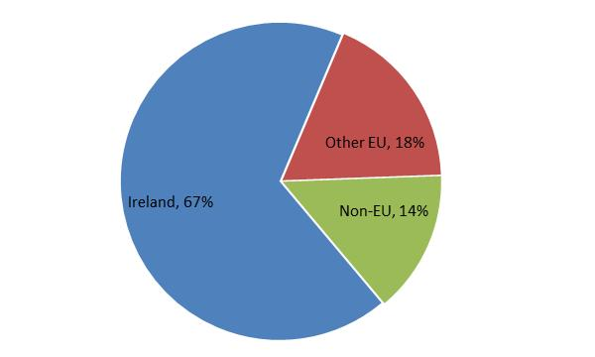

Organisation
[Narrative that describes the research organisation in the school, including thematic areas, research governance structures, research centres & institutes, major programmes etc.]

Examples
[UCD School of Agriculture and Food Science, Periodic Quality Review, Self Assessment Report (October 2013)
‘These four research areas are, for the most part, aligned with the four management sections within the school: Animal and Crop Science (ACS), Environment and Sustainable Resource Management (ESRM), Agribusiness and Rural Development (ARD), Food Science and Nutrition (FSN). However, there are many examples of collaborations between these research areas and many researchers operate in a multi-disciplinary environment.’

The current numbers of staff and research students in each section of the School are shown in Table 6.1.
Table 6.1: Staff and Research Students (2012-13)
Section | Academic Staff | Technical staff | Research Funded Staff | Postgraduate Research Students
Agribusiness and Rural Development (ARD) | 12 | 0 | 2 | 30
Animal and Crop Science (ACS) | 17 | 8 | 17 | 58
Environmental and Sustainable Resource Management (ESRM) | 15 | 6 | 5 | 33
Food Science and Nutrition (FSN) | 14 | 5 | 28 | 34
Total | 58 | 19 | 52 | 155

SAFS staff in the School are affiliated with a number of thematic Research Institutes:
• UCD Conway Institute (www.ucd.ie/conway) [4 SAFS staff]
• UCD Earth Institute (earth.ucd.ie) [3 SAFS Staff]
• UCD Institute for Food and Health (www.ucd.ie/foodandhealth) [17 SAFS staff]
• UCD Centre for Humanitarian Action (www.ucd.ie/cha) [4 SAFS staff]

University of Edinburgh, School of History, Classics and Archaeology
‘The School comprises the three subject areas of History, Classics and Archaeology, together with the Centre for the Study of Modern Conflict, the Scottish Centre for Diaspora Studies and the Centre for Medieval and Renaissance Studies.’]

Infrastructure
[Identification of non-human resources within the unit’s domain supporting the research mission.]

Examples
University of Bristol, MRC Integrative Epidemiology Unit
‘A major focus of IEU activities is the integration of omic measures (genomic, epigenomic, transcriptomic and metabolomic) into epidemiological investigations. To underpin this we have established the infrastructure to reliably and efficiently generate and handle the large data sets that we utilise.’

University of Manchester, School of Arts, Languages and Culture
‘Here in Manchester, we are extremely fortunate to be able to make full use of the University’s key cultural assets in our teaching and research: The University of Manchester Library, The Whitworth Art Gallery, the Race Relations Archive and The Manchester Museum. We also boast our own cultural assets including The Martin Harris Centre for Music and Drama and The Confucius Institute.’

Research Funding
[Description of the research income and awards received by the school.]

Example
UCD School of Agriculture and Food Science, Periodic Quality Review, Self Assessment Report (October 2013)
SAFS have maintained a strong track record of research funding in an exceptionally difficult economic climate. In particular, SAFS is currently the leading school for research income within the university. Research income averaged €7.8m per annum over the five year period 2008/09—2012/13 with an average of 60 new grants achieved each year. This equates to an average annual research income of over €140,000 per academic staff member. Over the recorded period, major grants in excess of €1m were routinely secured by SAFS staff.

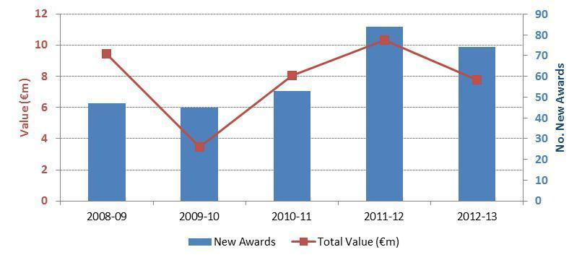

Sources of Funding
[Description of the sources of research income received by the school, noting any risks and issues.]

Examples
[UCD School of Agriculture and Food Science, Periodic Quality Review, Self Assessment Report (October 2013)
The sources of research funding for 2011-12 are shown [below]. The vast majority of research funding has been derived from national agencies such as DAFM, SFI, Enterprise Ireland, IRC and Teagasc. This dependency on Irish State agencies may be viewed as a weakness as the national exchequer budget remains tightly constrained due to challenging economic conditions. In this regard, the School is actively seeking to diversify its funding to encompass a greater emphasis on international (e.g. EU, Wellcome Trust) and industry sources.
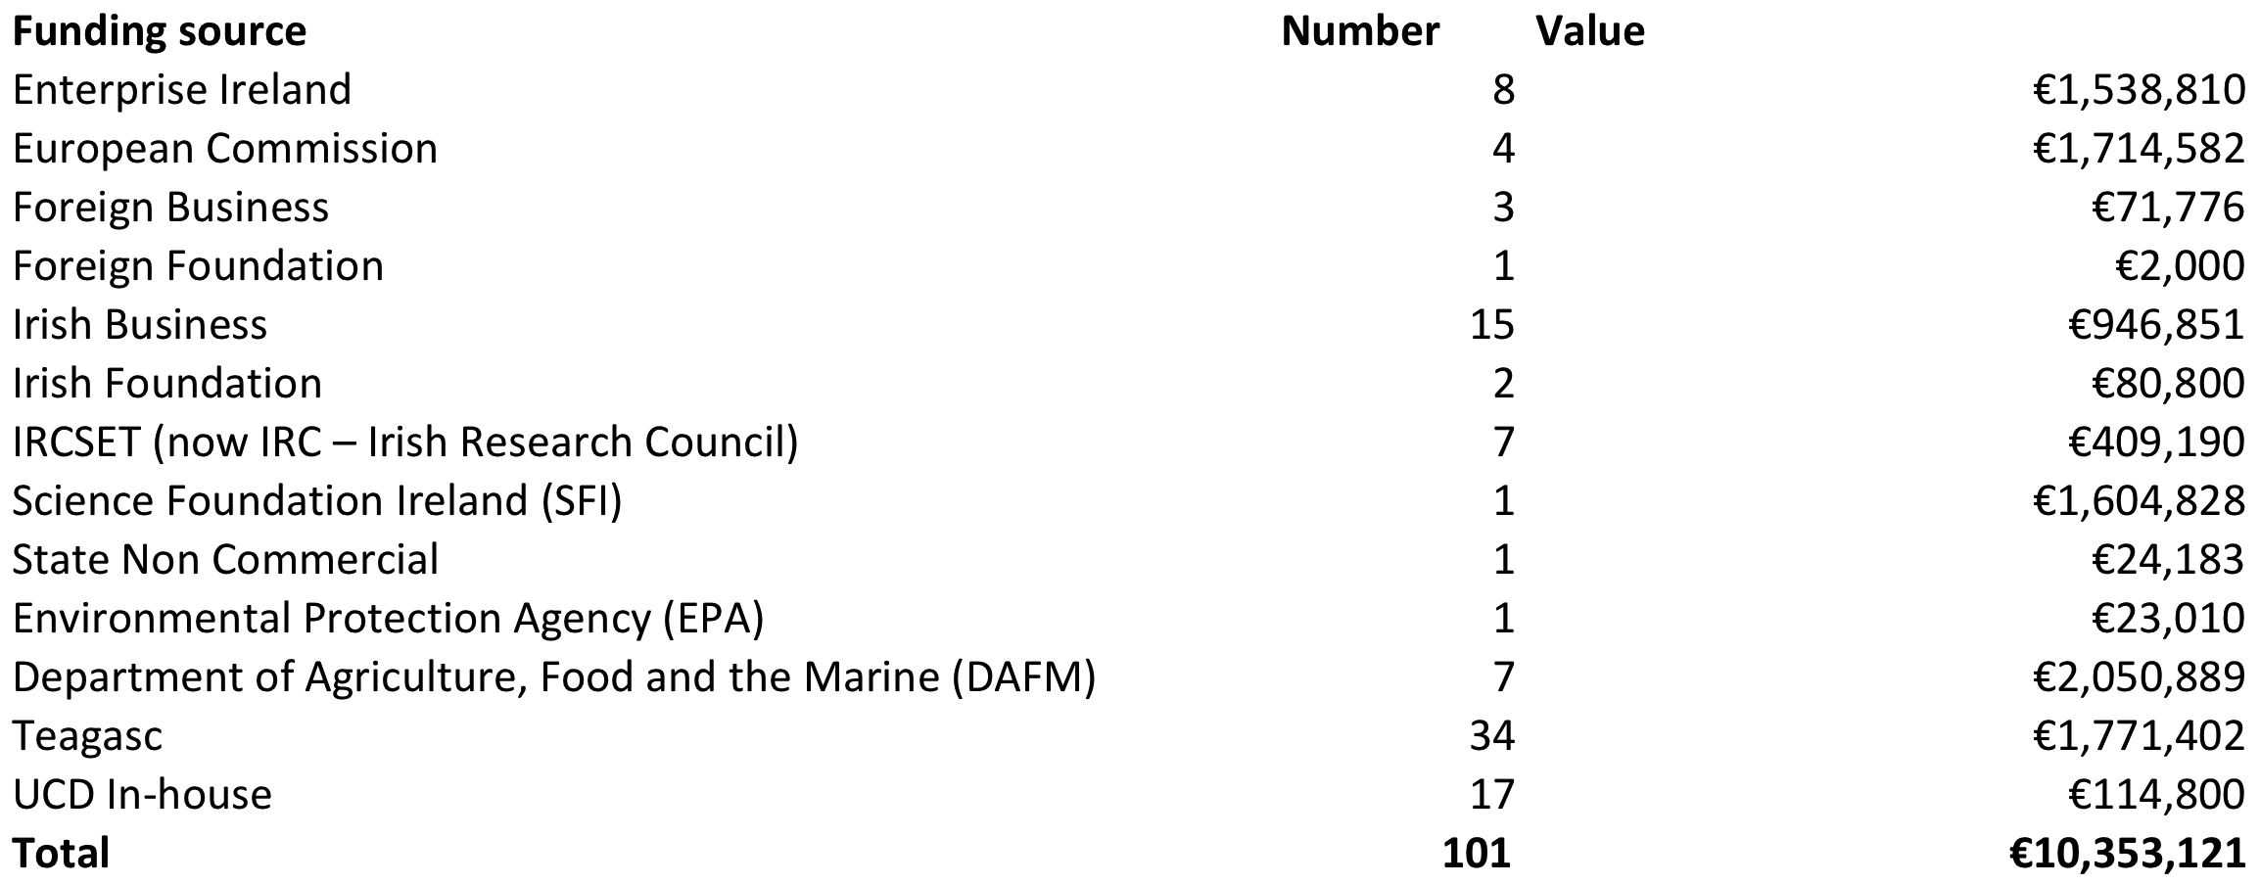
]

Activities
[Description of the research activities within the school]

Research Themes
Examples
[UCD School of Agriculture and Food Science, Periodic Quality Review, Website (December 2014)

Research activities within the School are driven by UCD’s Research Strategy which focuses on the following key research themes:
- Earth Sciences, Energy & the Environment
- Health & Healthcare Delivery
- Global Ireland
- Agribusiness & Rural Development
- Agri-Environment
- Animal Science
- Food and Health
- Forestry

Collaboration
UCD is building an environment that will support researchers across a broad spectrum of disciplines and that encourages collaborative research. Several research institutes and centres have been established to provide state-of-the-art resources and a critical mass of academics, including:
- Reproductive Biology Research Cluster
- UCD Institute of Food & Health
- Centre for Humanitarian Action
While researchers in the school collaborate with co-authors of publications from 45 countries, the majority of collaboration activity is national in nature. Teagasc in particular, is by far the leading collaborator by volume of publications, as evidenced by the table below.
Institution | Country/Territory | Times Cited | Web of Science Documents | Average Cites per Document
TEAGASC | IRELAND | 3,344 | 365 | 9.16
NUI GALWAY | IRELAND | 433 | 38 | 11.39
DUBLIN INST TECHNOL | IRELAND | 616 | 34 | 18.12
INRA | FRANCE | 410 | 32 | 12.81
TRINITY COLL DUBLIN | IRELAND | 318 | 24 | 13.25
INIA | SPAIN | 220 | 20 | 11.00
UNIV COLL CORK | IRELAND | 152 | 20 | 7.60
IRISH CATTLE BREEDING FEDERAT | IRELAND | 190 | 17 | 11.18
JUSTUS LIEBIG UNIV GIESSEN | GERMANY (FED REP GER) | 145 | 14 | 10.36
UNIV LIMERICK | IRELAND | 78 | 13 | 6.00

Outputs
[Description of the research outputs produced by the school. Outputs are products of research; typically :
- publications: scholarly publications (but not forgetting grey literature)
- products: prototype artefacts, research datasets, software;
- patents.]

Publications

Example
[UCD School of Agriculture and Food Science, Periodic Quality Review, Self Assessment Report (October 2013)
The total publications recorded by School staff on their RMS profiles in each calendar year over the period 2009 – 2012. In the years 2009-2011 the totals equate to between 6 and 7 publications per staff member in each year. There was a notable decline in output for 2012, which may partly be explained by some staff failing to update their RMS profiles in 2013 (RMS profiles are normally updated in September of each year). However, it may also to reflect a lagged effect arising from a dip in research funding that occurred in 2009-10.
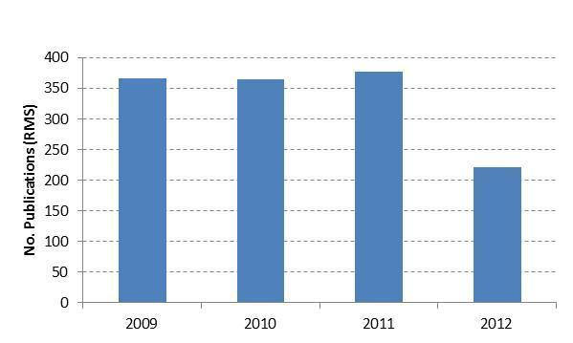

Publication types
Example
Report on Research Metrics for the UCD School of Architecture (July 2014)
The total publications recorded by School staff on their RMS profiles in each calendar year over the period 2004 – 2013. In the years 2004-2011 the totals equate to between 1 and 3 publications per academic staff full time equivalent (FTE) in each year.
Publication Type | 2004 | 2005 | 2006 | 2007 | 2008 | 2009 | 2010 | 2011 | 2012 | 2013 | Grand Total
Conference Publication | 5 | 7 | 21 | 14 | 10 | 11 | 13 | 8 | 5 | 4 | 98
Other Journal | 7 | 9 | 15 | 15 | 3 | 3 | 3 | 1 | 5 |  | 61
Peer Reviewed Journal | 4 | 1 | 2 | 9 | 4 | 2 | 4 | 6 | 9 | 1 | 42
Book Chapter | 1 | 1 | 3 |  | 6 | 2 | 8 | 5 | 7 | 4 | 37
Book | 5 |  | 5 | 3 | 3 | 1 | 3 | 1 | 3 | 4 | 28
Other Publication | 1 | 2 | 3 |  | 4 | 2 | 5 | 1 | 5 | 1 | 24
Edited Book |  |  |  |  | 4 | 1 | 1 |  | 3 | 2 | 11
Published Report |  |  | 1 | 2 | 3 |  | 2 |  | 1 |  | 9
Grand Total | 23 | 20 | 50 | 43 | 37 | 22 | 39 | 22 | 38 | 16 | 310
]

Open Access publications
Example
UCD Research Repository statistics for the School of Agriculture and Food Science
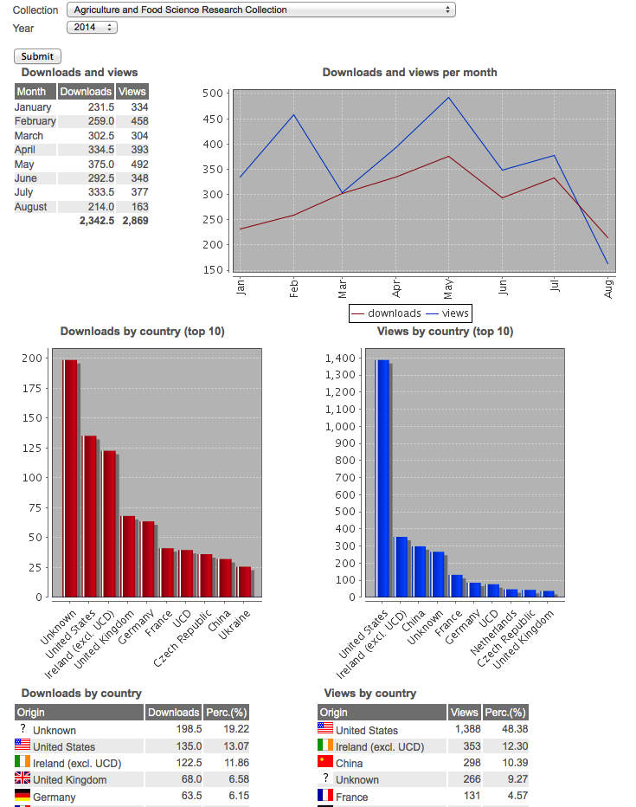

Masters and PhD theses
[The output of Masters and PhD theses (30-40 per year) is consistent with the number of research postgraduate students. Most PhD theses are now prepared as compilations of peer reviewed publications with a typical thesis involving the preparation of between 3 and 5 published academic papers. The adoption of this model ensures that generation of published outputs occurs in tandem with the thesis preparation thereby maximising the amount of published outputs from research theses.]

Commercialisation of research
[Some 58 per cent of staff responding to the online QRQ indicated that their research had potential for commercial applications. Over 80 per cent of staff felt that support for commercialisation of research within the School was at least satisfactory. Over the last decade, the School’s performance in commercialisation has started to gather momentum. For example, at time of the previous Faculty SAR in 2000 there was no evidence of commercialisation reported. Commercialisation can be demonstrated through a number of metrics:
• Invention disclosures: SAFS researchers have registered 26 invention disclosures since 2004.
• Patent applications: 15 patent applications have been filed by SAFS staff since 2006
• Licensing agreements: 5 commercial licensing agreements registered since 2009
• Spin-out companies: 5 campus companies have been registered since 2003: Belfield Technologies Ltd., Biosystems Engineering Ltd., Crop Research Ltd., Equilume Ltd. and Equinome Ltd.]

Outcomes
[Outcomes are the results or consequences of the research activities and outputs on academia, society or the economy: examples are cited publications, trained postgraduate staff, licence income from patents, follow-on grant income]

Citation activities
Example
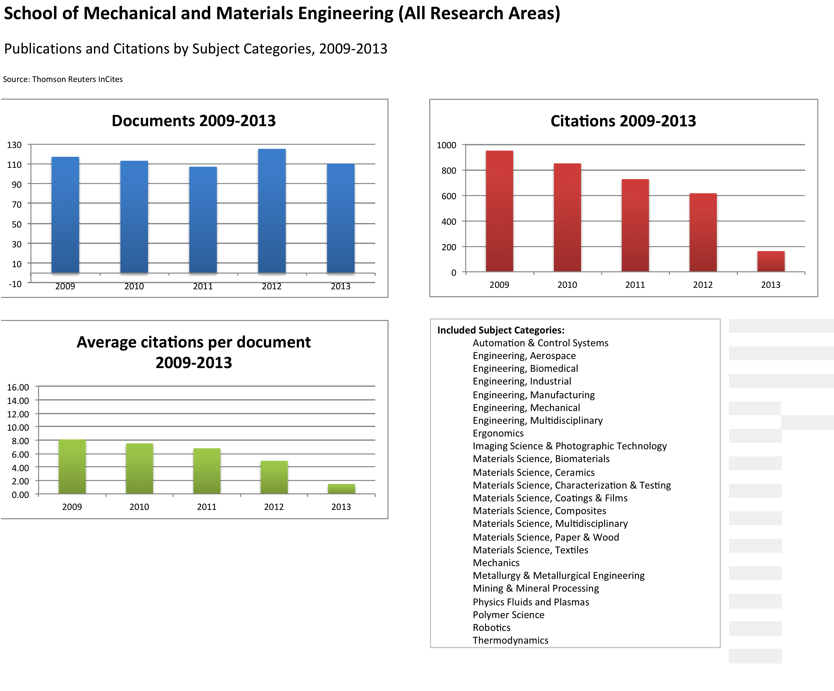

Comparators
Example
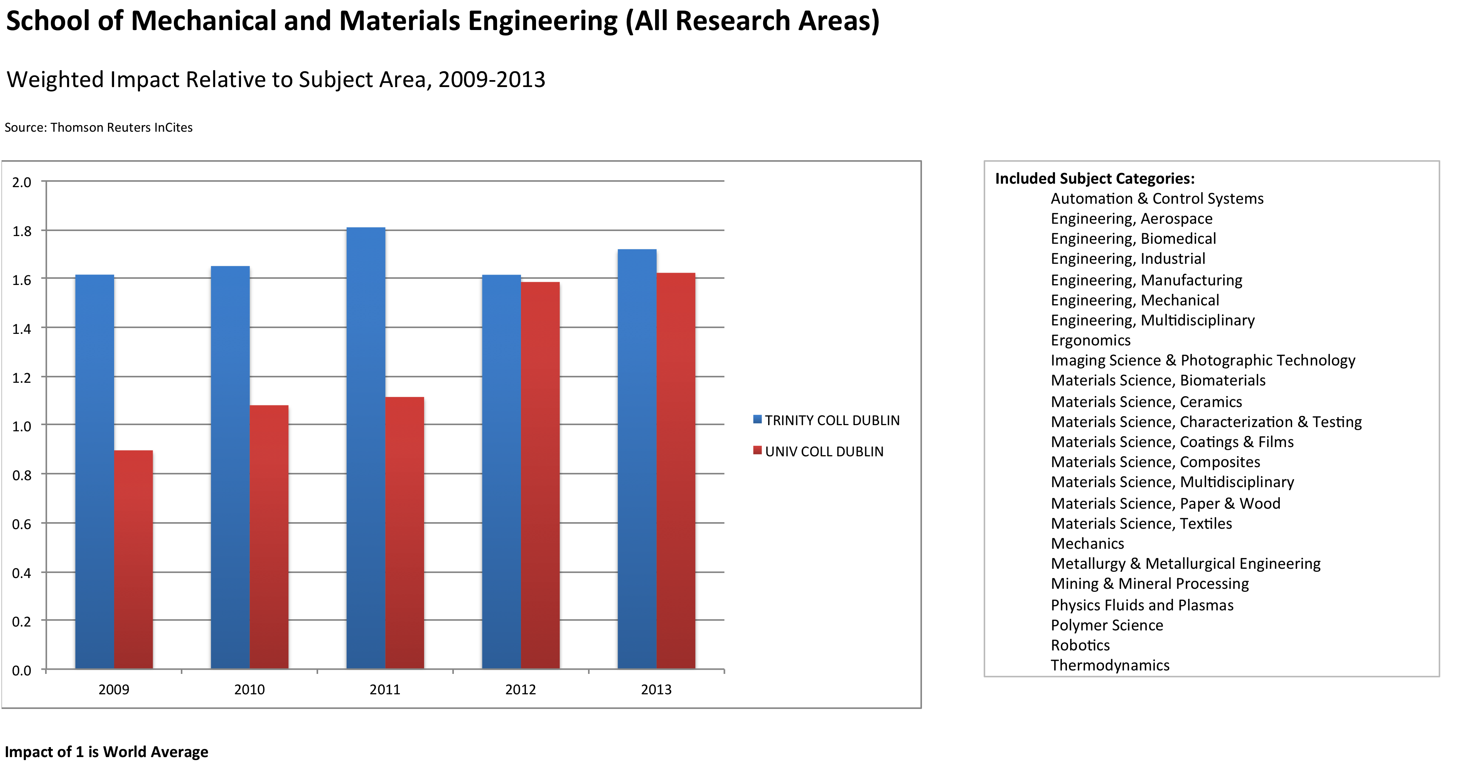

Impacts
[This section highlights some of the major impacts that research in the school has brought about, additional case studies can be found in the appendices. Impact is the contribution of the research on academia, the economy and society including business, health, environment, social cohesion etc. Examples are wealth creation (spin-out company capitalisation, number of employees); environmental benefit (river now 10% cleaner than before); healthcare (10,000 lives saved per year because of the drug developed by the research); social cohesion (policy developed in the research provides improved social networking among pensioners).]

Examples
[University of Glasgow, School of Engineering
The School has created robust pathways that utilise our facilities and capitalise on mechanisms for knowledge transfer to build partnerships with industry and to achieve impact from our research.

Key strategic relationships have led to commercialisation and industrially funded research, with impact that is manifest in multiple formats including licensing of Intellectual Property, formation of spin-out companies, direct co-development work with industry partners and through consultancy.

The School has worked with hundreds of industry partners over the period on a broad range of projects. In addition, we are a key partner for Government agencies and health organisations and participate in public engagement activities.

New gyroplane design standards improve flight safety
As a direct result of our research, there have been no deaths in a gyroplane accident in the UK since 2009. Previously, gyroplanes (also known as autogyros) had a questionable safety record
...

Gene Sequencing on Silicon: the Ion Torrent Personal Genome Machine
The development of microelectronic sensor arrays for biological applications, pioneered at the University of Glasgow, is central to a unique gene sequencing system developed by Ion Torrent....

Novel laser products open up new markets for spin-out company Intense
High-power lasers developed at the University of Glasgow now lie at the heart of state-of-the-art technologies in the commercial printing, medical and defence markets....]

Conclusions and Recommendations
[This section contains an overall assessment of research performance, challenges in delivering the research mission, high level suggestions for the improvement of quality and performance for consideration by the quality review panel.]

Department of Computer Science, University of Texas at Austin https://www.cs.utexas.edu/about-us/mission-statement [retrieved 18 August, 2014]
School of Business and Economics, Loughborough University http://www.lboro.ac.uk/departments/sbe/about/mission/ [retrieved 18 August, 2014]
UCD School of Agriculture and Food Science, Periodic Quality Review, Self Assessment Report (October 2013), p.30
School of English, Drama and Film, Quality Assurance Review 2013-14, Self-Assessment Report, p. 76-77
UCD School of Agriculture and Food Science, Periodic Quality Review, Self Assessment Report (October 2013), p.16, pp 30-31
UCD School of Agriculture and Food Science, Periodic Quality Review, Self Assessment Report (October 2013), p.16, pp 31
UCD School of Agriculture and Food Science, Periodic Quality Review, Self Assessment Report (October 2013), p.30
University of Edinburgh, School of History, Classics and Archaeology [retrieved 15/08/14] http://www.ed.ac.uk/schools-departments/history-classics-archaeology/about-us/about-school
University of Bristol, MRC Integrative Epidemiology Unit [retrieved 15/08/14] http://www.bristol.ac.uk/integrative-epidemiology/research/infrastructure/
University of Manchester, School of Arts, Languages and Culture [retrieved 15/08/14] http://www.alc.manchester.ac.uk/abouttheschool/our-background/
UCD School of Agriculture and Food Science, Periodic Quality Review, Self Assessment Report (October 2013), p. 6.
UCD School of Agriculture and Food Science, Periodic Quality Review, Self Assessment Report (October 2013), p. 6.
http://www.gla.ac.uk/schools/engineering/researchimpact/

