**UCD**

**Impact Planning Guide**

Published: May 2016

**Introduction**

Impact needs be considered up-front and throughout the research process in order to generate better research outcomes and contribute to greater impact.

This impact guide has been developed to assist researchers in developing impact sections for funding proposals. It has been designed to be used in tandem with the UCD Impact Planning Canvas (see Appendix One).

It is advisable that the UCD Impact Planning Canvas be utilised first and then the information generated can be developed out in more detail using this impact planning guide.

The canvas tool is best used covering the 9 sections in the following order: Challenge; Response; Beneficiaries; Unique Value Proposition; Reach and Engagement; Potential Impact; Measures of Impact; Resources and Team; Funding. It is suggested that you use post-it notes to work your way round the canvas which then allows you to be flexible in your thinking and easily change your responses.

It is intended that you use this impact planning guide as a template document where you can go through the document and complete each section. The impact plan can then be used as a source document to inform a research funding proposal or pitch for funding.

Throughout the course of your impact plan it is important to be as specific as possible using verifiable evidence in order to assist reviewers to assess the potential impact of the proposed research activity.

It is important to recognise that individual funding bodies will have a particular focus in terms of impact and therefore relevant sections in proposals should reflect this.

This impact planning guide is split into 11 sections:

1. Challenge Identification P.3
2. Research Response P.3
3. Beneficiaries P.3
4. Unique Value Proposition P.4
5. Reach and Engagement P.4
6. Potential Impact P. 5
7. Measures of Impact P. 9
8. Resources and Project Team P. 10
9. Funding P. 10
10. Track Record on Impact P. 10
11. Impact Plan Summary P. 10

Appendix One: UCD Impact Planning Canvas P. 11

Appendix Two: UCD Impact Case Study Template P. 12



1. **Challenge Identification**

This section is one of the most important parts of the impact plan as the remainder of the plan will emanate from a sufficient understanding of the key challenges/ needs that your research addresses.

* Highlight the key research challenges/needs that are being addressed.
* Discuss the major factors driving the research challenge area you have identified (e.g. industry trends, socio-economics trends, demographic trends, government regulation etc.)
* Engagement with potential beneficiaries of your research during your research programme will help to continually inform you of challenges/needs to be addressed.



1. **Research Response**

With the research challenges identified you can now set out how your research plan responds to them.

* Think about people, organisations or societies that have the challenges/needs and how it impacts them.
* What are the key elements of your research plan than respond to the research challenges identified.



1. **Beneficiaries**

This section provides an overview of the potential beneficiaries of the research. The beneficiaries of the research are central to the development of its impact and therefore this section is paramount to the validity of the impact plan.

Beneficiaries are those whose quality of life, practices or activities will be influenced by your research. Your research may impact upon one or many beneficiaries such as:

* individuals or groups of individuals (including the general public)
* communities or organisations (such as charities and NGOs)
* private sector organisations such as individual companies or groups of companies
* public sector groups or organisations
* policymakers or regulators

Beneficiaries can be direct or indirect. Direct beneficiaries are those who gain from direct involvement in any activities. Indirect beneficiaries are those who do not participate in any given activities but gain as a result of the involvement of a direct beneficiary.

* Who will benefit from the results of your research? Are they within the private sector, public sector, third sector or any other group?
* Detail each grouping of beneficiaries of your research results.
* How are the potential beneficiaries of your research responding to this challenge/need today?



1. **Your Unique Value Proposition**

The previous section looked at who will benefit as a result of your research output. This section now addresses how they will benefit.

* What benefits will your research provide to beneficiaries over existing research responses? I.e. what is your unique value proposition?
* Make sure you detail your unique value proposition to the various beneficiaries. You need to include verifiable evidence of literature, patent searches, competitors’, industry trends, policy and any other information that help define your unique value proposition to each beneficiary.



1. **Reach and Engagement**

For research impact you need to consider who your beneficiaries are and how you will reach and engage with them during your research programme. Optimised engagement with beneficiaries can be central to the development of impact from the research.

* What avenues have you identified in order to engage with the potential beneficiaries of your research during the course of your research programme?
* It is important to consider the most appropriate channels to reach the potential beneficiaries of your research, for example: through workshops; regular user groups; the establishment of an advisory group; or attendance at or hosting of conferences. You may have to use a variety of approaches to engage with the beneficiaries.



**6. Potential Impact**

Based on the identification of the potential beneficiaries of your research and an understanding of your value proposition to these beneficiaries you are now in a position to detail the potential impact of your research.

The European Science Foundation (ESF) classifies impact of research activity in terms of cultural, economic, environmental, health, political, scientific, social, technological and training impacts.

**European Science Foundation Impact Classifications**

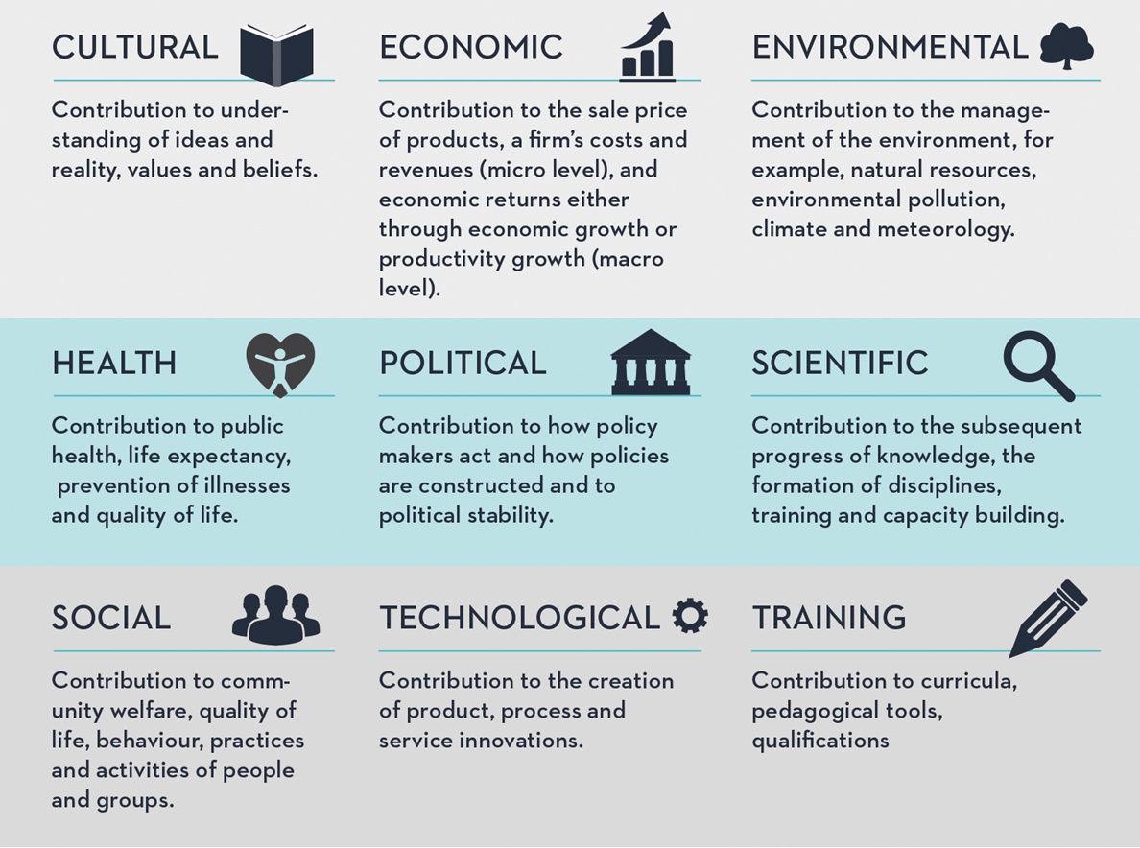

Further information on each of these nine potential impact areas is below. In addition, there are explanations of international engagement impacts and professional service impacts which SFI include in addition to the ESF impact classifications.

Please note your research may have multiple potential impacts in different areas.

**It is imperative that due consideration is given to the specific call or funding body in relation to their impact expectations or impact specifications.**

**Cultural Impacts**

These are impacts which contribute to the understanding of ideas and reality, values and beliefs. Your research may also have contributed to the design of cultural services (museums, galleries, libraries) through improving awareness or improving the design and accessibility of public facilities, thereby having a positive impact on the cultural life of a population and/or national identity.

**Economic Impacts**

Most impacts will ultimately have economic benefits but many of the funding agencies utilise the term economic impacts to describe impacts where the beneficiaries include companies (spin-outs, start-ups or existing businesses) or other organisations which undertake activity that creates jobs and revenue. The recipients of the impact may also include graduates, employees, trained scientists and the general public.

* Your research activity may have a potential impact on industry and impact on the economy and competitiveness at a national or international level. (Note that national impacts are particularly relevant in SFI funding proposals).
* There may be potential for commercialisation of your research and so you have to consider possible commercialisation routes:
  + Licensing: If there is the potential for licensing provide reasons for this commercialisation route and also evidence of engagement with/interest from industry (Irish industry is particularly relevant to SFI). You may licence a patent to a company which then expands as a result via this new or improved product/service. New employment may result in the company in addition to the company developing a new capability in this area.
  + Start-up Company: if there is the potential for a start-up company to be formed provide information on the reasons why this may be a viable route.
* You need to consider what further information/validation you will need overtime to inform the most optimal commercialisation route
* Letters of support may be included where appropriate. You can give an indication of industrial collaborators (Irish and International) and explain how they will enable increased impact.

**Environmental Impacts**

These impacts make a contribution to the management of the environment, such as natural resources, environmental pollution, climate and meteorology. The key beneficiaries are the natural and built environment with its ecosystem services, together with societies, individuals or groups of individuals. Examples may include:

* Environmental policy decisions or planning decisions may be stimulated or informed by research and research outputs.
* The management of an environmental risk or the management of natural resources has been influenced or improved.
* New/improved technology or process or an improvement in the sustainable use of resources has led to direct environmental impacts.

**Health Impacts**

These are impacts which make a contribution to public health, life expectancy, prevention of illnesses and quality of life of individuals (including groups of individuals) whose health outcomes have been improved through the application of enhanced healthcare for individuals or public health activities.

* For example patient health outcomes may have improved through the development of a new drug, treatment or therapy, diagnostic or medical technology, or via improvements to patient care practices or clinical or healthcare guidelines. These impacts may also lead to a reduction in costs for treatment.
* Quality of life may have been improved by new products or processes through mitigation of risks to public health or public awareness of a health risk.

**Political Impacts**

These impacts contribute to how policy makers act and how policies are developed. Recipients of this impact may include government, non-governmental organisations (NGOs), charities and public sector organisations and society, either as a whole or groups of individuals in society.

* Impacts can influence national policy or in other areas which might lead to subsequent economic benefits (e.g. public health, environmental, enterprise/skills development, cultural development).
* Impacts can occur both from top down policy changes or from bottom up via changing practices at delivery level.
* Potential impacts may include policy or regulatory changes or decisions that have been informed by research evidence. These changes may improve efficiency, efficacy and responsiveness of public services and / or Government regulation.

**Scientific Impact**

These are impacts where contributions are made to progress knowledge, the formation of disciplines, training and capacity building. Beneficiaries cover the entire population, such as the general public, the workforce, health professionals, policy makers, businesses and lead to capacity building. Many of these impacts will be interlinked with others. Examples include:

* Research activity that has potential impact on the education and training of students, the career development of research team members and the infrastructure for further research and education, e.g. facilities and instrumentation. The production of these highly educated and relevant people may be in demand by industry and academia.
* Performance may have been improved, or new or changed technologies or processes may have been adopted, in companies or other organisations through the employment of highly skilled people having taken up specialist roles that draw on their research.

**Social Impacts**

These are impacts where the beneficiaries include individuals of groups or individuals; communities or organisations; whose quality of life, practices or activities have been influenced by your research. Public debate and the awareness, attitudes, education and understanding of the public have been enhanced by engaging them with research activities or informed by research. Research may have contributed to community development and regeneration.

**Technological Impacts**

These are impacts where contribution is via the creation of a product, process and service. Technological impacts are very much inter-related to economic impacts as discussed above.

**Training Impacts**

These impacts contribute to curricula, pedagogical tools and qualifications.

In addition to the ESF impact classifications above SFI include international engagement impacts and professional service impacts.

**International Engagement Impacts**

These impacts are in particular appropriate to SFI funded research where the beneficiaries include Irish based research scientists who are striving to improve their international reputation and international scientists who wish to relocate their research groups to Ireland. Irish businesses and Irish headquarters of MNCs may also benefit from increased international engagement. Examples from SFI include:

* Significant contribution to global challenges, for example in the areas of health, the environment and poverty reduction.
* Contribution to international relations and the international profile and reputation of Ireland.
* Attraction of international scientists and talented people.
* Leveraging of international funding through industrial and collaborative research.
* New connections to international expertise have been developed providing access to new markets and state-of-the art knowledge.

**Professional Service Impacts**

These refer to impacts where recipients may include individuals or organisations that are engaged in the development and delivery of a professional service. Quality or productivity changes to professional standards, professional services, guidelines or training have been informed by research.



**7. Measures of Impact**

When detailing information regarding impact potential it is most important that information is provided on how you propose the impact from your project could be measured. The information required here will link back to your reach and engagement with the research beneficiaries. Research collaborators may also enable impact. The impact lifecycle diagram below provides examples of research inputs, activities, outputs, outcomes and impacts.

**The Impact Lifecycle**

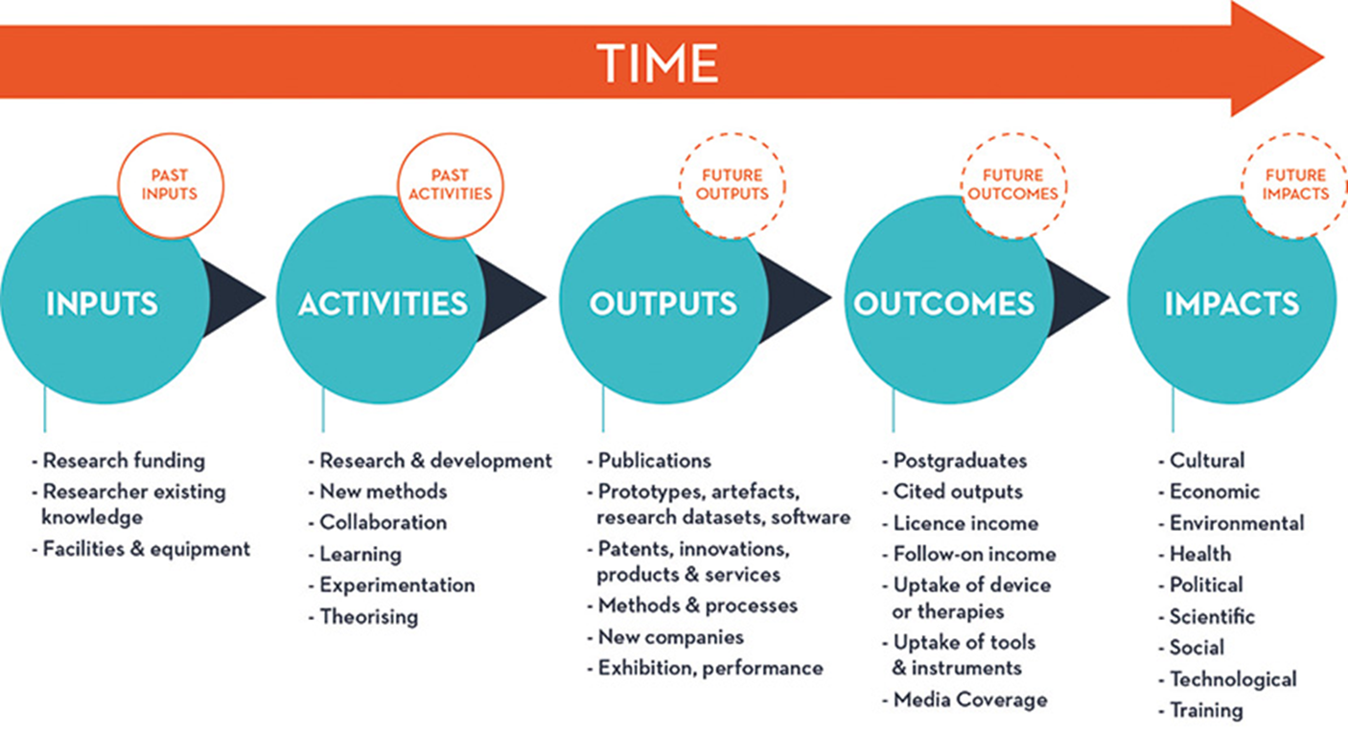

* Considering impact early in your research programme will ensure that you collect suitable types and amounts of data.
* Think about how you plan to collect evidence to document the potential impacts. It is important to note that a combination of metrics or measurements is often used in the assessment of impact. A document that might be helpful to look at is the ‘UK Panel Criteria and Working Methods’ published by the UK REF in January 2012. This document includes examples of impact and how these impact examples might be evidenced for individual disciplines. For more see: [www.ref.ac.uk/pubs/2012-01/](http://www.ref.ac.uk/pubs/2012-01/)
* What are the expected time frames for the potential impacts(s) identified?
* State specific and appropriate deliverables and milestones associated with the potential impact in the short-term, medium-term or longer-term. The impact life cycle above provides information on potential pathways to impact.



**8. Resources and Project Team**

This section should include information on the resources, project team and collaborators which are relevant to the successful completion of the project.

* What resources will you require to deliver this project in terms of people, materials, equipment, travel expenses, etc.
* Will you require any collaborators/partners to deliver your project? For example:

academic partners; industry partners; other organisations.

* If the project requires a collaborative partner or partners please indicate the role of the partner and the value to the project.



**9. Funding**

The purpose of this section is to indicate what funding will be obtained in the longer-term to support the resource requirements for your research programme.

* What sources of funding will you target as part of your research funding road map?
  + National Funding Agencies and their individual programmes
  + International Funding Agencies and their individual programmes
  + Industry or commercial funding
* Please note multiple grants/ funding sources may be required.

**10. Impact Track Record**

The purpose of this section is to demonstrate your accomplishments in relation to research impact generating activities to date. Include information on previous projects you have been involved in that have led to impact in the context of the proposed research project.

**11. Impact Plan Summary**

As part of the impact plan it would be advisable to have a diagram or table depicting the time line for implementation for the pathways to impact which includes realistic time frames. The appropriate milestones and deliverables associated with the potential impact should be indicated in the short-term, medium-term or longer-term. You could utilise the impact life cycle diagram in Section 7 to assist with this.

**Appendix One**



**Appendix Two**



|  |  |
| --- | --- |
| 1 | **Researcher(s) Name:** |
| 2 | **Name of School (and Institute where applicable):** |
| 3 | **Types of Impact:** Most research projects will have impacts in multiple areas. Please tick all that apply to your research.  ☐Academic ☐Cultural ☐Economic ☐Environmental ☐Health ☐Political ☐Scientific ☐Social ☐Technological ☐Training |
| 4 | **Title of Case Study:** Strong, easy to understand title expressed in layman’s terms that draws in the reader. |
| 5 | **Images:** Paste in image files or insert links to images online. NOTE: Please ensure that the relevant permissions have been sought, copyright is not infringed and that any necessary release forms have been signed. |
| 6 | **Summary (indicative maximum 100 words):** A concise overview, avoiding jargon or overly scientific language, that clearly shows the reader the main impacts and gives an indication of the significance and reach of the work described. |
| 7 | **Research Description (indicative maximum 250 words):** This section provides details of what research was undertaken, in what timeframe and by whom (include collaborators). It should outline the key research insights or findings that underpinned the impact achieved (to be described in next section below). |
| 8 | **Details of the Impact (indicative maximum 500 words):** This section should provide a narrative, with supporting evidence, to explain:   * How the research underpinned made a distinct and material contribution to the impact. * The nature and extent of the impact.   Be as clear as possible about exactly **WHAT** the impact was, adding some sort of precise quantification wherever possible. Numeric data and indicators need to be meaningful and contextualised to clearly support the case being made (not used as a substitute for a clear narrative). Avoid generalised or exaggerated statements about impact.  Clearly identify specifically **WHO** has benefited from the work or which groups/organisations have changed something as a result of it (bear in mind that this may include ‘intermediary’ organisations as well as your intended ‘end users’ or audiences). It can be useful to indicate the numbers of people impacted and **WHEN** these impacts occurred. Also relevant is **WHERE** the impact has occurred, particularly whether the impact is local, national and/or international in scope.  Case studies can be brought to life with greater resonance by including quotes that illustrate the impact - significant credibility is added if these quotes are from people with high profile and relevant job titles. |
| 9 | **Potential Future Impact:** If applicable, outline the future expected impact of the research. |
| 10 | **Research References:** In this section you can include references, web links, grant information, awards, reviews, peer review or other quality assurance processes. **If referencing publications, please include the link to the publication and the DOI:** <http://dx.doi.org/10.1006/jmbi.1995.0238> DOI: 10.1177/0192512114544068 |