Welcome to the Microanalytical Laboratory section of the School of Chemistry and Chemical Biology website.

About Microanalysis

The Microanalytical Laboratory provides a service to the School, other UCD schools and undertakes work from outside UCD academic institutions and industries.

The elements analysed are primarily carbon, hydrogen and nitrogen but also halogens, sulphur, phosphorous and some metals.

Instrumentation

The laboratory is equipped with an Exeter Analytical CE 440 elemental analyser, a Varian 55B Spectra AA Atomic Absorption Spectrometer and various Metrohm titrators.

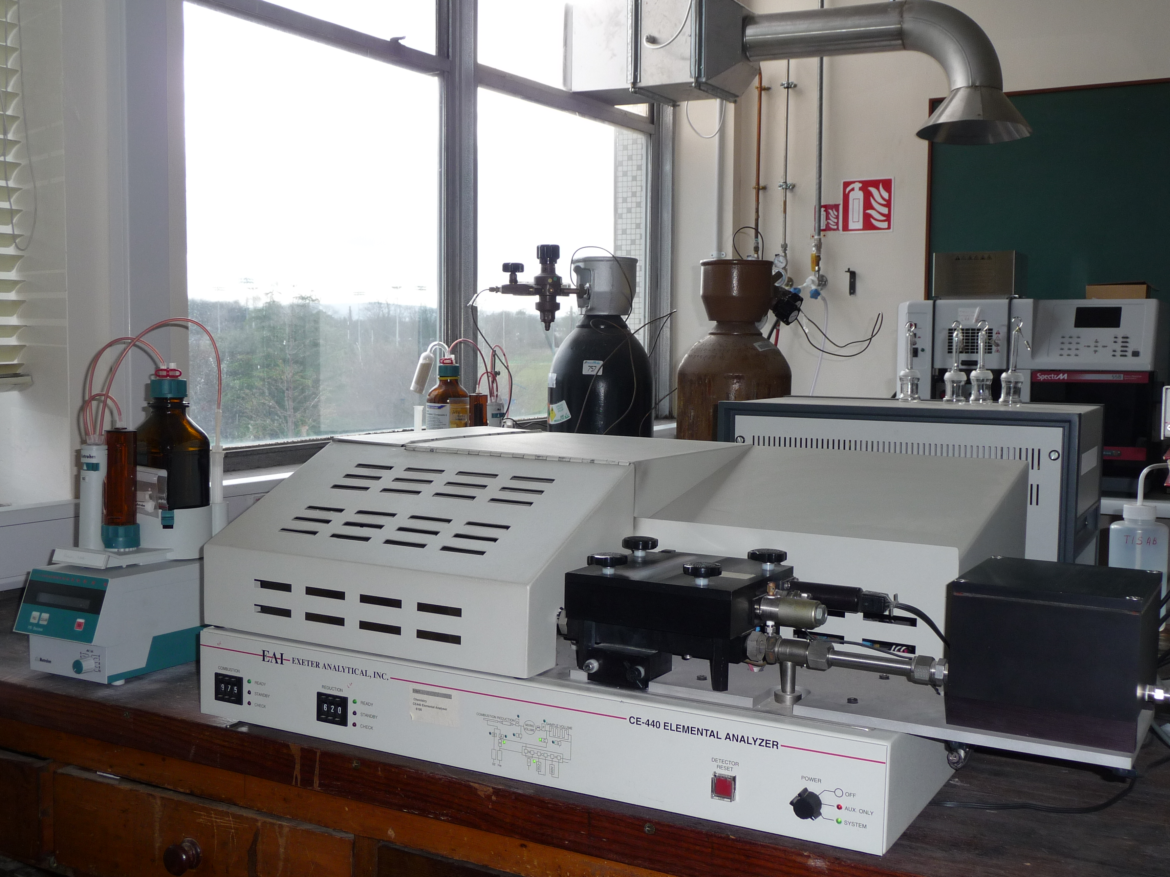

Microanalytical Staff:

Ann Connolly
School of Chemistry and Chemical Biology
Microanalytical Laboratory
Belfield, Dublin 4

Telephone: 00353 (0)1 716 2287
E-mail: microlab@ucd.ie

