University College Dublin

Report to UCD Governing Authority on Quality Review Activity

2007-08 and 2008-09

UCD Director of Quality
Roy Ferguson
September 2009

Contents

1. | Introduction | 3
2. | UCD Quality Framework | 3
3. | Academic Council Committee on Quality (ACCQ) | 4
4. | The UCD Quality Review of Schools and Support Units | 4
5. | Thematic Review | 6
6. | Institutional Review | 7
7. | Other Quality Related Activity | 9
 | Appendix 1: UCD Quality Review Schedule
 | Appendix 2: Legislative Basis for Quality Assurance in Irish Universities
 | Appendix 3: Academic Council on Quality (ACCQ)
 | Appendix 4: External Members of UCD Review Groups
 | Appendix 5: Schedule of Review Visit – Example of Academic Unit
 | Appendix 6: Schedule of Review Visit – Example of Support Unit
 | Appendix 7: All Quality Review Recommendations 2007-2009
 | Appendix 8: Recommendations – Academic Units
 | Appendix 9: Recommendations – Support Units
 | Appendix 10: Examples of Recommendations in Each Category
 | Appendix 11: Institutional Review

1. Introduction

This report is a summary of the key quality review activities undertaken in the academic years 2007-08 and 2008-09. Reference will be made in the report to various UCD Quality Review Guidance materials and Quality Review Reports – full copies of these documents may be accessed from the UCD Quality Office website: www.ucd.ie/quality.

2. UCD Quality Framework

The University is responsible for the academic standards of awards made in its name and for ensuring that the quality of learning experiences is adequate and appropriate to enable students to achieve these standards. In order to discharge those responsibilities, the University has a range of policies and procedures for assuring and enhancing the academic standards of awards and the quality of its educational provision. The mechanisms include:

- Periodic Peer Review (of Academic and Support Units) – the review schedule for 2009-2010 is attached at Appendix 1

- Robust approval processes for new modules and programmes (including major revisions and withdrawal of modules and programmes)

- Module evaluation

- External Examiner Reports

- Student: Staff Consultative Committees or equivalent

- Systematic student participation and feedback in QA/QI processes

- Regular review of QA/QI processes

UCD has an excellent record in Quality Review and Enhancement systems and processes, as demonstrated in a range of internal and external review reports such as the EUA Institutional Review Report (2005).

The University’s implementation of its QA/QI procedures, also enable it to demonstrate how it discharges its responsibilities for assuring the quality and standards of its awards, as required by the Universities Act 1997 (see Appendix 2).

The Quality Framework seeks to provide a deliberate, coherent structure for University quality development, which is intended to be achieved through a culture of critical reflection in teaching, learning and research; closing all feedback loops; joined-up thinking and actions; improving the flow of quality related information; and disseminating good practice.

Principles

- Quality teaching and learning, student experience, research and innovation, community and alumni engagement are essential to the University’s mission, goals and activities. The University’s quality assurance processes are intrinsic to the work of all staff who are undertaking or supporting those core areas of the University.

- Benchmarking and evidence-based approach. The University will evaluate its achievements against appropriate national and international benchmarks. Its quality assurance processes are evidence-based, where outcomes and feedback from stakeholders (including students, staff, employers and the community) will provide the basis for analysis and conclusions on which improvements are planned.

- Collegiality. The University’s procedures reflect the principles of rigorous peer review, as we aim to identify areas of improvement, to foster collaboration and exchange of best practice, and to encourage an ethos of critical self-evaluation.

3. Academic Council Committee on Quality

The UCD Director of Quality reports to the Deputy President and Registrar. Oversight of institutional quality review and enhancement processes is undertaken by the recently reconfigured Academic Council Committee on Quality (ACCQ) – terms of reference and composition are attached at Appendix 3.

4. The UCD Quality Review of Schools and Support Units

Typically, the quality review model of Schools and Support Units comprises four major elements:

- Preparation of a Self-assessment Report (SAR)

- A visit to a University School or support unit, by a Review Group (RG) that includes UCD staff and external experts, both national and international. A list of participating external reviewers in the reporting period is attached at Appendix 4. The site visit normally will take place over a two or three day period (a typical site visit schedule for an Academic School and a Support Unit are attached at Appendices 5 and 6, respectively)

- Preparation of a Review Group Report that is made public

- Agreement of a Quality Improvement Plan (also made public) based on the RG Report’s recommendations; the University will also review progress against the Improvement Plan, approximately 12 months after the submission of the Plan.

Full details of the review process can be found on the UCD Quality Office website: www.ucd.ie/quality.

The following quality reviews have been completed during 2007-09:

Academic

- Business Degree Programmes with Asia Pacific Management Institute, Hong Kong and Singapore (UCD School of Business)

- UCD School of Law

- UCD School of Computer Science and Informatics

- UCD School of Medicine and Medical Science

- UCD School of Languages and Literatures

- UCD School of Classics

- UCD School of Social Justice

- UCD School of Chemical and Bioprocess Engineering

Support

- UCD Student Services

- UCD Career Development Centre

- UCD Applied Language Centre

- UCD Buildings and Services

Review Follow-up

Follow-up is an integral part of the quality review process. The decisions on improvement, which are made in the follow-up to self-assessment and review, provides a framework within which each unit can continue to work towards the goal of developing and fostering a quality culture in the University. Review meetings to consider the progress of actions planned to address Review Group recommendations, takes place approximately 12 months after the circulation of the Review Group Report. The following progress review meetings are scheduled for 2009-2010:

- UCD School of Law

- UCD School of Computer Science and Informatics

- UCD School of Business Overseas Programmes (Hong Kong and Singapore)

Summary Findings

A preliminary analysis of the first ten unit reviews, undertaken during 2007-2009, suggests that Review Group Report Recommendations may be broken down into 11 broad categories:

Strategic Development | includes recommendations for strategy development; strategy implementation; strategic planning in prioritising activities
Organisation & Management | includes recommendations for enhancing administration of unit; college/university/school relations in managing unit; communications
Human Resources | includes recommendations for additional posts; addressing recruitment issues; building capacity in unit re staffing; rebalancing of staff resources
Staff Development | includes recommendations for individual staff/team development and support including training, mentoring etc.
Quality Assurance | includes recommendations for developing review/monitoring processes; feedback mechanisms; student participation; performance measurement
Linkages | includes recommendations for developing links with key areas within UCD, with external stakeholders and with potential collaborators
Student Experience | includes recommendations to improve student access to services and supports; quality of facilities; quality of resources; quality of student interface with university offices/staff - specific improvements re teaching and learning experiences are included under T&L
Teaching & Learning | includes recommendations that address course content; teaching methods; teaching resources; T&L ICT requirements; assessment issues
Workload management | includes recommendations that specifically mention using workload management to benefit staff and quality of unit
Space/physical facilities | includes recommendations re use of space; physical space requirements; additional space; reorganising of space; ICT resources; transport; student access to key resources
Finance/Budgets | includes recommendations to address budgetary processes or identified additional funding needs with regards to College/University allocations - recommendations under other headings may have budgetary implications but are included under appropriate headings

A summary of all the recommendation categories is set out in Appendix 7 and a breakdown of the recommendation categories by Academic/Support unit, are set out in Appendices 8 and 9 respectively.

Examples of recommendations falling within each category are set out in Appendix 10.

5. Thematic Review

The University recently approved a procedure to undertake thematic quality review. Thematic reviews allow close scrutiny of key areas and their operation across the University, in order to facilitate a greater focus of attention on the area of activity under review, that other quality assurance processes may not engender.

Review themes may be structured in a variety of ways, for example:

- Review themes aligned with aspects of the University’s Strategic Plan;

- Review at a cross-University thematic level, for example: the effectiveness of organisational structures or committees; the graduate experience; programme level review; how overseas students are supported and their programmes monitored;

- Review focussing on cognate ‘clusters’;

- College level (or cross-College or cross-School) review;

- Review on an ad hoc basis, in response to specific unit or institutional needs

Thematic Review may best be understood as one mechanism, in the broader spectrum of institutional quality assurance/quality improvement systems. In an academic context, this may be represented as a continuum of QA/QI activity, for example:
Module Evaluation
*Periodic Programme Review
College Review
Institutional Review

*Annual Programme Reporting
School Review
Thematic Review

* (Currently, these mechanisms are not formally in operation at UCD, however, Annual Programme Reporting will be piloted during 2009-10)

It is proposed that, for the pilot phase, proposals for thematic review will be considered by the Academic Council Committee on Quality (ACCQ).

6. Institutional Review

Introduction

In 2004, the Irish Universities Quality Board (IUQB) and the Higher Education Authority (HEA) jointly commissioned the European University Association to undertake the 1st cycle of institutional quality reviews of the seven Irish universities. The review of University College Dublin took place during the calendar year 2004. The outcomes of this review were published in 2005 as the Review of Quality Assurance in Irish Universities.

In 2009, following consultation with a range of key stakeholders (e.g. Irish Universities, IUA, HEQN, HETAC), IUQB finalised the process for the 2nd cycle of institutional quality reviews. This process, which will operate in accordance with national legislation and agreed European standards and guidelines, is termed Institutional Review of Irish Universities (IRIU).

The 2nd cycle of institutional quality reviews is expected to take place between 2009-2012. Institutions can expect to undergo IRIU normally every six years. The institutional review site visit of UCD will take place in February/March 2011.

The Institutional Review of Irish Universities (IRIU) operates in the context where institutional decision-making processes include an analysis of the effectiveness of internal quality assurance processes and the degree to which their outcomes and recommendations are used in institutional decision-making and where appropriate, for enhancing them. The IRIU aims to provide robust external assurances of the effectiveness of the internal quality assurance procedures established by each Irish university to sustain and enhance further the quality of their teaching, learning, research and support services, to meet the demands of a diverse student population, including diversity in terms of previous academic attainment. Further information on Institutional Review may be found on the IUQB website at www.iuqb.ie. (IRIU Handbook 2009: p.3).

The Review Team

The Review Team which will undertake the site visit to UCD, will normally consist of six reviewers appointed by the IUQB Board. Reviewers will be trained by the IUQB. The teams will normally consist of:

- two international reviewers (usually a President/Rector or Deputy President/Rector)

- one Irish reviewer (at a senior level, with experience of quality assurance processes – but not currently employed by an Irish university)

- a student representative

- an external stakeholder representative (national or international)

- a co-ordinating reviewer, with experience of quality assurance processes – likely to be an academic registrar or a senior official from an international quality assurance agency

The Review Site Visit

The Main Review Visit will not normally exceed five days in duration.
The Main Review Visit will be used by the team to confirm the processes employed by the University for assuring the effectiveness of its quality management process in accordance with national and European requirements. The Review Team will receive and consider evidence on the:
- ways the University responded to the institutional and sector-wide review reports of the 2004-05 EUA Review of Quality Assurance in Irish Universities
- ways the University meets its statutory requirements and the Part 1 of the European Standards and Guidelines for Quality Assurance
- ways the University is regularly evaluating its learning, teaching, research and support service activities against national, European and international best practice
- ways the university has been working to ensure that it has in place procedures (including,  for example, internal reviews and its external examiner processes) designed to evaluate how the learning outcomes are achieved for programmes that have been placed in the National Framework of Qualifications (NFQ)
- information published by the University, on the programmes and awards it is offering and  the outcomes and follow-up activities arising from internal and external quality assurance processes
- University’s approach to managing and maximising the outputs of internal and external quality assurance and enhancement activities
- ways teaching effectiveness is appraised, improved and rewarded
- role of support services in enhancing the quality of education provided by the University
- systematic engagement of external peers, external examiners, students and employers in  internal quality processes
- (optional) strategic enhancement theme identified by the University

A timeline associated with preparation for Institutional Review is attached at Appendix 11.

7. Other Quality Related Activity

Other quality related activity undertaken across the University during the reporting period includes (some categories have previously been reported):

  - During 2007-2008, UCD completed the pilot phase of its revised quality infrastructure and associated procedures. Feedback from the pilot phase was incorporated into the quality review/improvement processes and associated guidance material.

  - UCD has, during the reporting period:

- Undertaken a review of Registration 2008 and 2009 that also assessed the impact of changes recommended in the review of Registration 2007.

- UCD Centre for Teaching and Academic Development completed a Self-assessment exercise to inform the development of a new Strategic Plan.

- The University has approved a pilot Annual Programme Reporting process which will include internal programmes and overseas and collaborative programmes. This process will be piloted in academic year 2009-10.

  - The UCD Quality Office, in conjunction with the IUQB and the IUA 4th Level Network, organised the 6th Annual IUQB Conference; which was held on 14th and 15th October 2008, at UCD. Over 170 delegates attended the conference with the theme of “Opportunities and Challenges in Developing 4th Level Education”. Speakers included:

- Professor Frances Ruane, Director of the Economic and Social Research Institute

- Professor Jean Chambaz, Director of Doctoral School Pierre and Marie Curie, Paris VI University, Chair of the Steering Committee of the EUA-CDE

- Dr Beate Scholz, Scholz Consulting & Former Head of the German Research Foundation (DFG) Research Careers Unit

- Professor Dato Dr Sharifah Hapsah Syed Hasan Shahabudin, Vice-Chancellor, National University of Malaysia

- Dr Eucharia Meehan, Head of Research Programmes and Capital Programmes, Higher Education Authority

- Mr Martin Hynes, Director, Irish Research Council for Science, Engineering and Technology

  - Programme Approvals: A new programme approvals methodology was recently approved. The new approach will place much more emphasis than hitherto on how a new programme fits into the plans and strategy of the School, Programme, College and University. There will also be a greater emphasis on resourcing aspects (staff and physical resources) as well as the likely interest or need for the programme from an external perspective, (e.g. prospective students, employers).

  - Module Enhancement Projects: A project taking an overview of modules, including their grade distribution, student retention rates and, if optional/elective modules, their popularity, has been completed in the Colleges of Arts/Celtic Studies and Human Sciences during 2008-09. Almost 900 modules have been reviewed at School level across the two Colleges with the support of the Vice Principals for Teaching & Learning (VPTLs) and the Teaching Projects team. Suggestions for development and enhancement of modules to improve student learning have been discussed with the relevant College Principal. Another module enhancement project has been run in the College of Business and Law at the level of the BComm. Feedback from School Heads on both processes will go to informing similar projects in future years.

  - A round of Module Innovation Support Grants ran in May 2009, supported by the VPTLs. These awards (of up to €5,000) will be given to individual academics or interdisciplinary teams of academics to develop new approaches to teaching that fit with the University’s education strategy, specifically engaging students early in the first semester at university or as they move to graduate study. Grants will also support curriculum design focused on the teaching/research nexus.

  - Taught Graduate Enrolment Planning exercise: An enrolment planning exercise for the entire taught graduate portfolio has been undertaken for the 2009-10 session, providing projected student numbers, programme fee rates and associated revenue predictions. This has been a critical exercise in the context of current financial difficulties, and will henceforth become a regular feature of annual academic and financial planning.

  - Graduate Taught Portfolio Review Project: A review of the current constructs used within graduate taught programmes has been undertaken for the purposes of planning at the Masters level. The aim of this project is to create flexible and innovative pathways linking undergraduate and PhD activity and with a view to extending the successful, flexible, Horizons model to the graduate domain. A particular focus has been placed on the identification of growth enabling measures. The outcomes of this project directly support the activities of the College Graduate Taught Portfolio Taskforces and underpin growth and development of graduate education in line with the UCD Education Strategy.

  - Structured and Thematic PhD Shared Experience Project: The purpose of the project is to create a map of all of the elements and constructs currently used in structured and thematic PhD programmes across UCD in order to facilitate the sharing of best practice in the design and implementation of such PhD programmes in UCD. The first phase of this project has involved the collation of existing practice through meetings with thematic PhD Programme Directors; this phase is almost complete and the next phase will extend to discipline-based structured PhD programmes. The outcomes of this project, in addition to facilitating shared experience and best practice, will provide important input for the development of collaborative graduate programmes in the context of the DRHEA.

  - Graduate Taught Programmes Streamlined Admissions Pilot: UCD is introducing a range of revised admissions practices which facilitate fast, effective and valid decision-making processes at graduate (including international) without undermining quality assurance procedures currently in place. Admissions procedures governing graduate taught programmes has been identified as an area where the University can make a significant impact in the conversion rate from application to registration from the September 2009 intake onwards. To this end a pilot streamlined admissions project has been established which involves implementation of revised admissions procedures for 10 graduate taught programmes as approved by each of the Graduate Schools. The outcome of this pilot will inform the future roll-out of a streamlined admissions in the graduate taught domain.

  - Leiden Bibliometric Report: Profiling Research Excellence began as a programme in 2006. The programme activities are directed and overseen by a dedicated Steering Group. The first phase of the programme, Research Performance and Quality (RPQ), had a strong internal focus and centred on the collection, validation and assessment of research data by each of the Schools. This phase ran throughout 2007 and concluded with the submission of College-level reports to the Vice President for Research. The second phase, known as Profiling Research and Excellence (PRE), had an external focus to complement the work already undertaken in the first phase. As part of this phase, the Steering Group proposed that the university would undertake a bibliometric analysis of its research publications as an input to a university-wide review of the research excellence. The Steering Group selected Centre for Science and Technology (CWTS) University of Leiden, to undertake the bibliometric analysis.

  - In its report to the Academic Council in February 2008, the Academic Governance Working Group made a number of recommendations in relation to the academic governance structure of the University. A University Implementation Group was established, and charged with the implementation of these recommendations. The purpose, function, terms of reference and composition of UCD Academic Council Sub-Committees, including the Academic Council on Quality (ACCQ), has been reviewed and revised. The new committee will operate from 2009-10 academic year.

UCD Quality Office
September 2009

University College Dublin
Appendix 1

Quality Review Schedule

Reviews Scheduled: 2009-2010

 | 5 – 8 October 2009 | UCD School of Art History & Cultural Policy
 | 26 – 29 April 2010 | UCD School of Economics
 | 12 – 15 April 2010 | UCD School of Biomolecular & Biomedical Science
 | 27 – 30 April 2010 | UCD School of Physics
 | 8-11 June 2010 | UCD Commercial Office (Catering, Conference, Student Residence)
 | tbc | UCD School of Public Health & Population Sciences
 | tbc | NovaUCD
 | tbc | Irish Institute for Chinese Studies

Appendix 2

Legislative Basis for Quality Assurance in Irish Universities

Universities Act (1997), Section 35, Quality Assurance (Extracts)

(1) A governing authority, in consultation with the academic council, shall, as soon as practicable after the governing authority is established under this Act and at such other times as it thinks fit, require the chief officer to establish procedures for quality assurance aimed at improving the quality of education and related services provided by the university.

(3) A governing authority shall implement any findings arising out of an evaluation carried out in accordance with procedures established under this section unless, having regard to the resources available to the university or for any other reason, it would, in the opinion of the governing authority, be impractical or unreasonable to do so.

(5) A governing authority, in a report prepared in accordance with section 41, shall publish the results of a review conducted under subsection (4).

Appendix 3


Academic Council Committee on Quality (ACCQ)

Purpose and Function

The Academic Council Committee on Quality (ACCQ) was established by the Academic Council in May 1995. At that time, its brief was to devise and test acceptable procedures for Quality Assurance/Quality Improvement in UCD. The purpose and function has broadened considerably since 1995, which is now reflected in the current terms of reference.

Terms of Reference

The terms of reference of the Academic Council Committee on Quality are:
- To develop and foster a culture of evaluation and reflection and commitment to the maintenance of standards and quality in all UCD’s activities.
- To keep under review and develop University quality review policy and procedures in line with international best practice.
- To monitor issues relating to quality in teaching and learning and research; and to make recommendations to Academic Council/Senior Management/or any other body, as appropriate.
- To oversee and support units in undertaking self-assessment and peer review.
- To monitor peer review follow-up action and quality improvement plans.
- To commission and consider thematic reviews associated with standards and quality.
- To support, monitor and review implementation of policies related to standards and quality of UCD provision (including teaching and learning, research, support services, and the management of units).
- To receive review reports from relevant bodies and committees.
- To have oversight of the monitoring and review of taught collaborative partnerships.
- To monitor, and where necessary, recommend action in relation to developments in the external environment with implications for standards and quality.
- To consider and report on any matter referred to it by the Deputy President, Vice-President for Academic Affairs and Registrar; Academic Council or Senior Management Team.
- To review, and where necessary, to propose revision of these terms of reference as appropriate.

Composition

The following shall be members of the ACCQ:

Chair (appointed by the President)
Deputy President, Vice-President for Academic Affairs and Registrar (or nominee)
Director of Quality
One College Principal elected by the College Principals
One Vice-Principal Research and Innovation elected by the Vice-Principals Research and Innovation
One Vice-Principal Teaching and Learning elected by the Vice-Principals Teaching and Learning
One Head of School elected by the Heads of School
One Programme Dean elected by the Programme Deans
One Graduate School Director elected by the Graduate school Directors
One academic staff member from each College appointed by the Academic Council on the nomination of the College Principal
Two representatives of the Senior Administrative Staff nominated by the President
One person nominated by the Vice-President for Staff
Two Representatives elected by Academic Council from among its members
President, UCD Students’ Union
Education Officer, UCD Students’ Union
Technical Officer

Committee Chair

The President shall appoint a Chair for the Committee, from amongst the members of the Committee or from among the members of Academic Council.

Committee Support

The Committee and all related sub-committees shall be supported by the UCD Quality Office.

Conduct of Business

- Τhe Committee should meet at least four times a year.
- The meetings shall be convened by the Director of Quality in consultation with the Chair with a minimum of seven days notice of a meeting.
- The members of the Committee may not nominate others to attend meetings on their behalf.
- A meeting shall be considered quorate when a third of the members are present.

Reporting responsibility

- The ACCQ shall report at least annually to the Academic Council regarding all quality matters in UCD.
- The ACCQ will submit reports of its meetings to the Academic Council Executive Committee where necessary.

University College Dublin
Appendix 4

External Members of Review Groups

Date of Review | Unit Reviewed | External Review Group Members
5 - 12 March 2008 | UCD School of Business Degree Programmes with APMI, Hong Kong and Singapore | - Professor Chung Lai Hong, Nanyang Business School, Singapore
7 - 10 April 2008 | UCD School of Law | - Professor Irene Lynch Fannon, UCC  - Professor Roger Burridge MBE, University of Warwick
26 - 29 May 2008 | UCD School of Computer Science and Informatics | - Professor Muffy Calder, University of Glasgow  - Professor Kevin Ryan, Lero/University of Limerick
14 -17 October 2008 | UCD School of Medicine and Medical Science | - Professor Paul O’Neill, Manchester Medical School  - Ms Lynn Cuthbertson, Glasgow Caledonian University  - Dr Philip Anthony Carney, NUI Galway
1 - 3 December 2008 | UCD Career Development Centre | - Mr John Hannon, NUI Galway  - Mr Graham Nicholson, University of Dundee
2 – 5 March 2009 | UCD Student Services | - Ms Kathleen Yorkis, Bentley University, USA  - Mr Arie Rosenzweig, Tel Aviv University, Israel  - Mr Con O’Brien, UCC

30 March - 2 April 2009 | UCD School of Chemical and Bioprocess Engineering | - Professor Greg Foley, DCU  - Professor Gary Lye, University College London
20 - 23 April 2009 | UCD School of Languages and Literatures | - Professor Pól Ó Dochartaigh, University of Ulster  - Professor John M Kinsella, NUI Maynooth
21 - 23 April 2009 | UCD Applied Language Centre | - Professor Ken Hyland, Institute of Education, University of London  - Professor John Klapper, University of Birmingham  - Professor David Singleton, TCD
27 - 30 April 2009 | UCD Buildings and Services | - Mr Mark Poland, UCC  - Mr Derry Caleb, University of Surrey
27 - 30 April 2009 | UCD School of Classics | - Dr Edward Herring, NUI Galway  - Professor Graham Shipley, University of Leicester
5-8 May 2009 | UCD School of Social Justice | - Professor Peadar Kirby, UL  - Professor Madeline Arnot, Cambridge University
5-8 October 2009 | UCD School of Art History and Cultural Policy | - Professor Sheila Bonde, Brown University, USA  - Professor Joop de Jong, Maastricht University, Holland


Appendix 5
Academic Unit Example

Schedule for Review Visit to

UCD School of Chemical and Bioprocess Engineering

30 March – 2 April 2009

Monday, 30 March 2009
17.15-18.45 | Private meeting of RG only at hotel to agree work schedule and assignment of tasks for the site visit.
19.30 | Dinner for the RG, hosted by the UCD Registrar and Deputy President
Tuesday, 31 March 2009
Venue: Room 204, UCD Engineering and Materials Science Centre
09.00-09.30 | Private meeting of Review Group (RG)
09.30 – 10.15 | RG meet with College Principal
10.15-10.30 | Break
10.30 –11.15 | RG meet with Head of School and other members of senior staff nominated by the Head of School
11.15 – 11.30 | Tea/coffee break
11.30 – 12.15 | RG meet with SAR Coordinating Committee
12.15-12.45 | Break – RG review key observations and prepare for lunch time meeting
12.45-13.45 | Working lunch (buffet) – meeting with employers
13.45-14.15 | RG review key observations
14.15-15.30 | RG meet with representative group of academic staff – primary focus on Teaching and Learning, and Curriculum issues.
15.30-15.45 | RG tea/coffee break
15.45-16.30 | RG meet with support staff representatives (e.g. administrative / technical etc)
16.30-16.45 | RG review key observations
16.45-17.30 | Tour of facilities
17.30 | RG depart

Wednesday, 1 April 2009
Venue: Room 204, UCD Engineering and Materials Science Centre
09.15-10.00 | RG meet for private meeting
10.00-11.00 | RG meet with a representative group of postgraduate students (taught and research) and recent graduates (PG and UG)
11.00-11.15 | RG tea/coffee break
11.15-12.15 | RG meet with the School Research Committee or equivalent (and other staff members of nominated by the HoS)
12.15-12.45 | Break - RG review key observations and prepare for lunch time meeting
12.45-13.45 | Working lunch (buffet) - RG meet with representative group of undergraduate students
13.45-14.15 | RG private meeting - review key observations
14.15-15.00 | Optional meeting should RG wish to meet other categories of School or College staff and/or specified University staff
15.00-15.20 | Break
15.20-17.15 | RG private meeting – review key preliminary observations/findings – begin drafting RG Report
17.15 | RG depart
Thursday, 2 April 2009
Venue: Room 204, UCD Engineering and Materials Science Centre
09.00-09.30 | Private meeting of RG
09.30-10.30 | (Optional) RG meet with Head of School or specified University staff to clarify any outstanding issues or continue preparing draft RG Report
10.30-10.45 | Break
10.45-12.30 | RG continue preparing draft RG Report
12.30-13.15 | Lunch (Review Group + 1)
13.15-15.30 | RG finalise first draft of RG Report and feedback commendations/recommendations
15.30-15.45 | Break
15.45-16.00 | RG meet with Head of School to feedback initial outline commendations and recommendations

16.15 | Exit presentation to all available staff of the unit –made by an extern member of the Review Group summarising the principal commendations/recommendations of the Review Group
16.30 | Review Group depart

Appendix 6
Support Unit Example

Site Visit Schedule

UCD Student Services

Monday, 2 March – Thursday, 5 March 2009

Monday, 2 March 2009
Pre-Visit Briefing Prior to Site Visit
18.30-19.30 | Review Group and Director of Quality only meet at hotel to review preliminary issues and to confirm work schedule and assignment of tasks for the following two days.
20.00 | Dinner hosted by the UCD Registrar and Deputy President
Tuesday, 3 March 2009
St Stephen’s Chaplaincy
09.00-09.30 | Review Group – private planning meeting
09.45-10.30 | Meeting with UCD Vice-President for Students (including a 10 minute presentation)
10.30-10.45 | Break
10.45-11.30 | Meeting with Student Services Co-ordinating Committee
11.30-11.45 | Break
12.00-13.00 | Meeting with representative group of students from Sports and Societies
13.15-14.15 | Working Lunch with representative groups of students who have used Health, Counselling, Chaplaincy or Student Adviser services – Brief meeting with Director of Quality (if required)
14.15-14.45 | Break
14.45-15.30 | RG meets with representative group from Student Health Services
15.45-16.30 | RG meets with representative group from Student Counselling
16.45-17.30 | Meeting of Review Group representative group of academic staff
19.30 | Private Dinner for Review Group (at hotel)

Wednesday, 4 March 2009
St Stephen’s Chaplaincy
08.45-09.30 | Review Group Meet
09.30-10.15 | Review Group meets with representative members from UCD Chaplaincy
10.15-10.30 | Break
10.30-11.15 | Review Group meets with representative members from Student Advisers
11.15-11.30 | Break
11.30-12.15 | Review Group meets with representative members from UCD Sport
12.15-12.30 | Break
12.30-13.30 | Working lunch – Review Group meet with representative group of recent Graduates (including brief discussion with Director of Quality, if required)
13.30-13.45 | Break
13.45-14.30 | Review Group meets with representative members from UCD Societies
14.30-14.45 | Break
14.45-15.30 | Review Group meets with representative members from SU Bars and Shops
15.30-16.00 | Break
16.00-17.15 | Tour of key Student Services Facilities guided by UCD VP for Students and UCD Director of Student Counselling
17.15-17.45 | Private meeting – Review Group
19.30 | Private dinner for members of the Review Group (at hotel)
Thursday, 5 March 2009
St Stephen’s Chaplaincy
08.45-09.30 | Review Group Meet
09.30-09.40 | Meeting with individual staff – 10 minute sessions (by request to the UCD Quality Office)
09.45-10.10 | Review Group meets with representatives from UCD Buildings and Services
10.15-10.40 | Review Group meets with representatives from UCD Registry
10.45-11.00 | Break
11.00-11.30 | Sweep up meeting with VP for Students
11.30-13.00 | Review Group - preparation of first draft of Review Group Report
13.00-13.45 | Working lunch for Review Group
14.00-16.15 | Review Group - preparation of draft Report and exit presentation continues – and confirm arrangements for Report completion and deadlines
16.30-17.00 | Exit presentation to all available staff of the Unit – made by an extern member of the Review Group (or other member of the Group, as agreed) summarising the principal commendations/recommendations of the Review Group
17.00 | Review Group departs

All Quality Review Recommendations 2007-2009

100%

401
Total recommendations
2%
10
Finance/Budgets
7%
27
Space/facilities
2%
10
Workload management
12%
50
Teaching & Learning
7%
29
Student Experience
11%
43
Developing Link
19%
72
Quality Assurance
6%
24
Staff Development
7%
28
Human Resource
12%
49
Organisation & Management

15%

59
Strategic Developments
% Recommendations per Category
Number of Recommendations

All Reviews 2007/2008 & 2008/2009 (N=10)*
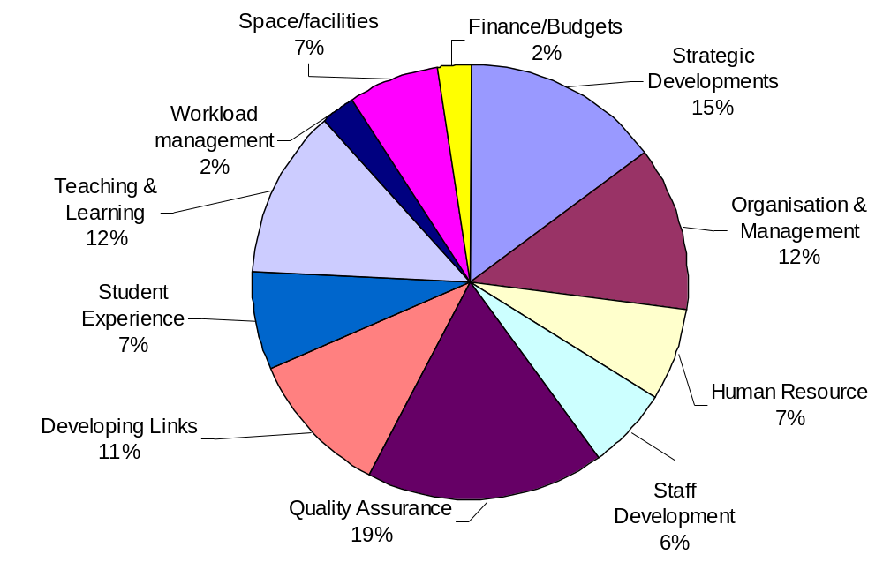

Appendix 7

Recommendations - Academic Units

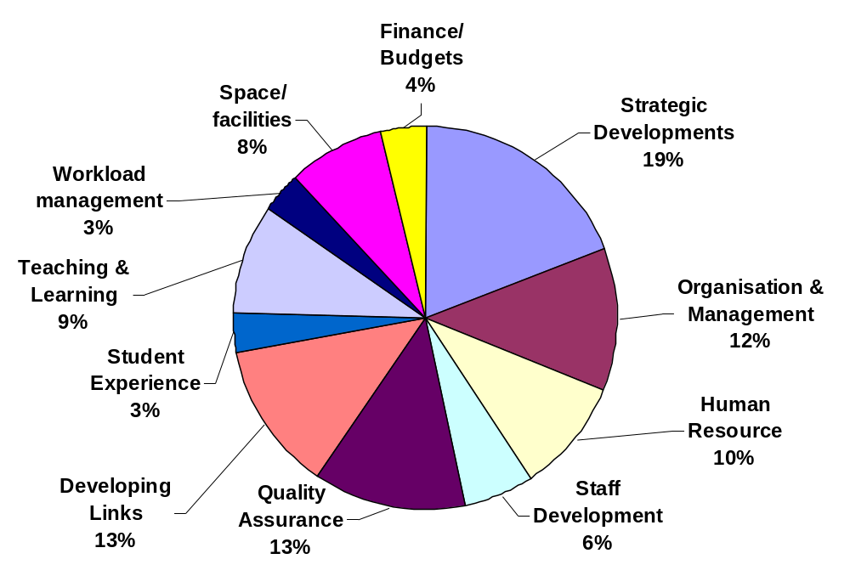
100%
184
All recommendations
4%
7
Finance/Budgets
8%
15
Space/facilities
3%
6
Workload management
9%
17
Teaching & Learning
3%
6
Student Experience
13%
23
Developing Links
13%
24
Quality Assurance
6%
11
Staff Development
10%
18
Human Resource
12%
22
Organisation & Management
19%
35
Strategic Developments
% Recommendations per Category
Number of
Recommendations
Academic Unit
Reviews 07-09
(N=8)

Appendix 8

Recommendations - Support Units

100%
98
Total recommendations
4 %
4
Finance/Budgets
12 %
12
Space/facilities
0 %
0
Workload management
2 %
2
Teaching & Learning
9 %
9
Student Experience
15 %
15
Developing Links
12 %
11
Quality Assurance
2%
2
Staff Development
8%
8
Human Resource
20%
20
Organisation & Management
16%
15
Strategic Developments
% Recommendations per Category
Number of
Recommendations
Academic Unit
Reviews 07-09 (N=2)
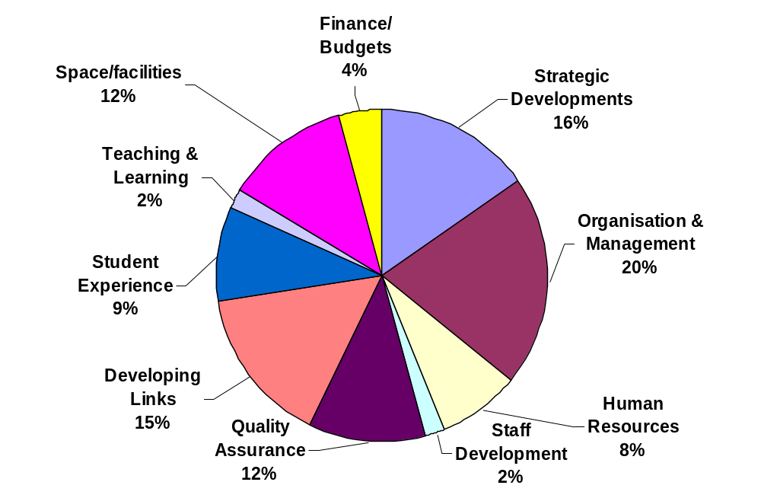

Appendix 9

Examples of Recommendations in Each Category

‘The non-staff budget should be reviewed and should meet the needs of a leading University service.’
Finance/Budgeting
‘Further develop the workload model to ensure full participation of all academic staff in the work of the School.’
Workload
‘Considerable thought should be given to the availability of wifi throughout the building.’
Space/Facilities
‘….better mechanisms to gather student feedback on the quality of procedures are needed.’
Quality Assurance
‘The School should further develop its relationship with employers of its graduates.’
Developing links/collaborations
‘The School should continue to develop and review the pastoral mentoring scheme and consider making a case study available to foster broader adoption throughout UCD.’
Student Experience
‘The School’s proposals for introducing more skills, problem based learning opportunities and clinical experiences should be implemented.’
Teaching & Learning
‘The Research and Innovation Committee should…ensure the implementation of good practice in mentoring younger staff in the development of their careers.’
Staff Development
‘the post should be regraded to reflect the range and extent of responsibilities…’
Human Resources
‘There is a case for a review of the committee structure, function and communications within the School.’
Organisation & Management
‘..the School should identify which of its many international links are strategically significant, and focus on developing these further.’
Strategic Development

Appendix 10

Appendix 11

Institutional Review

Preparation for Institutional Review – Review Timeline

October-December 2009 | Establish University Steering Group for Institutional Review
 | Begin IRIU Briefings for key stakeholder groups e.g. GA, SMT, class reps, SU, external reps
January-September 2010 | Begin preparation of Self-Assessment Report and consultation on drafts  IRIU Briefings continue
November 2010 | (i) | Institutional Self-Assessment Report and Supporting Information finalised
 | (ii) | Identify provisional staff/groupings to meet with Institutional Review Team
December 2010/January 2011 (6 weeks before site visit) | Institutional Self-Assessment Report (IRIU) submitted
January/February 2011  (4 weeks before site visit) | Planning Visit to UCD
February/March 2011 | Site Visit
12 weeks after site visit | Summary and review report received
Approx. 12 months after review | Institutional follow-up report (including action plan) to be submitted

