Log onto SISWEb
Go to Info Hub.

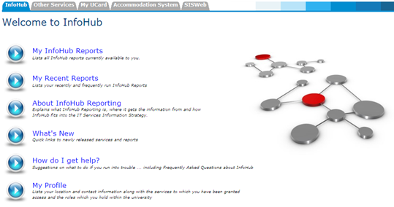

Click My Profile
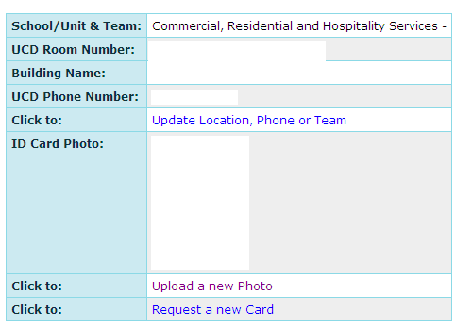
Click

Click Browse and locate your photo (image) file on your PC and click ok. Then Click upload.

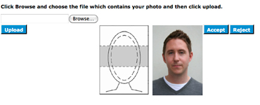
A preview of your photo should now show on the screen beside a template of where your head and eyes should be in the image. (Note, images that do not conform to this template will be rejected and your card will not be printed until an appropriate photo is uploaded)
You can at this stage Accept or Reject the photo you have uploaded.
  - If you reject your photo please revert back to step 2
  - If you accepted your photo it will then be submitted to UCD for approval and printing
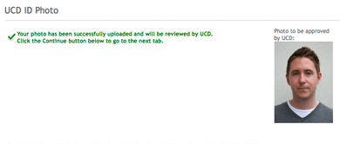
If your photo upload has been successful you will receive a confirmation notice
Once you have accepted your photo click “continue”.
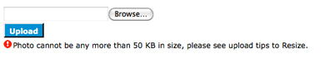
If you encounter problems uploading your photo due to file size, please click on the Image file resizing link on the previous page.

