‘Light Review’:
Some Questions for the Programme Team to discuss.

In a Programme Team Meeting/Workshop, reflect as a team on your programme assessment and feedback approaches using the following, or similar, questions. Discuss some key actions (quick fixes, long term actions, and/or sharing of good practice). This a key step in the UCD Framework for Programme Assessment and Feedback, i.e. Review, Plan, Articulate, Implement and the questions are broadly based on the Framework’s principles of articulated, aligned, space, integrated, varied and reliable (see image on page 3).

Programme/Major/Subject:……………………………………………………………………………
Contact person: …………………………………………………………………………….
To what extent do we agree with the following statements: | N/A | Don’t know | To some extent | Satisfactory | Excellent
Are your programme outcomes articulated and shared with key stakeholders?
Do students understand the rationale for their assessment approaches are, throughout the programme?
Do students understand the rationale for their feedback approaches are, throughout the programme?
Are your module assessment and feedback approaches aligned to your programme outcomes?
Is there time and space in the programme for more complex assessment?
Is there evidence of staff assessment overload, i.e., correction load?
Is there evidence of student assessment overload, i.e., student feedback on load, poor performance, non-attendance?
Do you have space in the programme to support students to develop their ability to judge their own work?
Are assessments, in general, developed throughout the programme, for example do they get increasing challenging, complex (vertically)
Is there a coherent approach to assessment approaches in each stage of the programme? (Horizontal integration)
Is there an opportunity towards the end of the programme for students to synthesise their learning in a holistic (capstone) assessment?
Is there a variety of assessment methods used across the programme, in particular, authentic, empowering and engaging approaches?
Is there a variety of feedback methods are used across the programme, in particular building towards student’ self-regulatory skills towards the end?
Are there any rubrics that can be used throughout the programme to assist in development of specific skills, i.e., team working, critical thinking, etc.?
Are there procedures are in place to ensure the reliability of the programme’s assessment and feedback approaches, including consistency, academic integrity, and comparability in grading.
Other questions

Based on this discussion, some initial thoughts for actions :

- Quick fixes:

- Longer term actions:

- Have you any related case studies of good practice to share with wider UCD community?

- If you don’t know, where would you find out (where is the evidence)?

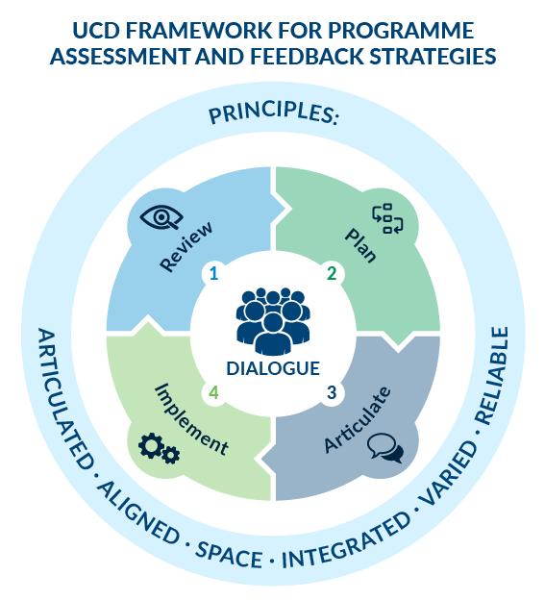

For other questions, see also: The Programme Design Dialogue Tool. See also the UCD Programme Assessment and Feedback Principles.

