Project Objectives

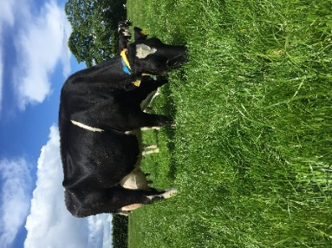
- To develop a sustainable high-output grass-based spring milk production system
- To incorporate the most recent advances in grassland management for dairy farms into a high- output system
- Use a type of dairy cow that has good genetic indices for both milk production and fertility
- Employ the best practices from nutrition research and dairy cow husbandry
- Incorporate nutritional studies into a high-output system
- To incorporate management technologies and system attributes that enhance the sustainability of dairy production

Farm Details Week 10/04/23
Stocking rate on MP (LU/ha) | 3.7
Farm Cover (DM/ha) | 807
Growth Rate (DM/ha/day) | 31
Grass demand (DM/ha/day) | 44
Average Concentrate fed (kg/day) | 8
Average DIM | 50
Area Grazed (%) | 100

Cow Details Week 10/04/23
Yield (kg/cow/day) | 31.60
Fat (%) | 4.07
Protein (%) | 3.25
MS (kg/day) | 2.29
SCC | 37250
Cows calved | 57/57

Grassland Management:
The first rotation finished on April 10th. Two paddocks (2.04 ha, 12% of MP) have been sprayed off this week for reseeding. A tetraploid (Abercyle, Abergain, Gracehill) and white clover mix will be used. Tetraploid only mixes have worked well for us on the platform previously and their growth habit pairs well with white clover. Cows are being allocated 12kg DM/cow/day of grass and are getting 8 kg of concentrate per day.

Comments:
Calving started on the 26th of January and all cows (57) have now calved. Pre-breeding checks will be taking place next week to ensure all cows for breeding are cycling and fit for breeding.

For more details on the High Output Systems Research Herd visit
https://www.ucd.ie/agfood/about/lyonsresearchfarm/lyonsdairyherd/

