Welcome to the guide

It doesn’t matter where you work and what your job role is, if you work with other people together as a team, you will always encounter the same challenges:
- Unclear goals and miscommunication that cause busy work and extra effort.
- Frustration builds up because internal challenges to getting the work done are not addressed.
- Sudden changes in priorities lead to a loss of focus and momentum.
- Muddled compromise takes the place of clear decision making, leaving everybody to come up with their own interpretation.
- Work to be done and responsibilities evolve over time – just what is in or out of scope becomes unclear.
- Projects and initiatives can take place, driven by need but not always with a clear sense of the issues being addressed, of the outcome being sought.

In short, a lack of structure leads to a waste of time and effort, scope that has a life of its own, projects that drag on for too long and frustrated operations that take more effort than they need to can lead to burnt out teams. We have all experienced some elements of this and it can be even worse when working in the Distributed Office.

What can we do to help make sure a team or unit is clear on what it is doing? How can we make a good start to change... given change is a day-to-day constant? What are the ideas and conversations we can use to help us deal with the complexity we live in? Ask the question...
Where are we now?

... and use the ‘now’ arising to get a grip on what is going on around you or in planning or in issue resolution or in team building or in communications planning... Knowing where you are now is the start of a wonderful journey.

‘DO Where are we now?’ comes from a bunch of work done through Work Smarter Together, the USM-supported Remote Working Group, and UCD Agile.

This guide, and the associated Mural Template for running a workshop on this topic, are meant to help you think about the ‘Where are we now?’ challenge (the concepts) and to give you some things you can do to address it (actions).

How long will it take to do a ‘DO Where are we now?’ workshop with my colleagues?
If we were running a session in UCD Agile we would normally allow two to two and a half hours for a first session as a chunk of time at the start is about the ideas behind this. These ideas – the concepts and language – are key to why and how you use this approach. The real driver for spending this time is what you are trying to achieve. Spend it well.

Contents
Before you get stuck in... 4
Using the guide 4
Working in the ‘distributed office’: DO 4
DO Where are we now? – the basic concepts 5
The workshop 6
Session introduction 7
Session approach 8
1 – Why be clear on where we are now 9
2 – Change: Why be clear on where we are now? 11
3 – What we do is not set in concrete... 12
4 – What we do has a number of elements 15
5 – What drives change for us? 17
6 – Mapping a business 18
7 – Working through now 19
Appendix – Lean HE survey on remit and clarity 21

Before you get stuck in...

Using the guide
This guide gives you the structure to follow – be sure to keep the structure in mind as it will help a first session with the sequence of ideas and activities.

If you really get stuck in, you’ll do more than one session but will not need most of the early sections of this guide after the first. This ‘if’ is down to what you are looking to achieve – you decide.

The timings shown in the sections below are just for guidance.

All the sections give you a ‘section guide’ on what to do in the section and why. Any additional comments provided can be of interest when you are getting familiar with this.

We use this symbol to tag ideas or theory.
We use this symbol where workshop work is required.

Working in the ‘distributed office’: DO

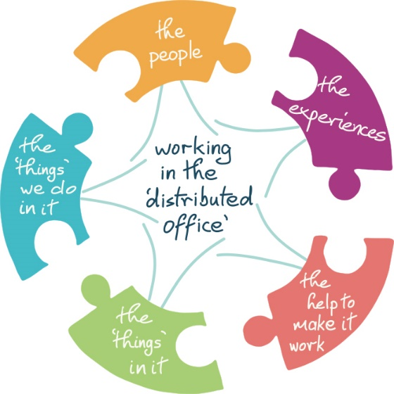 |  | The people  who we work with and the people we connect with
The ‘things’ we do
the tasks and actions that are our work
The ‘things’ in it
the practical things we require to make that work possible
The experiences
what happens through all the connecting, meeting and working with folks
The help to make it work
what we draw on from outside the office to make the work of the office possible.
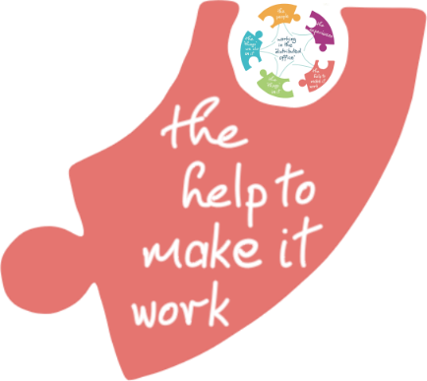 | The DO series of actions and workshops  DO Where are we now? is part of our series of ideas, actions and workshops aimed at helping to make working in the ‘distributed office’ easier.  DO Where are we now? touches on the ‘things’ we do in the office, the people we work with and the experiences we create through this.

DO Where are we now? – the basic concepts

What does DO Where are we now? give you
The ideas in this guide
The workshop structure outlined in this guide

Basic concepts
- The key to success of asking “Where are we now?” is knowing why you asked the question and what you want to do with the answer
- From Dan Pink, high performing teams that are good places to work
give their members mastery, autonomy and purpose
- Clarity of purpose = clarity of remit (in part)
- Our remit is all the things we are responsible for doing
- Everything we do is change – that’s what ‘work’ means – so change is a constant
- The journey to ‘better’ starts ‘now’ – the change journey
- If you do not know your ‘now’ you are already lost... and getting where you want to go – or others want you to be – is a matter of more hope than it should be
- There are different kinds of driver shaping remit, open to different degrees of influence
- Bringing the team together in this workshop helps them articulate and own the picture of their business

The workshop
So you are thinking of running a workshop on “Where are we now?” with your team or unit. Or perhaps you just want a structure to think through in looking at the business of your team or unit?

Here is the workshop sequence. By the time you have brought your colleagues through this you are down to naming concrete actions to deal with issues you have named together.  - Session outline  - Session approach  - Why be clear on where we are now  - What drives change for us?  - The change journey  - Mapping your ‘now’  - Mapping a ‘business’  - Using ‘now’ – dealing with change | If you have been to a DO Where are we now? training session you will have seen this approach in training mode. In training, we do not spend as much time on change drivers as in a session with a team or unit.  You would flesh out these details for your term, unit, or business in looking at your ‘now’. These are key steps when running this locally – they help a team thinks about and discuss their environment

This document follows the same sequence and is put together as a guide to this kind of workshopping. You don’t have to use it for that but it is a useful framework.

Session introduction
This is where you welcome folks to the workshop, set the context, and make sure everyone knows what you are going to get to – concrete actions addressing current challenges.

Section guide
Timing:
5 Minute introduction
Section covers
Why you are looking at mapping your ‘now’. This is a key point for you, the facilitator. What is the context for this session? For what issue / opportunity / challenge / etc. are you using this to baseline the ‘now’?
Are you looking at mapping your team, your unit, one of your businesses, an area of activity? Choose your scale.
What you hope to get from today? How will you use it? This is an exploration so you do not have to be definitive – the session should provide insights you were not expecting! That’s OK.
General approach and ground rules for participation.
Issue:
A key to making change, of most kinds, is knowing what you are changing.
This change may be developing a strategy, fixing an issue, updating your communications approach, publishing a policy, mailing 1000 students...
If you do not know where you are leaving from on your change journey, you are already lost.
“How do we map where we are now”?
Goal:
This session will help you map out where you (and your team) are now.
This gives you a key element of looking at how you will go where you want to go.
Going where you want to go is why you are looking at this at all.

Session approach

You need to let the participants know what they will be doing in the session. This is part of making your role as facilitator work better, helping shape a flow to the meeting and to set expectations on how folks can participate – what you are hoping for and how you are looking to achieve it.

Section guide
Timing:
5 Minute introduction

Section covers
How you are going to run today’s session, so everyone knows what lies ahead in the session.
If you have any breaks planned, or other housekeeping, now is the time to tell them.
This is where you cover behaviours too – how you are enabling participation and what folks need to be thinking about.
When they are busy with Post-its, they work in silence.
Everyone has a voice, everyone can contribute, they don’t have to compete to be heard.
The participants are clear that this session is about going from the ideas behind mapping the ‘now’ of a unit / team / business through to the map itself.

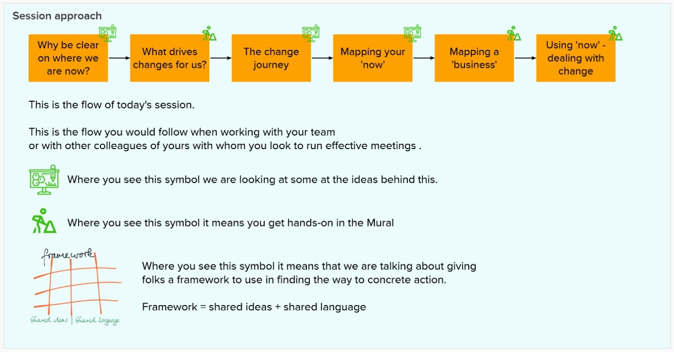

Key point – underlying all of this is the idea of giving your colleagues a framework they can use to slice and dice big challenges into more manageable chunks.
Framework = shared ideas + shared language

1 – Why be clear on where we are now
At the heart of 'Where are we now?' is helping teams be both high performing and a good place to work - one of those ideal win/wins.
Dan Pink brings the Mastery, Autonomy, Purpose way of looking at this.
Purpose is part of clarity for an individual or a team. "What am I doing? Why am I doing it? What will success look like?"
Focusing on where we are now is looking to see if there is clarity, if there is a clear sense of purpose and direction in the 'as is'.

Section guide
Timing:
7 minutes

Section covers:
Introducing Dan Pink’s Mastery / Autonomy / Purpose framework
Introducing remit as a way of talking of what you are responsible for
Tying purpose to remit
Looking at clarity of remit in order to clarify purpose
Activity
This is a theory segment of the workshop – the facilitator does the talking, mostly.
Key concepts: Mastery / Autonomy / Purpose
The facilitator needs to have become familiar with these concepts and have their own take on them to get this across. Watch the link!
Do not do the workshop until you have your own take on mastery / autonomy / purpose.
This concept is at the heart of the workshop and at the heart of creating an environment in which staff can thrive and perform at a high level.
Key concept: Remit
This is what we are responsible for.
Some of it you are accountable for on your own, some you share accountability with a line manage / team lead / director / etc.
Key concept:
Key concept: Clarity on remit is linked to clarity of purpose
In effect, if we are not clear on remit, we are not clear on actual purpose and so, by definition (!) are not as high performing as we could be, are not creating as good a work environment as we could.
Key concept: ‘Where are we now?” – maps – clarity of remit

The goal here is to give the participants a framework they can use to think and talk about the environment in which they are working.

Dan Pink’s Mastery / Autonomy / Purpose
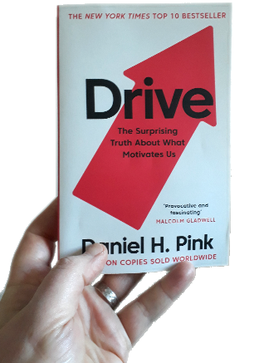 | 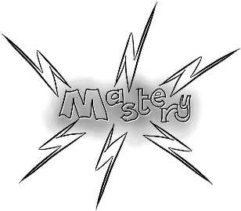

Check the book out at: https://www.danpink.com/books/drive/

Check the 10-minute animation at: https://www.youtube.com/watch?v=u6XAPnuFjJc

The animation is great. Take notes. Think about it. Form your own take on it.

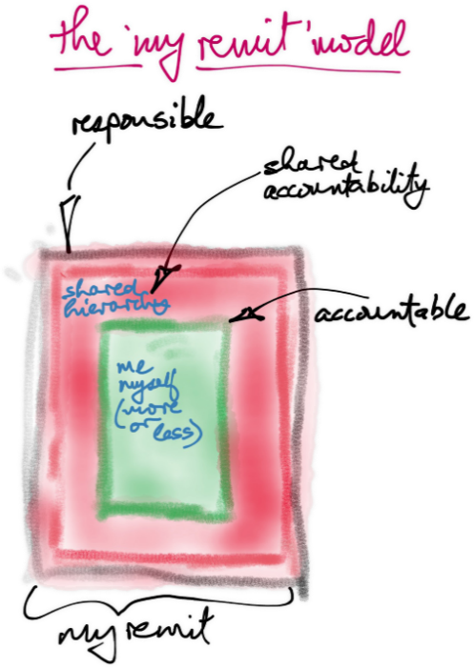 | You can look at remit in relation to a team or a unit or a person or a business or an area of activity...  What am I / are we responsible for?  Where does accountability lie?  Accountability is an important perspective. At the extremes, an unaccountable team or person or activity begs lots of questions., and to be an individual or team with no green zone – no independence, no autonomy – would be awful.  Folks can end up taking on responsibilities which are, or they see to be, theirs alone. How does this fit with a team or a unit’s remit? Teams can end up with responsibilities but without the accountability structure that can support and protect the team.
You have a team of folks.  They have a remit for which they are responsible.  For some of the remit they act on their own accountability, for some they share it with e.g. a line manager.  If you want the team to be high performing and a good place to work, you want the folks to have the mastery they need to do the job and the scope to develop that mastery, the autonomy to work to good effect, and |  | 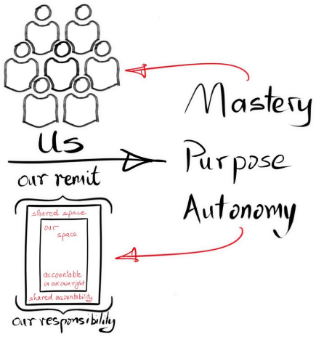
the clarity of purpose that helps them direct their energy, know the value they add, and make the decisions needed.

2 – Change: Why be clear on where we are now?

Section guide
Timing:
8 minutes they are only starting so need a bit of time
4 to write
4 to go through and cluster

Section covers:
Change is a constant – everything we do involves going from some ‘now’ to some ‘better’, with the gap in between being activity
If you want to get to ‘better’ you need to know where you are leaving from

Activity
In silence - folks add Post-its to the Mural, one for each issue they think of.
They should have particular meetings in their mind’s eye.
Do not name people – that would not be fair – but think about specifics.
Cluster similar points – this usually generates conversation.
It will be interesting to note if some categories of issue get more attention than others.

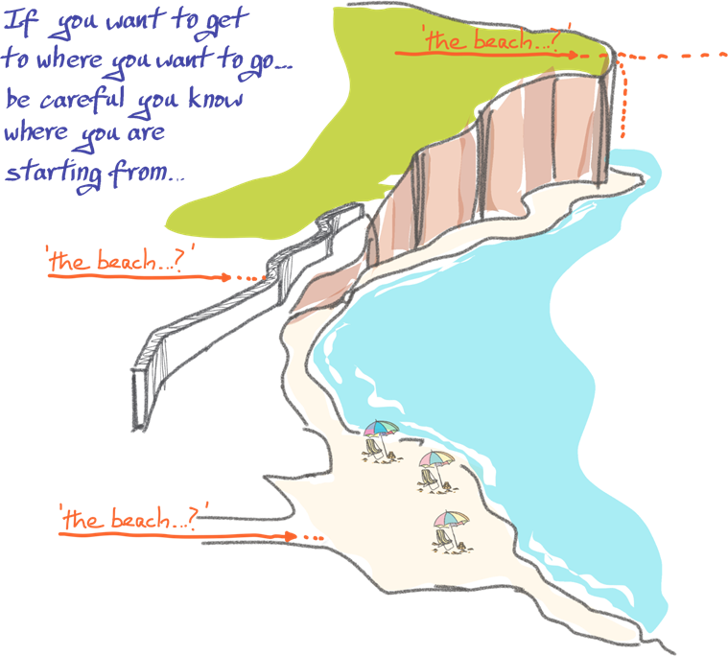
Everything we do involves change, going from some current state to some future state, and we make the change. The bit in the middle – the activity – is ‘work’. If you are doing ‘work’ you are making change.

There are lots of different kinds of change – from emailing a bunch of students to register to a lab to implementing a new research system to a new process to a new team structure.

“Why do we need to talk about this? Let’s just get going!”

“Let’s just get going”! If you are running this as a workshop online (e.g. Zoom and Mural) then ask your attendees to imagine being told the following: get up off your chair, leave your building, go out onto the road, turn left, walk for 400m, take the first left then first right, walk 300m... And you are at the bus depot in Donnybrook. Right?

“Let’s just get going!” You need to know where you are leaving from, especially if you are following someone else’s great ideas.

Three big risks with any kind of change
- you don't know where you want to go  ... or how to know if you have reached there | Purpose  Outcomes
- you don't know how to make the change | Process
- you don't know where you are leaving from | ‘As is’

It is common for change to begin with starting to make the change itself, without clarity on what outcomes the change is intended to produce, and without real clarity on the context in which the change is being made.

Asking “Where are we now?” is not about ‘the paralysis of analysis’. That kind of criticism is akin to arguing you don’t need a map because the last time you went out you headed north for 30 minutes and you got to where we were going. “We don’t have time for a map... let’s just go! And never mind where ‘there’ is, it’ll only take 30 minutes.”

If a change is new or big, you need to spend more time on “Where are we now?” in order to be sure you get the outcomes you want.

If it is the first time you have asked the question, you will spend more time on “Where are we now?”

If you have mapped out ‘now’ before, “Where are we now?” is a sanity check which helps you ground a team in ‘now’ (the issues / context / opportunities / challenges / purpose) before getting stuck into the work or measuring how far you have progressed.

And don’t forget “Where do we want to be when we get there?”... but that’s a different session.

3 – What we do is not set in concrete...
If we think we know where we are, but do not check, we are probably lost already.

Remits evolve, sometimes through conscious decisions, sometimes unconsciously, sometimes with a cumulative effect that is missed in the detail.

What are the general kinds of remit shapers?

Section guide
Timing:
7 minutes

Section covers:
Remits evolve over time
There are four basic shapers
- From top down in the University (e.g. Strategy)
- From standing operational necessity
- From emerging issues / needs
- From job descriptions and local organisation
Clarity of remit / purpose can be lost over time
Activity
The facilitator brings the attendees through the ideas

The starting point is some notionally clear remit.  If your team is newly formed or has been through some kind of review or re-organisation, there may be a good match between a formal remit and what you actually do.  Job descriptions can be (!) clear descriptions of remit for a given post, especially near the point the post was taken up or if the team is quite structured.  A clear remit gives you clear scope to talk about mastery, autonomy, and purpose, about performing and thriving. | 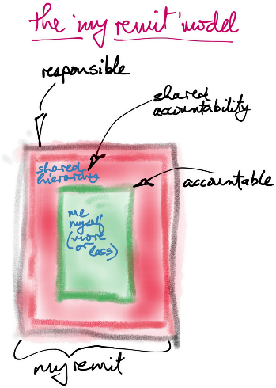

In the following there are four basic direction from which remit gets shaped
- From top down in the University (e.g. Strategy)
  - These are the major forces which can shape what an area or team is responsible for e.g. Strategy 2020-2024, new Academic Regulations, major organisational structures (School / College, support unit structures etc.
- From standing operational necessity
  - Monthly payroll, trimester’s exam season, annual Orientation etc.
  - These typically ‘just have to be done’ and govern most of what a given team or unit will do
- From emerging issues / needs
  - COVID is the most compelling example of change
  - Rollouts of new systems or processes can trigger remit change, some of which is intended, some of which just emerges
  - There can be a lot of this type of activity.
- From job descriptions and local organisation
  - Posts can have their own remit within a team, teams often have structures which determine who is responsible for what, teams can be within a unit and responsibilities be periodically reviewed and redistributed
  - Change in this area is less common as a ‘shaping’ influence
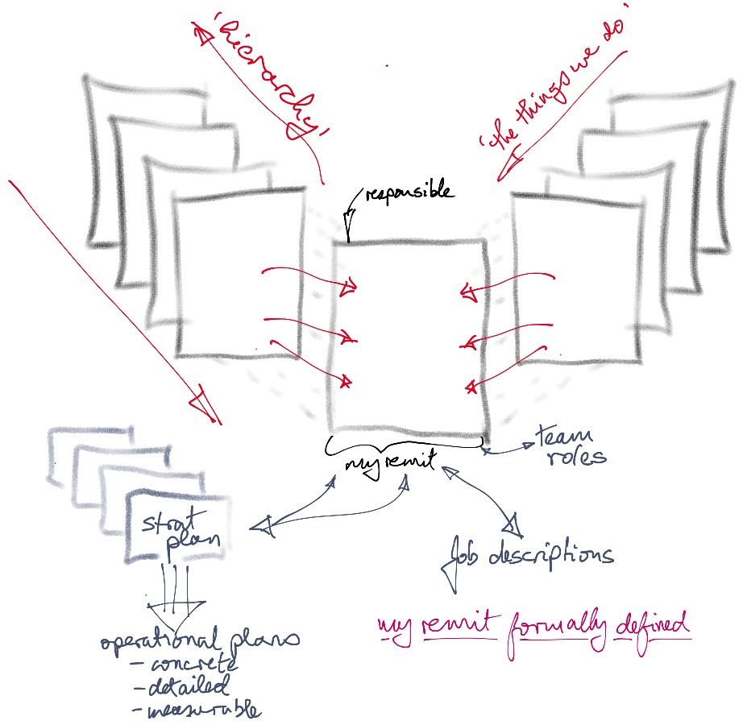 | » | becomes  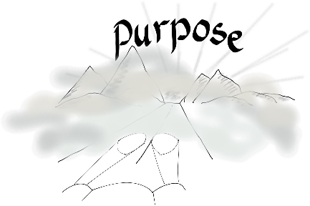

4 – What we do has a number of elements
Remits evolve, sometimes through conscious decisions, sometimes unconsciously, sometimes with a cumulative effect that is missed in the detail.

What are the general kinds of remit shapers that will be influencing the remit, and hence the clarity of purpose, of the folks you are working with in the workshop?

Section guide
Timing:
7 minutes

Section covers:
Remits evolve over time
There are four basic shapers
- From top down in the University (e.g. Strategy)
- From standing operational necessity
- From emerging issues / needs
- From job descriptions and local organisation
Clarity of remit / purpose can be lost over time
Activity
The facilitator brings the attendees through the ideas

The essence of this session is to give the participants the framework for the six elements of a remit map.

 | 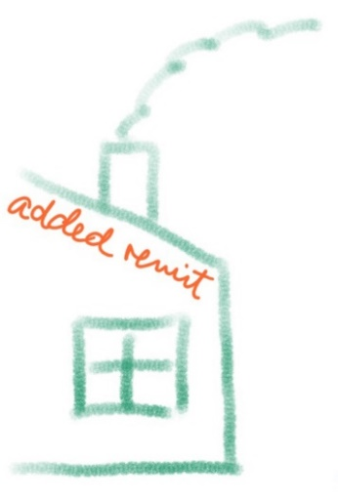 | 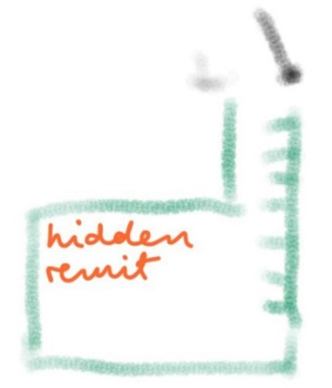
‘My remit’ – the starting point | ‘Added remit’ – formally added (or subtracted) changes to remit | ‘Hidden remit’ – the things the unit / team / person does that are not part of formal remit
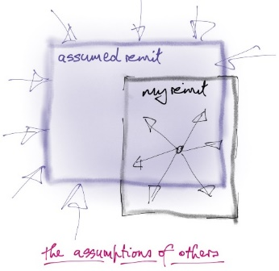 | 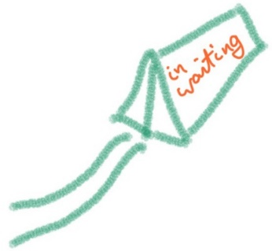 | 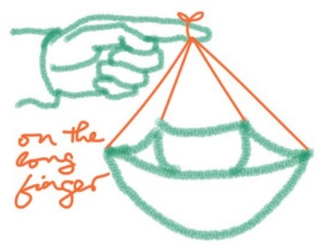
‘Assumed remit’ – the things others assume are in remit... but are not... and so have to be dealt by doing or passing on | ‘In waiting’ – changes to remit that are on the way but have not happened yet. These may have been formally planned or seen as inescapable consequences | ‘On the long finger’ – elements of remit which do not get dealt with, things with a ‘should’ on them

‘Hidden remit’ can be interesting. This can be work folks have picked up along the way, quite enjoy doing, are known for... but is not part of remit and therefore takes time and energy away from remit.

The purpose of mapping remit is to trigger conversation in the team.

“Should this be here... that is growing and getting bigger... I didn’t know we did that... what will be the consequences of...”

You are giving the team shared concepts and language, helping them have very important conversations, and making it easy to come back to them again over time.

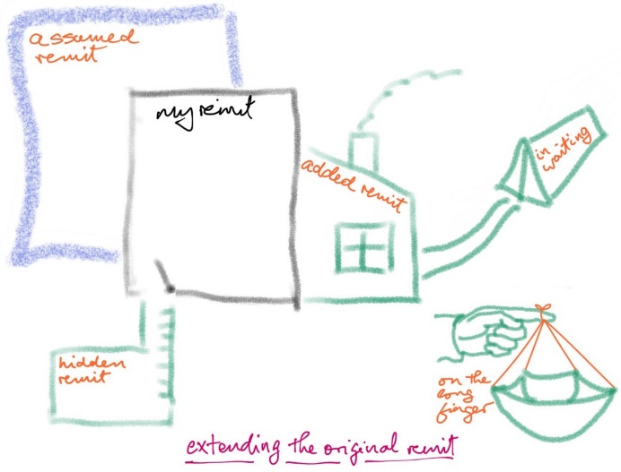
This, then, is the picture that is filled in when a team gets to remit mapping.

It can often be the first time a team has looked at itself in this way.

If a team has a high staff turnover it can be a great way of getting everyone on the same page.

Lots of value. Lots of uses.

5 – What drives change for us?

Section guide
Timing:
5 minutes – individual participants put down the drivers they see
3 minutes – cluster the drivers, in each of the quadrants, by theme
5 minutes – look at the clusters and patterns of drivers

Section covers:
How the four basic shapers are at work on this team’s remit
- From top down in the University (e.g. Strategy)
- From standing operational necessity
- From emerging issues / needs
- From job descriptions and local organisation
The team gets to look at their environment and the impact it is having, or going to have, on what they are responsible for
Activity
Individuals
- Use Post-its to name the drivers of change
- Put them in whichever quadrant fits them best
Participants
- Invite them to cluster the Post-its by theme in each of the quadrants
- Themes tend to emerge
Facilitator
- Go through the clusters in each of the quadrants
- Help the participants talk about, and reflect on, the patterns that emerge. These are the drivers which shape their business.

Part of recognising the drivers for change is developing a sense of the extent to which you can influence them or not.  This is, in part, about managing ‘up’ as we as managing the immediate environment.  How exposed is the team to change? | 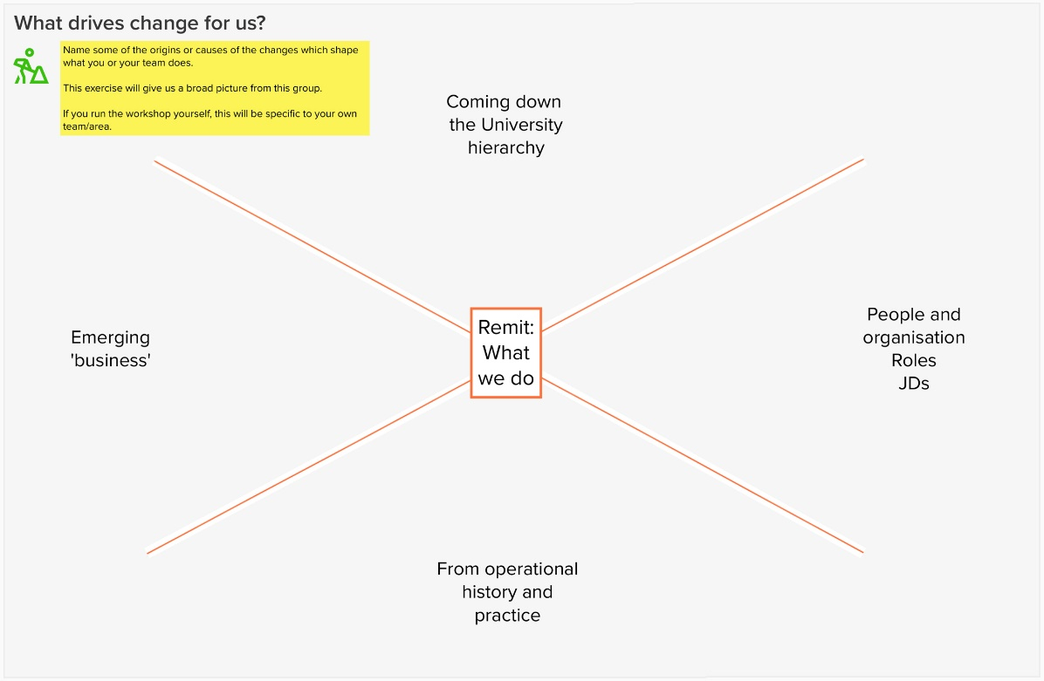

6 – Mapping a business
In a training session, the example of a pizza restaurant is used (The Revolution in Rathgar – excellent pizzas) as the business to be mapped.
Participants, most of whom will have lots of experience with pizza in restaurants or take aways or making them in their own kitchen, are asked to map out the restaurant, with COVID as the added remit. No right or wrong, just imagination!

If using this with a team or unit they do, of course, focus on their own business.

Section guide
Timing:
5 minutes – individual participants put the activities they see into one of the six elements of the map
3 minutes – in a given element, cluster the activities
5 minutes – look at the clusters and patterns of activities

Section covers:
Mapping a business using the six elements
Activity
Individuals
- Use Post-its to name the activities in the team / unit / business
- Put them in whichever of the elements of the map fits them best
Participants
- Invite them to cluster the Post-its by theme in each of the elements
- Themes tend to emerge
Facilitator
- Go through the clusters in each of the elements
- Help the participants talk about, and reflect on, the patterns that emerge. These are the elements of their business.
- The participants may already have a clearly defined structure to their business – you will see that emerge in how they cluster – or the clustering will have asked for a new way of thinking about their business.

This section takes the most time but the least explaining. The section “What we do has a number of core elements” covers the six elements of the map:
- The formal remit
- The added remit - formally changed
- The assumed remit
- The hidden remit
- The remit in waiting
- The remit on the long finger

In the pizza restaurant exercise, the added remit is the constraints COVID-19 has triggered on running the restaurant. Be sure you all agree before they start – for this exercise they can be anything you want as long they can be seen as ‘added’ after an initial remit.

7 – Working through now
The participants as individual build the first ‘now’ map – it is a collection of their individual perspectives, with some ‘team’ in the clustering.

Take a copy of the map at this point – export the area from Mural is easiest. Or copy the area within the mural, parking it off to one side.

In this section you work through the map and see what, if any, of the items in assumed, hidden, on in waiting or on the long finger should move into the main body of the map. This is where the team (the participants) take a shared ownership of the picture of ‘now’ that they have painted.

Section guide
Timing:
5 minutes – individual participants put down the driver they see
3 minutes – cluster the driver, in each of the quadrants, by theme
5 minutes – look at the clusters and patterns of drivers

Section covers:
Taking the map from its early state of individual contributions, plus clustering, to a team-owned aggregation of that content.
Some items may well remain in assumed, hidden, awaiting and on the long finger

Activity
Facilitator
- Go through the clusters the four elements outside ‘remit’ and ‘added’ and see if they move in to one of the clusters in ‘remit’ and ‘added’.
- Clusters will get adjusted and, if not already, named as this goes along.
- Some items may remain in outside ‘remit’ and ‘added’. These may trigger discussion on actions outside the session.

You now have your ‘now’.

- Participants have individually populated the six elements of ‘now’.
- They have clustered the elements in a way which make sense to them, with lots of discussion.
- In this section, the map has been worked through, lots of the non-core elements have been looked at and many have been moved.
- Some initial additional discussions have been identified.

You now have the raw material for the “Where are we now?” element of your journey. And you have a reference point to check back on later. If the agenda driving the session was strong, you will have already started those conversations. Good luck with the rest of the journey!

Appendix – Lean HE survey on remit and clarity
UCD Agile gave a presentation on remit mapping at the Lean HE Global Festival in October 2020. As part of the session three surveys were run on how clearly defined and understood he attendees’ team’s remits were set and understood.
(There were about 40 respondents to each question.)

By those outside your team – how clearly understood is your team’s purpose and activity?

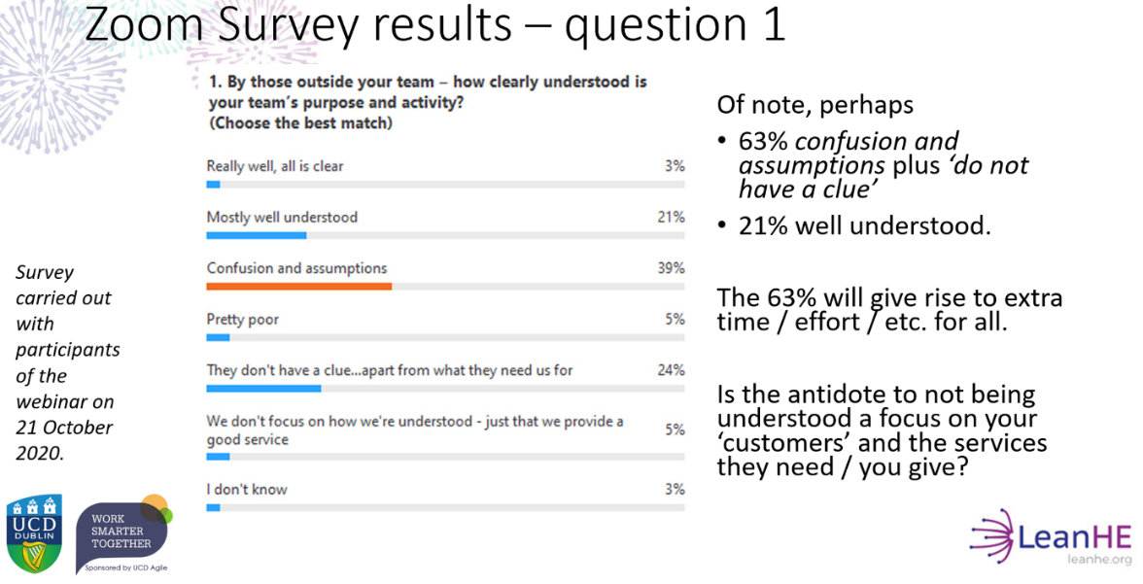

By those in your team – could all members give a clear breakdown of all of what you do and why you do it?
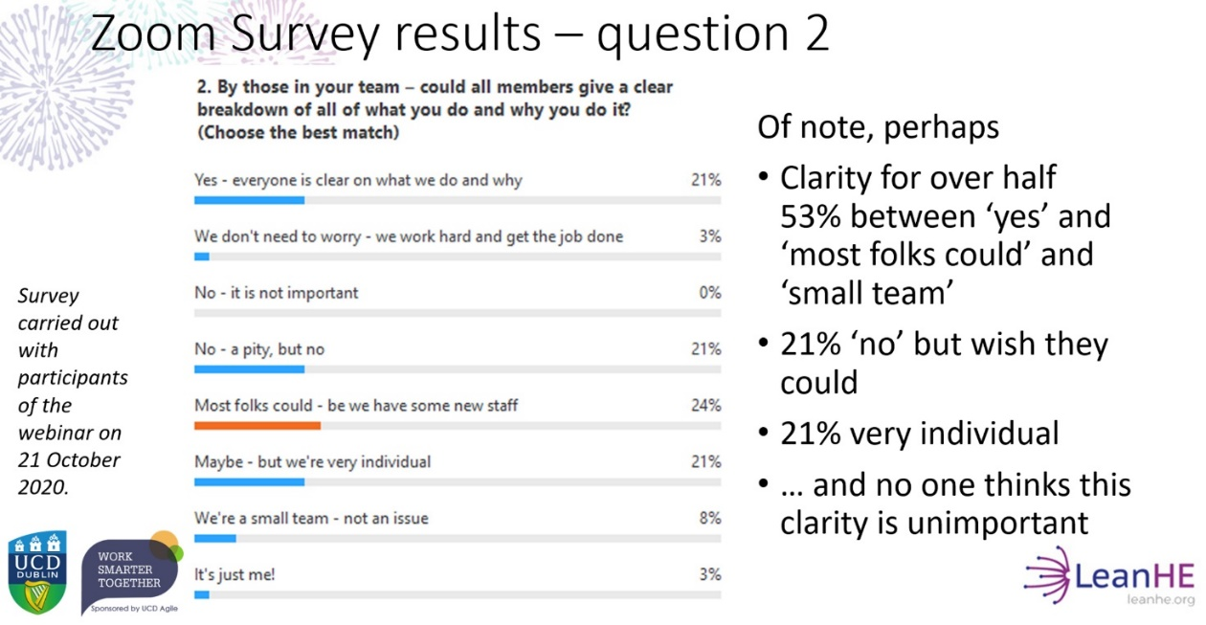

How long is it since the last time your team’s remit was formally set / defined / named?
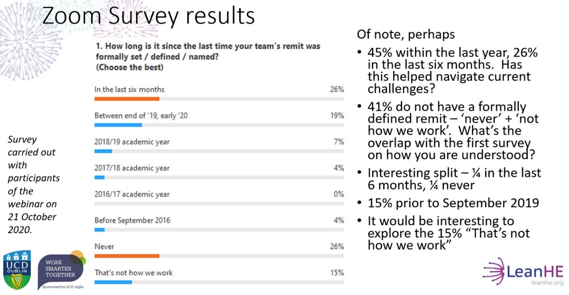

Reflection
Ask yourself and your team these three questions too:
- By those outside your team – how clearly understood is your team’s purpose and activity?
- By those in your team – could all members give a clear breakdown of all of what you do and why you do it?
- How long is it since the last time your team’s remit was formally set / defined / named?

Have you the data to answer these questions for your team?

Why does your team’s purpose and activity need to be understood by those outside it?

What about the answer “We don’t focus on how we’re understood – we just provide a good service”?
Which is the better focus, if you had to choose – that your team is understood or that your services are clear and accessible?
One is looking inwards at the team, the other is looking outwards at the customer.

40% of the survey respondents did not think their team’s members could give a breakdown of what the team does and why.

