Introduction  Remit mapping looks to the questions to pose, and models that could be used, in pursing the goal that we own, understand and take responsibility for our businesses and are supported in being successful in them.  This goal applies to, and can be used by, both teams and individuals | This document is about how you can use the ‘remit model’ to help a team or an individual plot their road to clarity of purpose – clarity which supports performance and helps deliver results.
Remit mapping is based on the intersection of two key ideas – that high performing teams that are good to work in need ‘mastery, autonomy and purpose’, and that a team’s purpose is found in its remit, with remits evolving under many influences and, potentially, becoming unclear. Remit mapping is, in essence, about clarifying purpose through exploring the ‘now’ of a team.
The ‘mastery / purpose / autonomy’ model (borrowed from Dan Pink) looks to two things – what it takes to create a satisfying and motivational work environment and, consequently, what it takes to enable strong performance.  The ‘my remit’ model looks to what I am responsible for, my autonomy and accountability in that, how this connects with my team and line management, and how this in turn connects with the University’s structures. My remit, broadly, provides me with the purpose in ‘mastery, autonomy and purpose’. | 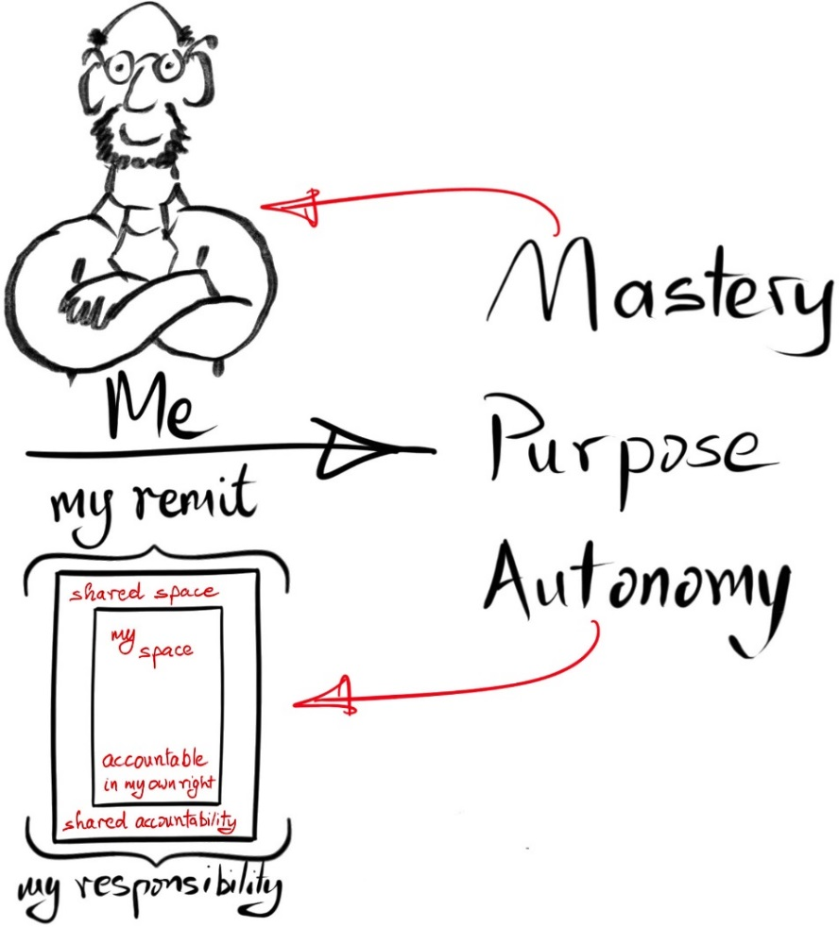  Note: This cartoon is not to imply all those who work in UCD’s support ecosystem are bespectacled, bearded and male, just that there are limits to the author’s cartooning skills.
The two models can be applied by teams and units as well as by individuals.  The same questions arise.  Is our team’s remit clear to us? Is it clear to others?  Is our purpose clear?  Have we the mastery, the clarity of purpose and the autonomy of action we need in order to perform well and to create a motivating and satisfying work environment?  Can we use these two models when we look to how we deliver our business, how we are organised, how we fit into the overall picture, how we can best collaborate with others? | 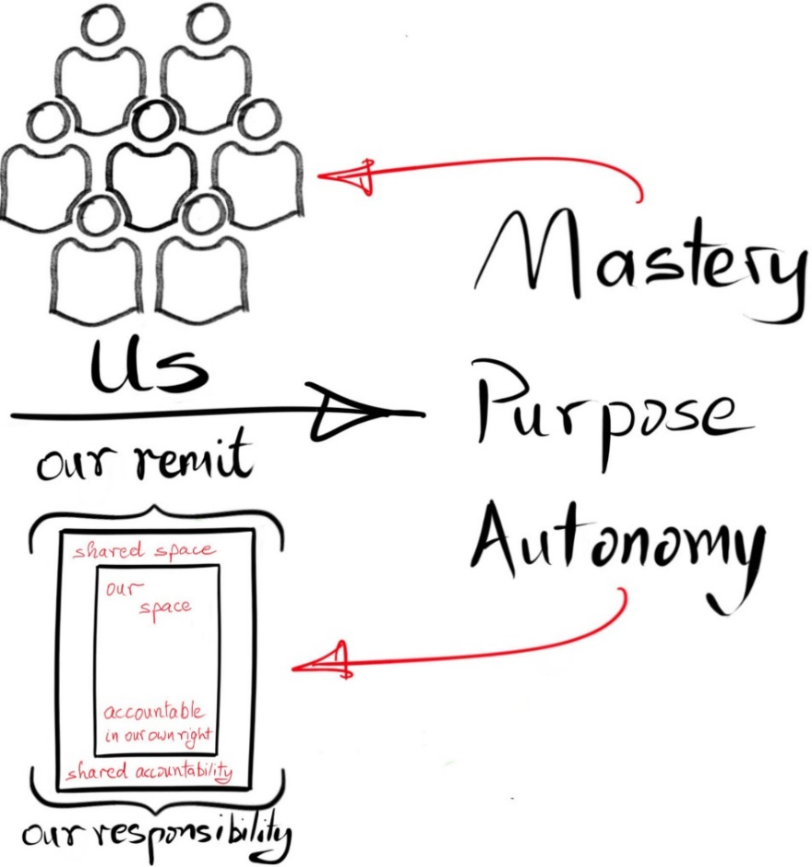
This document begins with an exploration of the ‘my remit’ model, looking at ‘my remit’ in itself and at how it connects with other remits through our structures and organisation. A key element of this is the importance of clarity, not just in terms of roles and responsibilities but as an enabler for collaboration and creatively carrying out our job.
This document further explores on three areas of particular importance – this question of ‘clarity’, the ‘mastery / autonomy / purpose’ model, and ‘empowerment’.
This document is about creating, encouraging, and providing the concepts and language for, dialogue within teams. Why? Dialogue, if carried out well, empowers and is the road to shared clarity. And clarity is good.

‘What is my/my teams remit and how does it connect with others?’
and
‘If mastery/autonomy/purpose are key both to personal/team motivation and performance, is our purpose clear, are we developing mastery and what autonomy have we in pursuing this purpose?’

These are invitations to personal and team reflection as well as for managers in reflecting on how they manage, create clarity of purpose, empower etc.
In essence, the models here are intended to underpin reflection and dialogue with the concepts and language introduced.
© UCD
Contents
1 Introduction 1
2 How do you use this document 4
3 My remit – the basics 5
4 My remit – its structure 6
5 My remit – five ‘risks’ to having a clear picture 7
6 How is my remit shaped? The broad institutional context 8
7 How is my remit shaped? The institutional context – more detail 9
8 How is my remit shaped? Incremental change 10
9 How is my remit shaped? The assumptions of others 11
10 How is my remit shaped? Where remits overlap or intersect 12
11 What is the goal of a clear remit? 13
12 Mastery, autonomy and purpose 14
12.1 Mastery 15
12.2 Autonomy 16
12.3 Purpose 17

How do you use this document
This work originally arose in relation to the decision making, authority and empowerment strand of a UCD staff engagement survey, three strongly connected aspects of our working life. In this work we use conversations about ‘my remit’ and ‘autonomy, mastery and purpose’ to explore the same space.
What follows is an invitation to engage on a journey using these ideas as ways of navigating the questions and opportunities which arise. This document steps you through the two models – ‘my remit’ and ‘mastery, autonomy, purpose’.
The images on pages 5-13 and 15-18 can be used as the basis of a workshop. The text with them in this document provides a guide on how to work with the images. UCD Agile also provides remit mapping training: contact UCD Agile if you would like to take part in one of our sessions.
These models also be used for personal reflection and the basis for various conversations, providing useful support for P4G and development conversations, for example.

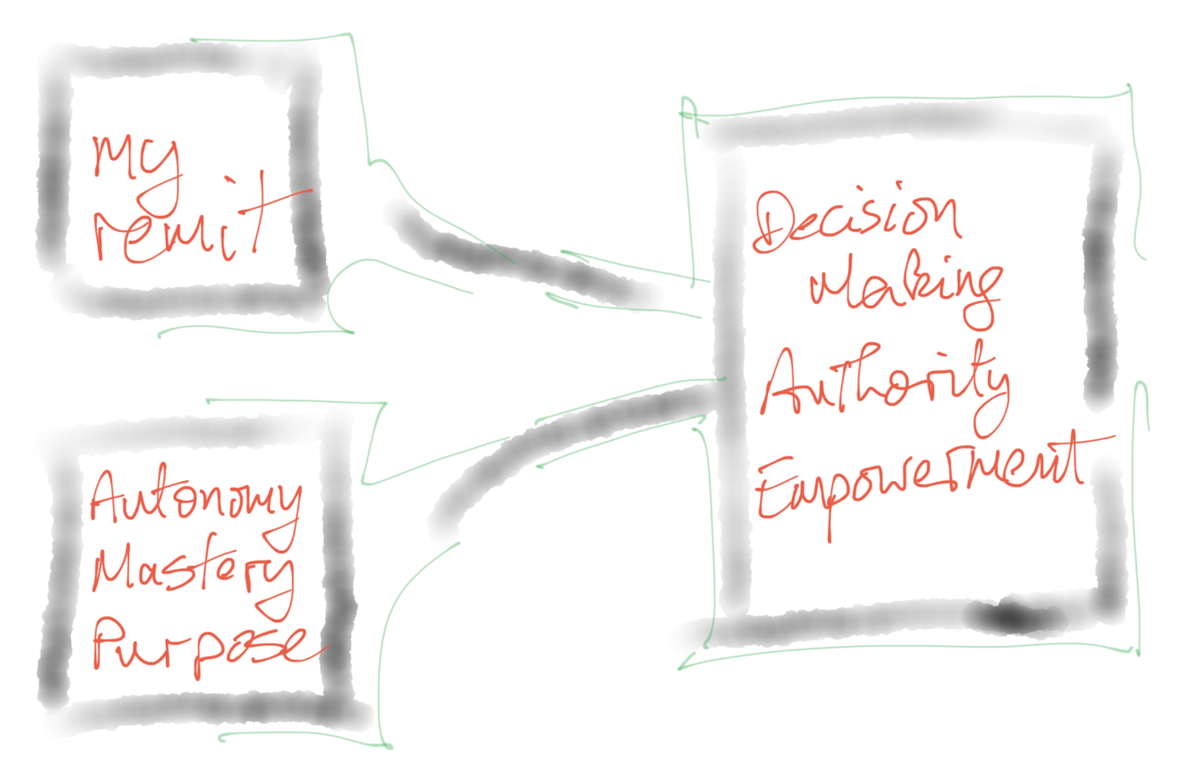
The essence of this work is dialogue – with yourself (!), with your team, with your line manager. Clarifying remit requires dialogue. Connecting remit with greater goals requires dialogue. Being supported in developing mastery requires dialogue. Crafting the boundaries within which you have autonomy requires dialogue. Refining and articulating purpose requires dialogue. Remits evolve over time: this is an invitation to ongoing dialogue.

My remit – the basics
These ideas are the basis of what follows.

Basic concept – my remit describes the things I am responsible for doing in my job.

Allied concept – our remit is the things our team/unit is responsible for doing.

Basic concept – clarity of purpose is a key enabler of my engagement, of my dialogue with my manager, of my collaboration with others, of empowerment, of autonomy etc. etc.

Basic concept – mastery, autonomy and purpose are key to personal motivation and satisfaction as well as performance in the job.

We are therefore using the ‘my remit’ model both in terms of itself (clarity as to what I am responsible for) and as the source of the ‘purpose’ in mastery/autonomy/purpose model.

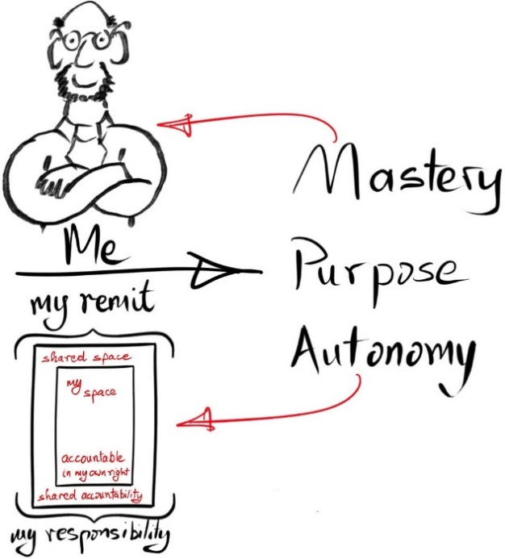
We will use this basic image for ‘my remit’ (above) in many of the sections below where we are looking at how your remit fits in with others and the environment around you. But first, let us look at the inside of ‘my remit’ in a little more detail.

My remit – its structure
I am responsible for all of my remit  – the outer border in this image  I share accountability for some of my remit – e.g. share it with my team, my line manager.  - the red area  I am fully accountable for some of my remit.  - the green area  My autonomy lies in the green area - I am free to make decisions or take independent action without seeking further approval or guidance and I have the authority to do so.  I do not have full autonomy in the red zone – I must get input or approval before acting or making a decision.  The amount of autonomy you have will be affected by many factors – the remit itself, your experience and skills, your manager’s perspective on your experience and skills etc. | 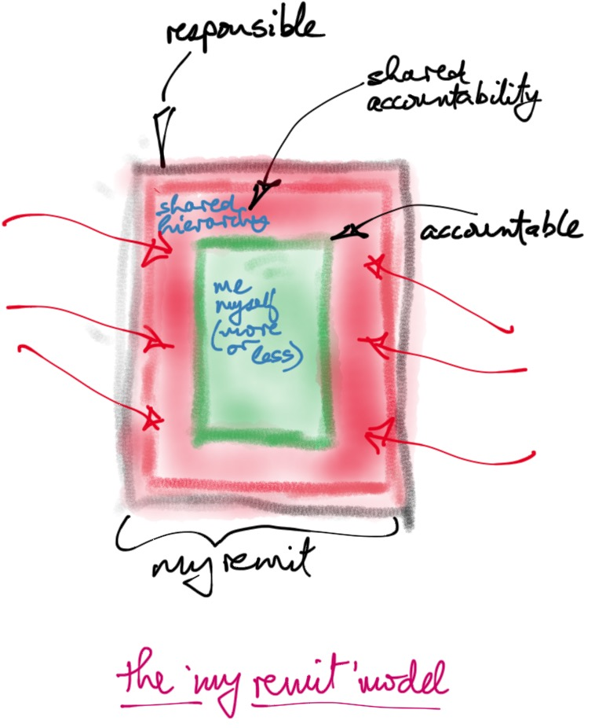
A key to creating autonomy is empowerment.
From Mac McIntire’s “How to empower employees…”
“Empowerment is the extent or degree of responsibility and authority given to an employee or to a team.
Different people and different teams will have varying degrees of empowerment based upon their level of experience and expertise.
Empowerment is the act of identifying the tasks on which an employee is trusted to act independently versus those tasks the employee must get input on or approval before proceeding.
Employee empowerment also entails identifying how much responsibility and authority an individual can effectively handle without becoming over-burdened or distressed.”

My remit – five ‘risks’ to having a clear picture

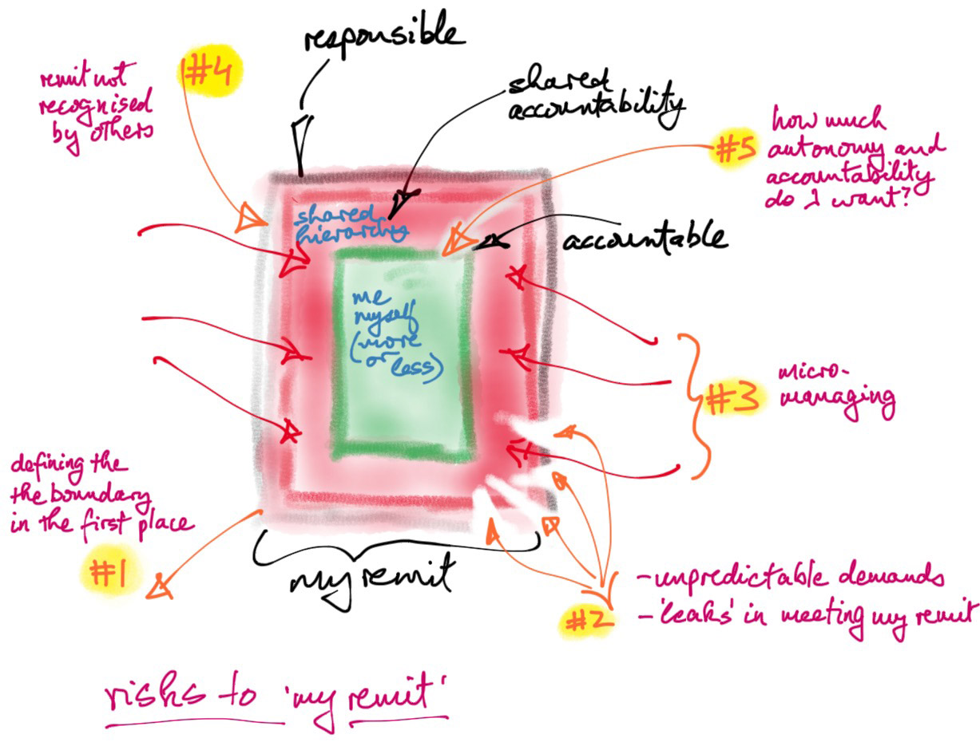
- defining the ‘remit’ boundary in the first place | Job descriptions define remit, in principle.  They often contain ‘other duties as assigned…’, or some such phrase, which means they may not provide detail.  Jobs evolve over time, sometimes without clear planning.
- unpredictable demands or leaks | You may not be able to fulfil your remit because unpredicted or new demands.  Your remit leaks… new demands… and you do not meet it.
- ‘micro-managing’ | You and your manager agree the shared accountability zone but the manager strays into autonomy – they are not good at empowering and standing back.
- remit not recognised by others | You know what your remit is but others do not and their expectations and actions impact on what you can do.
- how much autonomy and accountability do I want? | These are personal questions – how much autonomy within your remit do you want, and to what the degree are you comfortable with empowerment.  You might want more than agreed, you might want less.

These risks arise both in terms of personal remit and a team’s remit.

How is my remit shaped?
The broad institutional context
Our remit comes from the institution – the jobs we do we do for UCD.  At least initially our remit is defined by the job description which covers our role and our recruitment.  Job descriptions can have a built in fuzziness… “… and other duties which may be assigned…”  Jobs and job descriptions can quite naturally go out of synch over time.  The same is true for team remits, perhaps more so if the team is creative and responsive, adjusting how it operates over time.  What you do fits into the UCD’s ‘what we do’ greater scheme of things. | 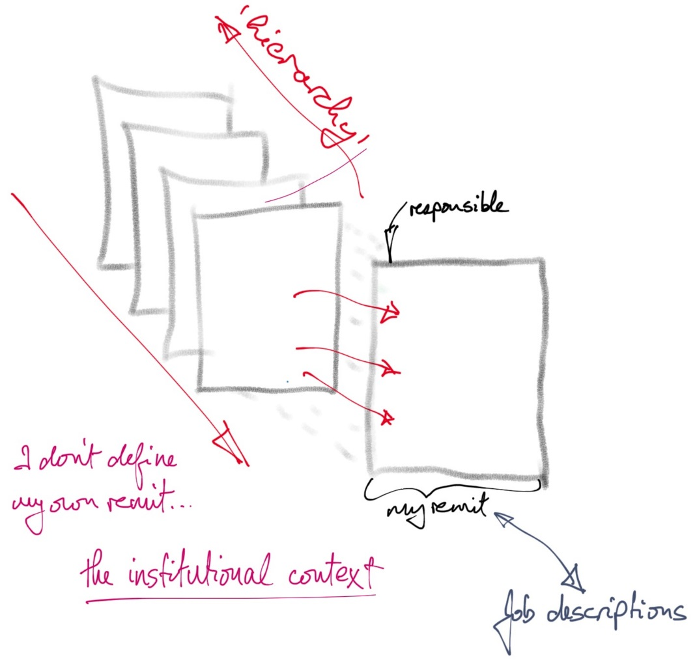
Have you clear line of sight of how your own remit fits into your immediate environment – your team or unit? Where does your remit come from?

Have you a clear line of sight of how you team’s or unit’s remit fits into the greater scheme of things?

Where does your team’s or unit’s remit come from?

If remit never comes up in discussion then remit is probably not being thought about which means you may be assuming what it is, or others may be assuming, and there may be no one actively supporting you or connecting you in with the greater scheme of things.

How is my remit shaped?
The institutional context – more detail
What shapes my remit?  The job description.  The dialogue, explicit and implicit, with your team lead or manager.  Your unit or team’s remit.  Your role in supporting the unit or team’s remit.  The connection of your remit to formal operational (in some sense) planning.  The connection between operational planning and strategic planning.  The hierarchy of remits that shapes the organisation.  Each shaper of remits implies a dialogue of some kind, structured or unstructured, which relates your remit to some ‘greater remit.  This shaping, the product of dialogue, produces clarity and around what is expect of you, what you are responsible for, and how that meets your overall purpose.  So this gives a set of questions like this. | 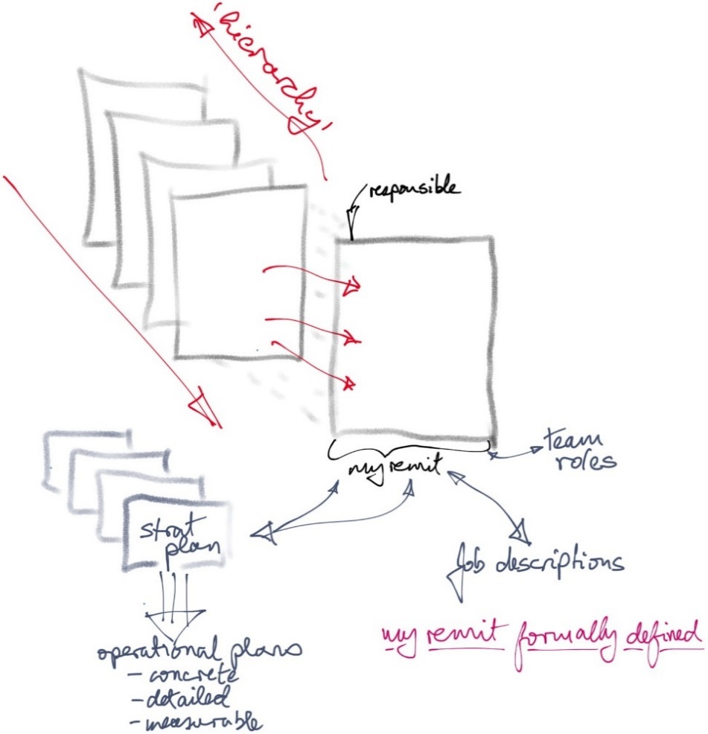
Is there a clear description of your remit? (Is your job description in any way close and/or useful in this regard?)

Is this clarity shared by your management line? Do you see your remit as something others do not?

Is your role in your team/unit clear? To you? To those around you?

Does your team’s/unit’s remit fit into a clear picture? Does that picture connect with clear planning etc.?

Is the relationship clear between your immediate environment and whatever overarching remit defines what you do?

Does your dialogue with your line management help establish and sustain this clarity?

In short, does your institutional context, for want of a better phrase, give you clarity as to what your responsibilities are, how they relate to others’, and how you can best be supported in carrying them out?

How is my remit shaped?
Incremental change
You start with your formal remit.  You add on new elements over time – the extensions.  You add on new elements over time – the cellars perhaps only you know about.  These extensions can come about by intention, force of circumstance, emerging need, front line learning etc.  They can be visible to others or invisible. Who knows about how the remit has evolved?  They can be extensions you like and want to hold onto, even though they are not part of your formal remit.  They can be extensions you do not like and wish were not there. | 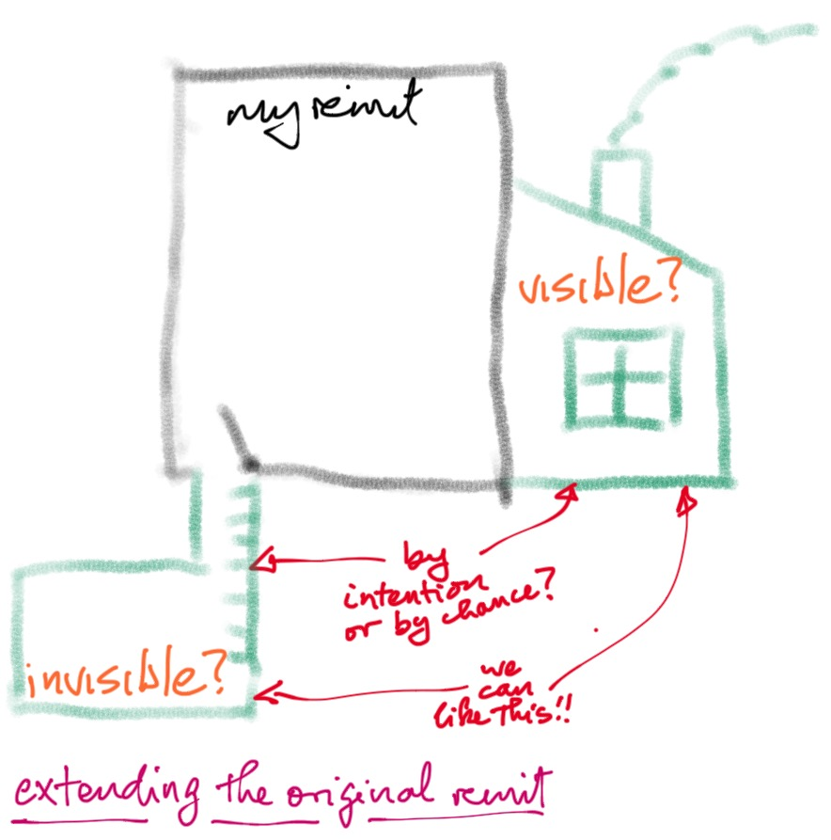
What extension have been added to your formal remit?

What hidden extensions have you got in the cellar?

Is everyone clear the remit has changed?

How is my remit shaped?
The assumptions of others
You know what your remit is.  Your team knows what its remit is.  Others, however, assume your remit is something else.  That is, they assume you are responsible for things you are not responsible for and they act on this basis.  These assumptions can be simple misunderstandings.  These assumptions can be convenient for the assumer.  These assumptions can be unhelpful, even harmful.  These assumptions always tell you something interesting about the context in which you are working. | 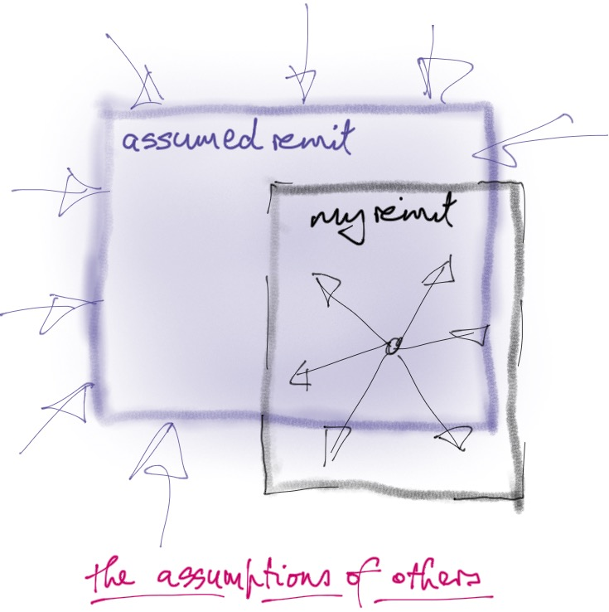
What signs are there that others have incorrect assumptions about your remit?

What is the source of these assumptions?

What does the gap between your remit and their assumptions tell you?

How is my remit shaped?
Where remits overlap or intersect
One of the enablers of successful collaboration, and indeed the sharing of responsibility, is clarity.  Where people, teams or units work alongside each other for common or overlapping goals, respective responsibilities may not be ‘equal’ – you may have the formal responsibility, the other contributing to it, or vice versa. Respective responsibilities may be unclear.  Your respective responsibilities may be intrinsically unclear – you share a space and have to figure it out as circumstances emerge.  The ‘institutional context’ mentioned above may not have provided you both with clarity on how your respective remits fit together. | 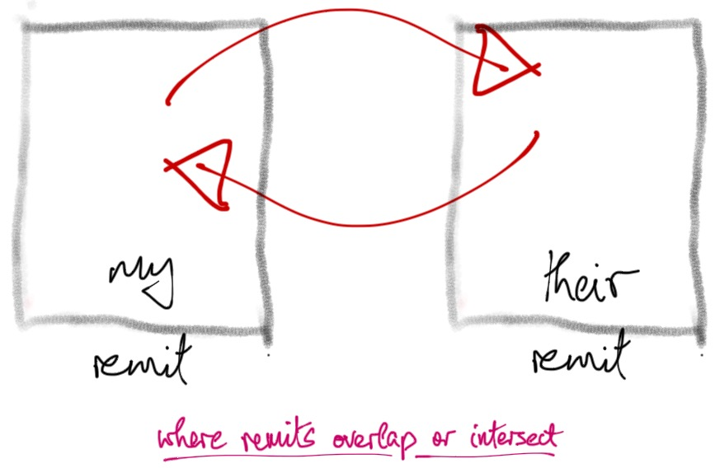
Are there areas in which you find yourself with these kinds of intersecting or overlapping of remits?

If you work in a common space with another person or team/unit, is it clear how your respective remits intersect or overlap?

Are you working in areas, full of overlaps and intersections, where no one has overall responsibility, where remits shift with circumstances and constant adapting is the norm?

What is the goal of a clear remit?
Have you got a clear remit?
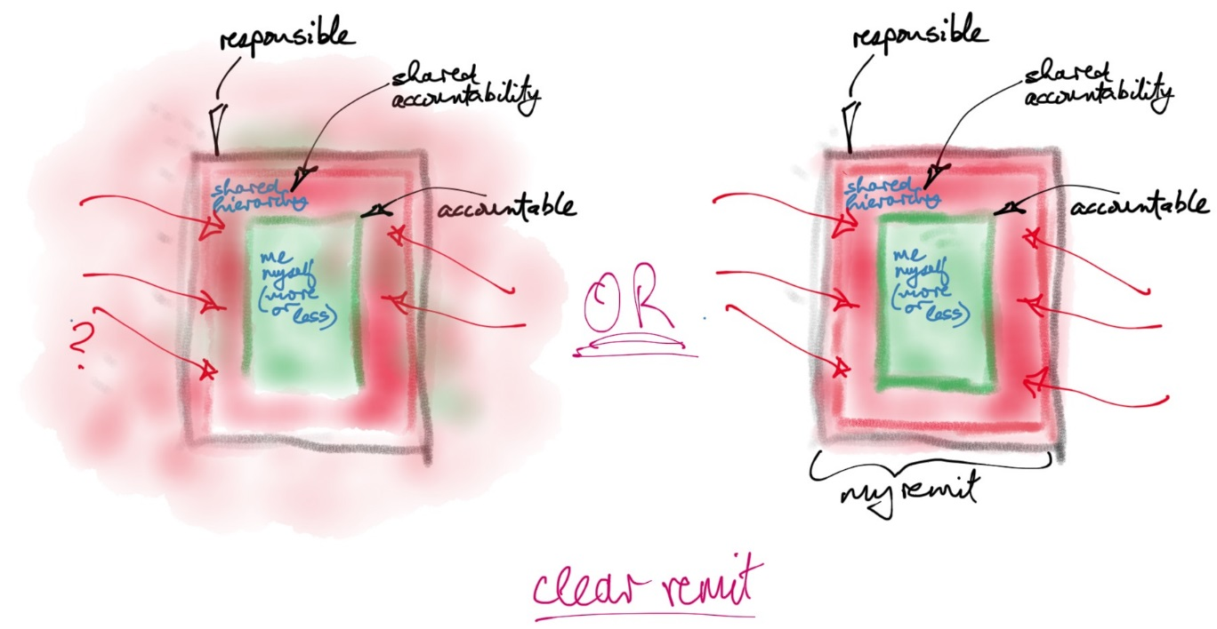
Do you know
- what you are responsible for,
- where you have autonomy and are directly accountable,
- where you share accountability,
- how to work with your line management and team/unit on keeping your remit clear,
- how your remit fits into the greater scheme of things?

Mastery, autonomy and purpose
Dan Pink was the source of our inspiration for using this model.  Mastery, autonomy and purpose clearly map onto decision making, authority and empowerment. They also go beyond the mechanics of how decisions are taken and how authority is exercised, looking to how we can create work environments where we consciously foster motivation and job satisfaction as well as achieving high performance. | Mastery, autonomy and purpose  are the key to motivation,  job satisfaction and performance.
This model also emphasises the importance of being able to articulate purpose. In a University environment whose purpose is education and research, being able to connect our purposes in the various elements of Academic Affairs to University purposes is really important.
The value in doing this becomes clearer when you realise this is not an abstract exercise but is driven by the desire to enable motivation, job satisfaction and high performance.
There is a very interesting 10 minute cartooned video of Dan Pink’s talk on autonomy, mastery and purpose.  You will get a sense from the video of how the ‘autonomy, mastery, purpose’ model can be applied personally and to teams and structures.  Check the video at  https://www.youtube.com/watch?v=u6XAPnuFjJc | 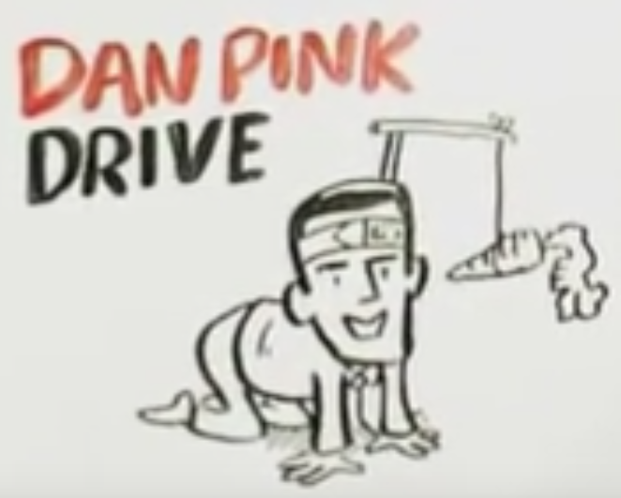
From Dan Pink’s self-publicity for his book Drive:
Most of us believe that the best way to motivate ourselves and others is with external rewards like money—the carrot-and-stick approach. That’s a mistake, Daniel H. Pink says in, Drive: The Surprising Truth About What Motivates Us, his provocative and persuasive new book. The secret to high performance and satisfaction—at work, at school, and at home—is the deeply human need to direct our own lives, to learn and create new things, and to do better by ourselves and our world.
Drawing on four decades of scientific research on human motivation, Pink exposes the mismatch between what science knows and what business does—and how that affects every aspect of life. He demonstrates that while carrots and sticks worked successfully in the twentieth century, that’s precisely the wrong way to motivate people for today’s challenges. In Drive, he examines the three elements of true motivation—autonomy, mastery, and purpose—and offers smart and surprising techniques for putting these into action. Along the way, he takes us to companies that are enlisting new approaches to motivation and introduces us to the scientists and entrepreneurs who are pointing a bold way forward.
http://www.danpink.com/books/drive/

Mastery
People like to be good at what they do.  We tend to like to get better at doing things.  A sense of progress, not just in our work, but our capabilities, contributes to our inner drive.  From a blog on this topic, we “should look at calibrating what people must do by looking at what they can do. If the must-tasks are too difficult, people will become worried and feel out of their league. If the must-tasks are too easy, they’ll will get bored.  The must-tasks should be just right. So Pink concludes that we should work on Goldilocks tasks, which are neither too difficult nor too easy. The trick is not to give tasks fitting a person’s exact capabilities, but to give them space and support to reach a little higher to foster improvement, continual mastery, and growth. What this requires of employers is paying more attention to how employees are doing and feeling about their tasks in order to avoid keeping square Bob or triangle Mary from trying and losing heart at fitting into round tasks.” | 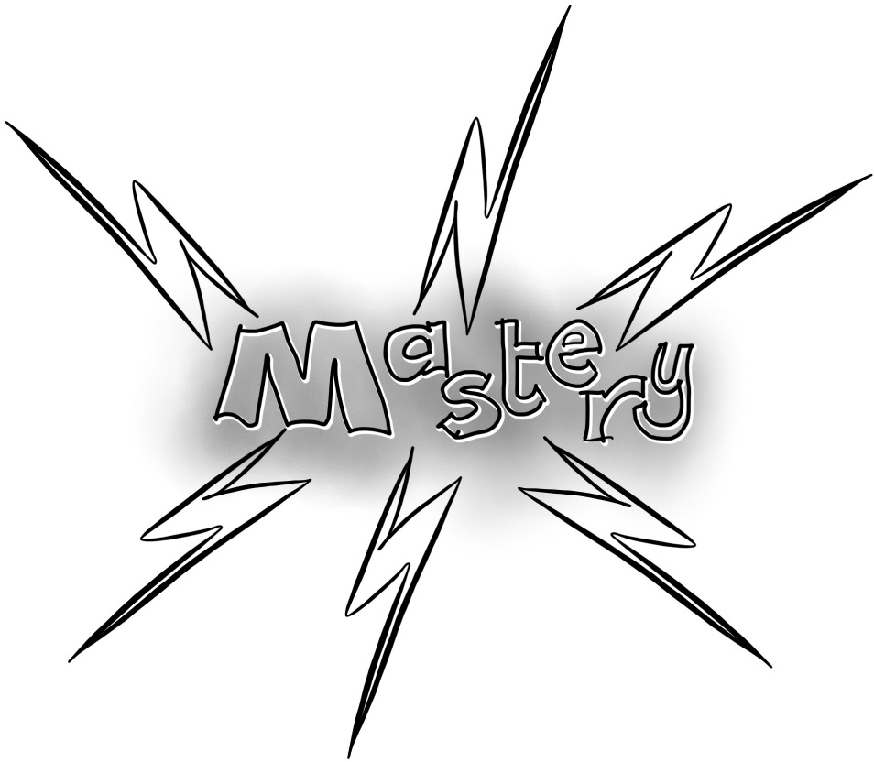
Developing mastery is a key element of motivation, job satisfaction and performance.

So the mastery question is an interesting one in relation to our roles and remits.

The question for the individual is about how, and in what, you pursue and develop mastery. How do you make sure this is an aspect of your work life? Where do you already have mastery?

The question for line management is how you work with the individual on this, making this part of their work environment, working to ensure this is aligned with their role, their team’s needs etc. What are you doing to foster this?

Where is your own mastery now? As a team exercise, where is your team’s mastery? What strengths will you build on? Assuming we like to be good at what we do and to gain new skills, what are you doing to develop and extend your mastery? How do you stretch and grow?

This requires dialogue.

Autonomy
People like to be self-directed, to have the freedom to exercise their skills and judgement

This is true for teams too.

Autonomy requires clarity. Line management needs to be clear on what the boundary conditions are, for example through:
- Clearly setting deadlines, way points and milestones
- Having measures
- Tracking progress
- Allowing for dealing with exceptions
- Having the right person for the right job
- Allowing for making mistakes.

It is easier to micro mange then to give autonomy.

There is a real risk of ‘casual de-autononymising…’, autonomy taken away unconsciously / over time / unintentionally…
Highlights the need for clarity – begin clear
Having autonomy is a key element of motivation, job satisfaction and performance.

Autonomy can mean helping staff by giving meaningful feedback, choice over how to do things, encouragement, clarity on expectations and outcomes etc.

All roles and contexts are constrained in one way or another so giving autonomy always has limits and boundaries.

You empower when you genuinely give autonomy. Empowerment is the extent or degree of the autonomy and authority given to a staff member or to a team. Different people and different teams will have varying degrees of empowerment based upon their level of experience and expertise.

This requires dialogue.

For the individual or team, how much autonomy have you in your remit? Where do you think it could be expanded and why would this make things better? What would you need to make this possible?

For line management, how to you enable autonomy? How to you create clear contexts in which you can empower and support staff and teams? What will it require from you to make this successful?

Purpose

As Dan Pink says, we are purpose maximisers. We like to have a transcendent purpose. We like a greater goal we believe in, beyond the simple having the consequences of a given action.

A huge purpose-giver in UCD is our commitment to the students, both as individuals and as travellers through the transformation their time here bring for them.

(This greater purpose is one of the reasons the language of ‘customer’ jars for many people).

Pink says that when you connect to a cause larger than yourself you find the deeper motivation. Purpose is what gets you out of bed in the morning and into work without groaning and grumbling(!).
Having a clear purpose is a key element of motivation, job satisfaction and performance.

The University is a complex and diverse place.

What purpose can you name for yourself?

What purpose can your team name for itself?

How do these purposes fit into a greater picture? How do you connect your contribution to the University?

How do you find a way of articulating and framing purpose so that you get the motivational boost, and the satisfaction premium, Dan Pink talks about?

How does line management work to connect individuals and teams with greater purposes? How are contexts connected and clarified? How are you creating contexts in which your staff will be motivated, find job satisfaction, and perform at a high level?

How do we give staff the clarity of purpose that provides motivation, helps job satisfaction and enhances performance?

This requires dialogue.

http://www.imglv.com/articles/how_to_empower_employees.pdf © 2002, 2011, INNOVATIVE MANAGEMENT GROUP, 840 Trotter Circle, Las Vegas, Nevada 89107, 702-258-8334.
Pink, D. H. (2011). Drive: The Surprising Truth About What Motivates Us. Penguin.
Regarding mastery, autonomy and purpose: http://blog.deliveringhappiness.com/the-motivation-trifecta-autonomy-mastery-and-purpose

