This risk assessment template should be used when risk assessing the use of nanomaterials / nanoparticles in UCD laboratories. It can also be used to assess the risks from non-nano chemicals in use during any process involving nanomaterials.

Persons completing this assessment should refer to the UCD Chemical Safety Manual, the associated chemical safety guides as necessary, and must review the SDS for the chemicals under assessment

1. General Information

Name of Person(s) involved in the Process and their Position
Principal Investigator / Supervisor
(Person responsible for ensuring safety)
Date of Assessment
Location of Works
Frequency of Process
Nanomaterial(s) in use
Other chemical agents in use

2. Title and Details of the Process Involving the use of Hazardous Agents –– give details of the process(es) in question - if necessary, attach a written procedure. Please describe the entire lifecycle of chemical usage from delivery to disposal. Include details of any hazardous reaction products or wastes generated and how these are to be managed.

Title of Process:
Details:

3. Hazardous Agent(s) to be used
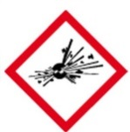  GHS01 | 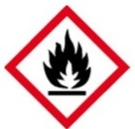  GHS02 | 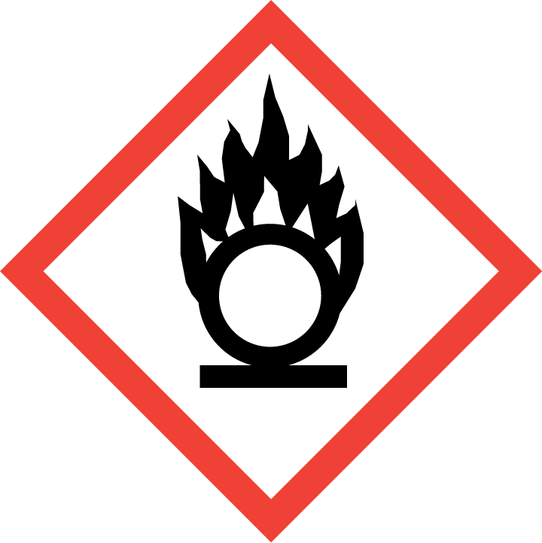  GHS03 |  | GHS04 |  | 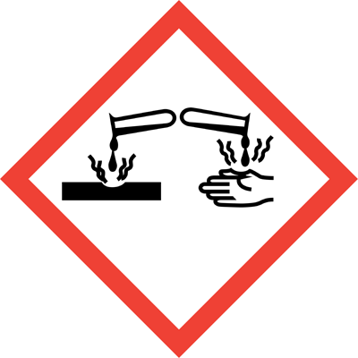  GHS05 | 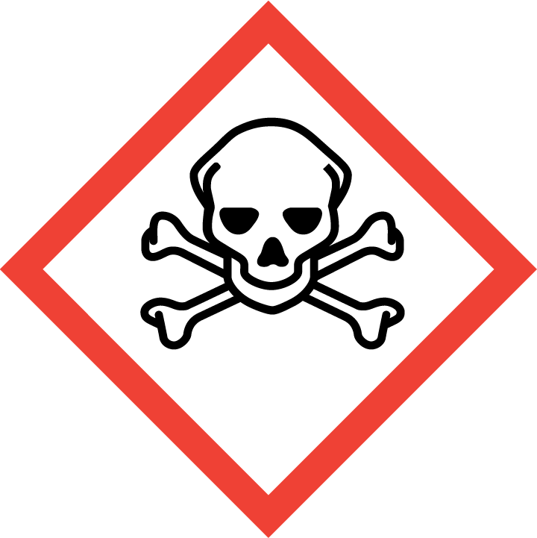  GHS06 | GHS07 |  | 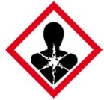  GHS08 | GHS09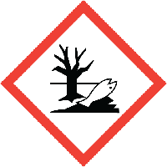
☐ | ☐ | ☐ |  |  | ☐ | ☐ | ☐ | ☐ |  | ☐ | ☐
Chemical name (or formula where no name) |  |  |  |  |  | Hazard Statements
Hazard Class
Signal Word |  |  |  |  |  | Precautionary Statements
Amount
Form
(Add additional tables as required)

Has a safer alternative been considered for all hazardous chemicals including nanoparticles (Give details)?
____________________________________________________________________________________________________________________________________________________________________

Provide scientific justification for the use of chemicals classed as Carcinogen, Mutagen or Reproductive Toxins; and high-risk nanoparticles (HARNs; carbon nanotubes; materials of unknown toxicity)
____________________________________________________________________________________________________________________________________________________________________

Are any of the chemicals in use incompatible (give details): __________________________________________________________________________________
Check potential reactions with the Chemical Reactivity Worksheet

Location of SDS for each Chemical: _____________________________________________________

4. Potential Experimental / Reaction Outcomes (give details where applicable)

Exothermic: ☐ Explosive: ☐ Release of gas / vapours: ☐ Pressurisation: ☐
Generation of unstable compounds: ☐ Effects on normal atmospheric conditions: ☐
Other: ☐____________________________________________________________________________________________________________________________________________________________________

5. Reaction Products & Waste
If possible list the reaction products generated and indicate their hazards -

Reaction Products

GHS01 | GHS02 | GHS03 | GHS04 |  | GHS05 | GHS06 | GHS07 | GHS08 | GHS09
☐ | ☐ | ☐ |  | ☐ | ☐ | ☐ | ☐ | ☐ | ☐
(Add additional tables as required)

If possible list the wastes generated and indicate their hazards -
Wastes Generated

GHS01 | GHS02 | GHS03 | GHS04 |  | GHS05 | GHS06 | GHS07 | GHS08 | GHS09
☐ | ☐ | ☐ |  | ☐ | ☐ | ☐ | ☐ | ☐ | ☐
(Add additional tables as required)

6. Control Banding of Nanoparticle(s) in Use

Complete Appendix 1 to identity a Control Band for the nanomaterials in use and tick relevant band.

No banding applied | Use standard lab precautions and good laboratory practice | ☐
Band / Control Type A | Use capturing hood / local exhaust ventilation discharged to a safe place outside. HEPA filtration to be used if air is to be recirculated back into the workplace. | ☐
Band / Control Type B | Partial enclosure discharged to a safe place outside. HEPA filtration to be used if air is to be recirculated back into the workplace. E.g. standard fume hood or Class 1 biosafety cabinet. | ☐
Band / Control Type C | Partial enclosure discharged to a safe place outside via HEPA filter e.g. ducted Class 2 biosafety cabinet. | ☐
Band / Control Type D | Full enclosure with HEPA filtration and discharged to safe place outside. | ☐
Note that the use of nanomaterials with poorly understood or a high level of toxicity (e.g. carcinogens) in a way that gives rise to airborne particles must not be undertaken until specialist advice has been obtained.

7. Nanomaterial Hazards
Identify each hazard associated with the nanomaterial and detail the control measures applicable to reduce the risks from same

- What is the form of the nanomaterial? E.g. powder, solution, pelletized, agglomerated, etc.
- In what proportions is the nanomaterial present?
- Are the particles long and thin / fibrous in nature?
- What is the particle size distribution?
- How dusty is the material?
- Is it water soluble?
- Is the nanomaterial toxic, a carcinogen, a mutagen, a reproductive toxin, a sensitizer, a bio persistent HARN or flammable? If yes have safer alternatives been considered? Is expert advice required?
- Is the stability and reactivity, especially the flammability and explosion risks, from dry nanomaterials a risk? If so, how has this been addressed?
- Are any nanoparticles likely to be made airborne? If yes how is this addressed?

8. Potential Exposure / High Risk Activities*

- Who (and how many) could potentially be exposed to these chemicals and in particular any nanoparticles. Consider all stages of the chemicals’ lifecycle from delivery through to disposal.
- Is there a part of the process which could lead to a release of the nanomaterial or any other chemicals into the air or onto a surface (give details)? What controls are in place to prevent this?
- What are the potential routes of exposure for each chemical? (Inhalation, ingestion, dermal, transplacental, sharps)
- What steps have you taken to minimise or eliminate the potential routes of exposure identified?
- What is the chance of the exposure occurring for each chemical? (Unlikely, Likely, Very Likely)
- Concentration / intensity, duration and frequency of exposure for each chemical
- Are maintenance activities of concern re. potential for exposure?
* For carcinogens, mutagens and reproductive toxin and high-risk nanoparticles the objective should be to eliminate exposure.

9. Controls in Place

- PPE in use | Lab Coat: ☐ Safety Glasses: ☐  Safety Goggles: ☐ Face Shield: ☐ Gloves: ☐ (indicate type) ___________  Other: ☐ (give details) _____________
- Engineering controls – refer to Section 4 | Fume hood: ☐ Other: ☐  * LEV / Desk Exhaust: ☐  * only suitable for low risk activities involving low risk materials.
- Other controls
- Storage arrangements – how will the nanoparticles and other chemicals be stored safely?
- Waste disposal procedure. In particular how will nanoparticles and materials contaminated with same be disposed of?

10. Further Risk Control Measures These additional risk control measures should be designed to tackle the hazards identified in Sections 3, 4, 5, 7 and 8 above. All questions must be answered.
- Can any of the hazardous agents be replaced with less hazardous materials? (give details)
- Can the amount of chemical in use be reduced?
- Can the duration / intensity of exposure / numbers of persons exposed be reduced?
- Are further safety / hygiene facilities required?
- Is warning signage required?
- Are transport or storage arrangements contributing to risk?
- Is appropriate first aid equipment / antidotes available?
- Is additional safety equipment required?
- In the case of high-risk materials are storage and labelling provisions adequate? High risk materials include nanomaterials of unknown toxicity, bio persistent HARNs, carbon nanotubes, fibre like nanomaterials/, carcinogens, mutagens, reproductive toxins and sensitizers.
- In the case of high-risk materials can a sealed working system be used?
- In the case of high-risk materials does the working area require demarcation?
- In the case of high-risk materials do the users require medical surveillance?
- Can the process be modified to reduce exposure risks?
- Is further training for personnel required?
- Can different equipment be used to control risk?
- Is further PPE required?
- Can further engineering controls be put into place?
- Is the product of the process creating a high risk that can be reduced?
- Does the working area require demarcation?
- Are safe handling procedures in place?
- Is occupational exposure monitoring required?
- Do ignition sources require isolation?
- Can the emergency responses be improved?
- Is health surveillance required?

11. Emergency Responses (Consult relevant SDS for further information)

 | Response Measures | Location of kits / specialist or response equipment
- Fire
- First Aid
- Accidental Release / Spill Response. For nanomaterials, be specific about the potential for spillages, locations, form of the nanomaterial and spillage response. If RPE is needed to deal with a spillage then users must be face fitted and trained.

12. Risk Rating

 | Severity
Likelihood |  | Low ☐ | Medium ☐ | High ☐
 | Low ☐ | Trivial | Acceptable | Moderate
 | Medium ☐ | Acceptable | Moderate | Substantial
 | High ☐ | Moderate | Substantial | Intolerable

Assessment of Liklihood and Severity
 | Severity of Outcome | Likelihood of Exposure
Low | Slightly Harmful (low) | Unlikely
Medium | Harmful (medium) | Likely
High | Very Harmful (high) | Very Likely

Severity | Likelihood | Risk Rating

- Trivial Risk: No further action needed
- Acceptable Risk: No additional risk control measures required
- Moderate Risk: Implement further risk control measures if possible
- Substantial Risk: Further control measures must be implemented. If this is not possible then work must be strictly managed to ensure safety. Expert advice may be required.
- Intolerable: Work must be prohibited until further control measures are implemented.

Is the risk rating acceptable: Yes: ☐ No:☐
If yes sign and date below and ensure all risk control measures have been implemented.
If no identify further control measures and reassess risk. If the risk cannot be reduced to an acceptable level then the process cannot be carried out.

Is this work suitable for lone working: Yes: ☐ No: ☐

Signed: Date: Position:

________________ __________ ________________

Signed: Date: Position:
________________ ___________ ________________
This document must be signed by the person carrying out the assessment and their academic supervisor / manager (person responsible for ensuring safety).
Appendix 1. Nanoparticle Control Banding Assessment (tick boxes as applicable)

Note that the use of nanomaterials with poorly understood toxicity in a way that gives rise to airborne particles must not be undertaken until specialist advice has been obtained.

Will the nanoparticle be……….
Bound in a matrix

Will the matrix be cut or abraded?

No further action required

Use minimum of Type B or C Control
No
Yes
Abraded / cut using power tools

Abraded / cut by hand

Use minimum of Type A Control
Follow good practice

Chart No. 1

Suspended in a solution

Will the NPs be extracted and dried

Go to the beginning of Chart No. 3

Use minimum of Type B or C Control
Yes
No
Could an aerosol be produced?
Intentional?

Use minimum of Type C Control
Follow good practice

Chart No. 2

Follow good practice

No
Yes
No
Are any substances used toxic, flammable, carcinogenic, mutagenic, reproductive toxins, CNT, biopersistent HARN or a sesntiser?
No
Yes
Yes
Dry and free

Are NPs to be made airborne deliberately?

Use minimum of Type B or C Control
Yes
No
Could NPs become airborne inadvertently?
Use minimum of Type D Control
Follow good practice

Chart No. 3

Yes
Are any substances used toxic, flammable, carcinogenic, mutagenic, reproductive toxins, CNT, biopersistent HARN or a sesntiser?
No
Yes
Use minimum of Type B or C Control

No
Follow good practice

From chart no. 2

The above charts and banding protocol have been adapted from Working Safely with Nanomaterials In Research & Development. UKNSG, 2016.

