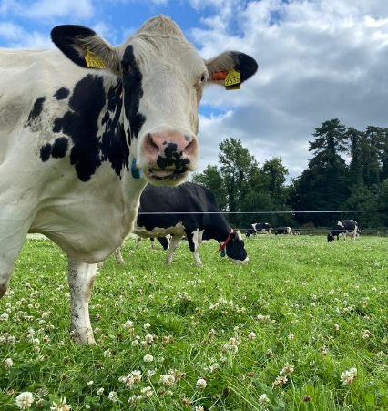
Project Objectives

- To develop a sustainable high-output grass-based spring milk production system
- To incorporate the most recent advances in grassland management for dairy farms into a high- output system
- Use a type of dairy cow that has good genetic indices for both milk production and fertility
- Employ the best practices from nutrition research and dairy cow husbandry
- Incorporate nutritional studies into a high-output system
- To incorporate management technologies and system attributes that enhance the sustainability of dairy production
Farm Details Week 28th– 3rd Sept 2023
Stocking rate on MP (LU/ha) | 3.27
Farm Cover (kg of DM/ha) | 639
Growth Rate (kg of DM/ha/day) | 36
Demand (kg of DM/ha/day) | 35
Average grass DM (%) | 13.5
Average Concentrate fed (kg/day) | 3
Average DIM | 197
Cow Details Week 28th – 3rd Sept 2023
Yield (kg/cow/day) | 23
Fat (%) | 4.78
Protein (%) | 3.66
MS (kg/day) | 1.94
SCC | 46,545

Grassland Management:
Grass growth has been steady over the last week, with grass growth keeping ahead of demand at the moment. Overall farm cover is lower than desired for the time of year. Despite the lower overall farm cover, grass quality is excellent across the MP which is being reflected in the milk output in both litres and solids.

Comments:
Final scans post breeding were carried out on the 15th August.
 | Number of cows | Percentages
Number of cows bred | 56 of 57 cows in the herd | 92.9% (52 cows in calf)
Submission rate 21 d% | 50 | 89%
First service conception rate % | 39 | 69.6%
6-week pregnancy rate % | 48/52 (52 cows scanned in calf) | 92%
Empty rate of total cows %* | 52/57 | 8.8% including pre-breed culls

All incoming heifers were synchronized and received sexed FR semen. Of the 56 cows submitted for breeding for 2023, 16 of these received sexed FR semen. The 10 first lactation cows and 6 elite cows. All other cows received beef semen. Between the 16 cows in the herd and calves from the heifers we should be able to breed enough replacement heifers.

