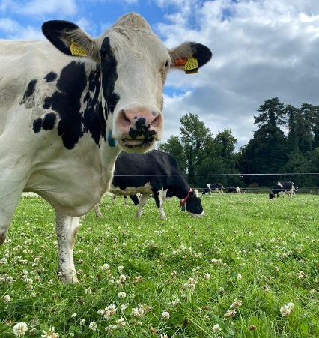
Project Objectives

- To develop a sustainable high-output grass-based spring milk production system
- To incorporate the most recent advances in grassland management for dairy farms into a high- output system
- Use a type of dairy cow that has good genetic indices for both milk production and fertility
- Employ the best practices from nutrition research and dairy cow husbandry
- Incorporate nutritional studies into a high-output system
- To incorporate management technologies and system attributes that enhance the sustainability of dairy production
Farm Details Week 4th– 10th Sept 2023
Stocking rate on MP (LU/ha) | 3.16
Farm Cover (kg of DM/ha) | 716
Growth Rate (kg of DM/ha/day) | 51
Demand (kg of DM/ha/day) | 38
Average grass DM (%) | 18
Average Concentrate fed (kg/day) | 3
Average DIM | 204
Cow Details Week 4th – 10th Sept 2023
Yield (kg/cow/day) | 22.96
Fat (%) | 5.05
Protein (%) | 3.62
MS (kg/day) | 1.99
SCC | 71,182

Grassland Management:
Overall farm cover is lower than desired for the time of year which will likely impact the length of the grazing season. However, favourable weather conditions currently are resulting in good grass growth, ahead of demand in recent weeks. Grass quality is excellent across the MP which is being reflected in the milk output in both litres and solids.

Comments:
BCS was carried out on September 5th. Of the 55 cows scored, 93% of cows fell within the normal range of 2.75 to 3.25 with 4 cows scoring 2.5 and no cow scored above a 3.25.

BCS | Number of cows | Percentage of Herd
2.5 | 4 | 7
2.75 | 16 | 29
3 | 25 | 46
3.25 | 10 | 18

