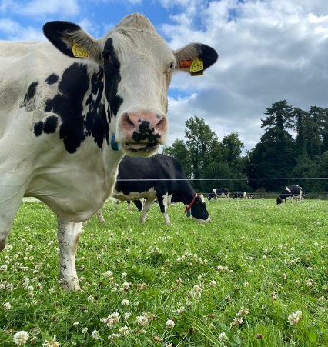
Project Objectives

- To develop a sustainable high-output grass-based spring milk production system
- To incorporate the most recent advances in grassland management for dairy farms into a high- output system
- Use a type of dairy cow that has good genetic indices for both milk production and fertility
- Employ the best practices from nutrition research and dairy cow husbandry
- Incorporate nutritional studies into a high-output system
- To incorporate management technologies and system attributes that enhance the sustainability of dairy production

Farm Details Week 9th– 15th Oct 2023
Stocking rate on MP (LU/ha) | 3.16
Farm Cover (kg of DM/ha) | 625
Growth Rate (kg of DM/ha/day) | 21
Demand (kg of DM/ha/day) | 19
Average grass DM (%) | 15.9
Average Concentrate fed (kg/day) | 4
Average DIM | 238
Cow Details Week 9th-15th Oct 2023
Yield (kg/cow/day) | 19.3
Fat (%) | 5.04
Protein (%) | 3.7
MS (kg/day) | 1.68
SCC | 50,722

Grassland Management:
There is currently 23% (4.07 ha) of the platform closed for the season. Graze-out residuals of 70-90 kg DM/ha are being achieved as pre-grazing covers are averaging approx. 1040 kg DM/ha. Cows are being offered 10 kg DM of 68.9% DMD first cut pit silage with a crude protein content of 24.9%, 6 kg DM grass and 4 kg of concentrate in the parlour.

Comments:
From the same period last year, milk production was 17.45 kg/cow at 4.65 % fat, 4.02 % protein (1.51 kg MS) and SCC was 51,000. BCS was carried out on the 14th Oct, with 55 cows scored. Of those cows scored 93% were within target BCS (2.75-3.25). This is an ideal position to be in at this time of year with no over conditioned cows within the systems herd.

BCS | Number of Cows
2.5 | 4
2.75 | 18
3 | 25
3.25 | 8

