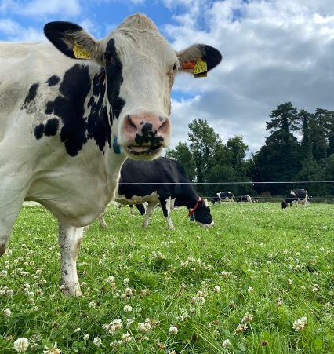
Project Objectives

- To develop a sustainable high-output grass-based spring milk production system
- To incorporate the most recent advances in grassland management for dairy farms into a high- output system
- Use a type of dairy cow that has good genetic indices for both milk production and fertility
- Employ the best practices from nutrition research and dairy cow husbandry
- Incorporate nutritional studies into a high-output system
- To incorporate management technologies and system attributes that enhance the sustainability of dairy production
Farm Details Week 10th– 16th July 2023
Stocking rate on MP (LU/ha) | 3.27
Farm Cover (DM/ha) | 636
Growth Rate (DM/ha/day) | 56
Demand (DM/ha/day) | 52
Average grass DM (%) | 18
Average Concentrate fed (kg/day) | 3.6
Average DIM | 154
Cow Details Week 19th - 25th June 2023
Yield (kg/cow/day) | 25.3
Fat (%) | 4.35
Protein (%) | 3.54
MS (kg/day) | 1.993
SCC | 139,000

Grassland Management:
Grass growth is picking up with the July round of fertiliser gone out on the 10th July.
Grass quality is currently excellent. Lowering demand but the introduction of silage to the diet has allowed AFC to build back to a respectable 636 kg DM/ha. However, demand is now floating just below growth, therefore a tight eye on growth levels is needed to ensure grass availability as we look at the autumn and building covers.

Comments:
Parity | Number of animals | Average weight (kg)
1st Lactation | 10 | 508
2nd Lactation | 9 | 554
3rd Lactation | 12 | 585
4th Lactation | 10 | 638
5th Lactation | 6 | 642
6th Lactation | 5 | 644
7th Lactation | 2 | 640
8th Lactation | 3 | 603
Total | 57 | 590
Cows were weighed and body condition scored on the 20th July. 98% (51/57)of the herd were within target BCS (2.75 -3.25) with 3 cows scoring 2.5 and 3 cows scoring 3.5 for BCS. Cows are in ideal condition for this stage in lactation. Body condition scoring cows regularly allows us to forward plan for dry off later in the year, paying particular attention to any cows following outside the optimum range of 2.75 – 3.25 BCS. The average weight of the herd was 590 kg.

