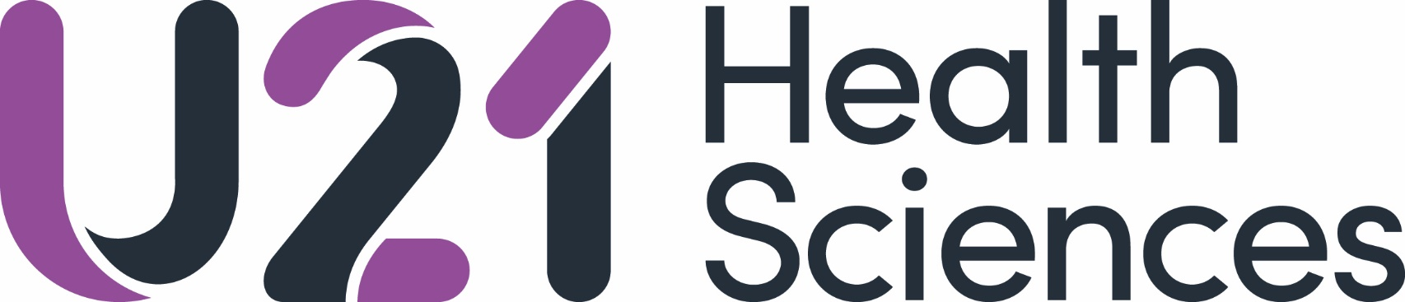

U21 Health Sciences
Teaching Excellence Award 2022

Internal Expressions of Interest (EoI) Process

- EoI Form should be submitted to Margaret.tiuchta@ucd.ie by COB Friday 10th June 2022

Expression of interest (EOI) (500 words maximum for 1. and 2. combined)

- Please outline your teaching highlights, touching on any/all of the following key points (these would then be expanded upon in your final application if your EOI is successful):
  - Interdisciplinary / interprofessional teaching and learning
  - International collaborations in teaching and learning / internationalisation of curricula
  - Evidence of sustained excellence in teaching and learning with a focus on teaching innovation

- Please provide a brief overview of the proposed topic themed around Teaching Innovation to be presented at the Teaching Excellence Award Workshop at the U21 HSG Annual Meeting 2022 (this will be expanded upon in your final application if your EOI is successful).

