COMMUNICATIONS PLANNING FOR RESEARCH QUESTIONNAIRE
This questionnaire will help you to:
- Understand the goals of your research project
- Identify and know your most important audiences
- Develop the key messages for each of your audiences
- Decide important milestones and timings across your communications calendar
- Choose communications types, tools and channels
- Develop content and activities that enable necessary engagement
- Allocate resources and measure your success

The UCD Impact Planning Canvas can also help you in answering Questions 1 to 4.

1. Determine Your Goals
What objective(s) are you trying to achieve through your research?
Examples:
- Capturing the experience/voice of specific cohorts
- Impacting policy
- Changing behaviour
- Driving adoption of new technology
- Reforming economic/market strategy
Add notes here…

What do you want to achieve through your communications?
Examples:
- Raising awareness of your research/benefits of your research among key stakeholders
- Gaining further funding, investment, partnerships or collaborations
- Driving uptake and understanding of the value of the research among key audiences (academic, industry, Government/policymakers)
- Retaining the interest of key stakeholder groups for the duration of the project
Add notes here…

2. Know Your Audiences
Who are the main beneficiaries of this research?
Examples:
- Patient cohorts
- Low income families
- Schools
- Industry
Add notes here…

Are there beneficiary third parties you must engage throughout the project life cycle?
Examples:
- Gatekeeper organisations such as patient advocate non-profits
- Sectoral or civil society representative associations
- Charities and trusts
- Industry associations or federations
- Consumer groups
Add notes here…

Are there cohorts who can help promote the research and its goals?
Examples:
- Potentially any of the above, especially representative associations and advocacy groups
- Partners/collaborators
- Academics
- General public

Note: When targeting the general public, think about which demographic (age profile, working/not working, urban-rural etc) and in what context (voter, consumer, school-leaver etc) in order to consider the best communications formats and channels to reach them.
Add notes here…

Who could help drive the impact or reach of the research?
Examples:
- Academic networks within and outside your institution
- Elected representatives
- Government departments, particularly policy research units
- Industry networks
- Community networks
Add notes here…

Finally, prioritise your audiences in terms of importance to the success/impact of the research project.
Example: Longitudinal study of primary school children’s lives
Primary (most important/influential) e.g. Academics, policymakers
Secondary (interested/less influential) e.g. Education professional/sectoral groups
Tertiary (potentially interested/supportive) e.g. Parents, general public

Specifically to drive research impact, the UCD Research Impact Toolkit highlights Professor Mark Reed's Stakeholder Analysis Template to prioritise audiences based on how much they stand to benefit from the research as well as how much they can contribute to it.
PRIMARY AUDIENCE:

SECONDARY AUDIENCE:

TERTIARY AUDIENCE:

3. Develop Key Messages
Create separate message briefings for each audience considering both their needs and the project goals.
Consider if messages change in different phases of the project and create new message briefings for each audience for each phase if necessary.

Example: Longitudinal study of primary school children’s lives

PRIMARY AUDIENCE: Policymakers, Academics
MESSAGE: The quality and uniqueness of the data/methodologies; the usefulness of the outputs (new datasets, case studies, new qualitative findings)
PRIMARY AUDIENCE:

MESSAGE:

Example: Longitudinal study of primary school children’s lives

SECONDARY AUDIENCE: Education Community (professional/sectoral groups, civil service)
MESSAGE: Key findings and highlights of interest to these targets (communicated to draw them in and sustain interest in the next stages of the project OR to encourage engagement with and championing of the research on completion of all or a phase of the project)
SECONDARY AUDIENCE:

MESSAGE:

Example: Longitudinal study of primary school children’s lives

TERTIARY AUDIENCE: Parents, General public
MESSAGE: The value of the research now and into the future (to encourage support for funding of future studies/uptake of this research by the primary and secondary audiences)
TERTIARY AUDIENCE:

MESSAGE:

4. Timings and Important Milestones
Your plan should consider communications needs for project milestones ahead of time, to maximise your opportunities to reach key audiences and achieve project goals on time.
Be aware of the timing of various activities and include them in your communications calendar for the year.
Examples of such activities include:
- Running a survey
- Releasing a report or results from publicised surveys
- Publishing journal articles or other outputs including datasets
- Holding a conference or seminar
- Releasing a high quality video
- Participating in a high profile event
Add notes here…

5. Choose Communications Types, Tools and Channels
Communications plans can include both passive and active modes of communication.
Passive refers to creating a record and making information available, e.g. websites, publications, social media, conference papers, posters, articles.
Active refers to more interactive communication to escalate uptake and understanding, e.g. workshops, co-design/co-creation, outreach, surveys and polls.
Consider the needs of your audiences to choose the most easily discoverable and accessible communications types and channels, as well as your project’s resources.
You must also consider the project goals with respect to each audience so that you REACH, ENGAGE and PROMOTE your research most effectively, and ultimately achieve your intended Impact.
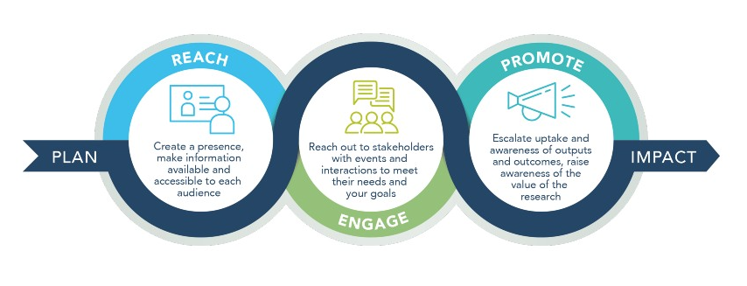
Use the resources below to choose tools and channels to help create and execute your communications.
REACH (including websites, digital/social media, video, direct marketing)
ENGAGE (including events, workshops, polls ans surveys)
PROMOTE (including Impact case studies, conferences and media engagement)

Example: Longitudinal study of primary school children’s lives
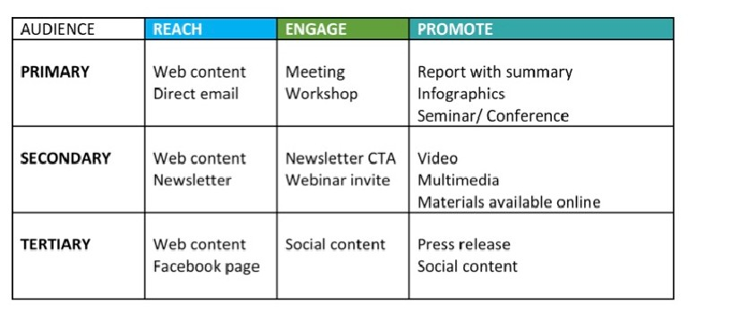

6. Develop Content and Activities
Having decided on the most effective communications types and channels to reach and engage your audience, you must develop the right content and activities to fulfil those plans – again always bearing in mind each audience’s needs and the project goals.
You must consider language (technical or lay), length (short-form or long-form), image versus text, what is the value for the intended audience and likelihood of attention depending on the format.
Remember that some communications (such as the website) are intended for multiple audiences and the content should reflect all their needs. Meanwhile, other formats (such as video) may be available to all but are more important for one specific audience, therefore the content should remain focused on communicating key messages for them.
Time, and budget when necessary, must be allocated to creating content that is valuable and effective.
Add notes here…

7. Plan and Measure
Once you have created your plan, assign enough budget and time resource from the beginning to ensure it can be executed effectively.
Set Key Performance Indicators (KPIs) for your activities so you can measure and evaluate the effectiveness of your communications and engagement towards your project goals.
Examples of KPIs:
- Web traffic/report downloads
- Social analytics such as media engagement (e.g. clicks on infographics, video views)
- Altmetrics attention score
- Media measurement (e.g. press articles, comment and interviews)
- Scopus/FWCI
- Impact measures
- Events/workshop participant numbers by target audiences
- Events/conference participation by project
Use tools such as Elsevier Scival and Scopus and Altmetric Explorer to track the attention and usage that your research outputs receive.
See examples of KPIs from other communications plans:
- Dragon-Star Plan KPIs [PDF]
- Acctivate Plan KPIs [PDF]

___________________________________________________________________________
When you have now completed the Communications Planning Questionnaire for your research project, apply your timings and choices to the Communications Plan Template.

