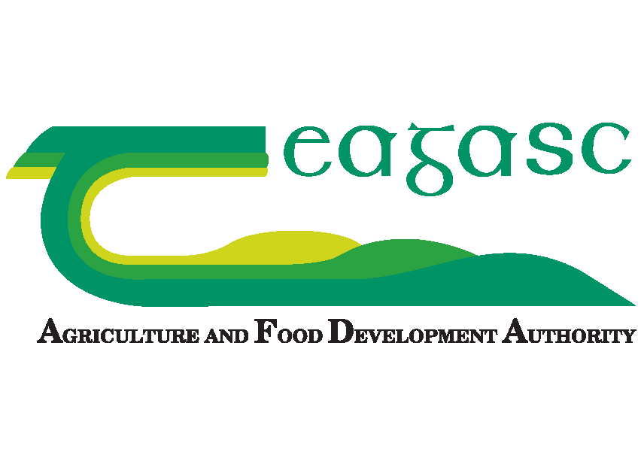

APPLICATION FORM 2018 for
Walsh Fellowship Funded KT MASTERS PROGRAMMES

OPTION | Programmes | Preference
A | M.Agr.Sc in Agricultural Innovation Support (Masters by research with 15 month placement in Teagasc)
B | M.Agr.Sc in Agricultural Extension (Taught Masters with 2 year placement in Teagasc)

1. Personal Details
Name
Address
Phone - Land line
Phone - Mobile
E Mail

2 Education – Third Level
Title of Award & Designatory Letters  (Certs/Diplomas/ Professional Qualification or Higher | Type of Award  (Cert/Diploma/ Degree etc.) | Grade Achieved  (First Class Honours etc) or expected if not yet awarded | University/ College Attended  *see note |  | Level of Qualification  **see note | Awarding Body | Month & Year of Award
e.g. BSc Hons in Land Management in Agriculture | Degree | 1.1/ 2.1/ 2.2 | UCD/ WIT/ DKIT |  | Level 8 | WIT | June 2010
* For non-UCD graduates please include a copy of your transcript from the awarding university/ college
** Give level of award as per the National Framework of Qualifications e.g. Level 8
3. Main Subjects / Modules / Units taken in your primary degree

4. Dissertation(s) undertaken as part of your primary degree

5. Post Graduate study details (if applicable)
6. Current or Most Recent Job / Employment
Name of Employer: |  |  |  |  | Job Title
From: mm/yy |  |  | To: mm/yy |  | Location:
Nature of Work/Main Responsibilities:

7. Previous Appointments
Start with the appointments which preceded that described above and work backwards through your career.
Period in Months | From  mm/yy | To  mm/yy | Company Name. Address & description of business. | Brief Job Description and Main Responsibilities | Reason for Leaving

8. Do you hold a Full Clean Driving Licence? Y _____ N _______

9. Other Relevant Details

If you selected Option A or C (Research Masters option) as Preference 1, 2 or 3 please complete 10 and 11 below.

10. Research Topic Preference (to be completed if you have indicated interest in the Masters in Agricultural Innovation Support by research)
Based on the list of research topics below please indicate the top three areas you would most like to research using 1,2 and 3 in the boxes on the right (1 = most preferred area to research; 2 = second most preferred area; 3 = third most preferred area)
 | Topics for Research in the 2017-19 MAIS Programme | Choice involved
1 | The implementation of supports and materials to improve advisor/farmer engagement in OHS (occupational health and safety) adoption.
2 | Top down Knowledge Transfer (KT) or Co-creation - how to support innovation better
3 | Observations on the CPD (continuous professional development) initiatives supporting farm advisors - a case study in Teagasc
4 | A study of the role and effectiveness of local led KT initiatives - examining the "Grass on the By-Pass" project.
5 | Can on-farm use of a decision support tool improve nutrient management? - A case study of the slurry hydrometer
6 | To develop and pilot a Teagasc Agri-pod app
7 | Examining the use of Whatsapp groups as a method of knowledge transfer
8 | Support for increased use of digital information by farmers and the impact of User Experience (UX) through a co-creation approach
9 | Capacity building for Commonage Groups in the Wicklow Sustainable Uplands Agri-Environmental Scheme
10 | The role of Knowledge Transfer and farmer engagement in halting the decline of threatened farmland species
11 | Effective advisory supports for farming in an archaeological landscape
12 | Perfecting the message on Silage Quality
13 | A qualitative approach to developing guidelines for employment of drystock farmers on dairy farms
14 | Development of a Continuous Professional Development (CPD) programme for farmers including graduates of Teagasc Educational Programmes and Host Farmers.
15 | KT - based appraisal and learning from rollout of forestry Knowledge Transfer Groups (KTGs)
16 | Equipping Teagasc teachers to teach using a Problem Based Learning (PBL) approach
17 | Integration of technology on the College farm and in practical training programmes
18 | Innovative teaching methods for Teagasc Distance Education courses
19 | Integrating the apprenticeship model into the existing Teagasc education framework
20 | Determining technical and human factors parameters for optimal rollout of online assessment across the range of Teagasc education courses

11. For your number 1 selected Research Area in 10 above please outline in max of 300 words: what would be the main aims of the research project; what specific aspect of this research area would you want to look at, how you would undertake the research project and make it successful; what would the project produce and how would the output from the research benefit advisory or education services

Specific Title for your proposed research project
Main aim of the project (max 50 words)
How you would complete the project and make sure it was successful (max 150 words)
General description of what the project would produce and how this would be useful to advisory / education services (max 100 words)

For all Options please complete 12 and 13 below.

12. Personal Statement of your interest and motivation in agricultural advisory and education work (Max 250 words)

13. What in your opinion are the priorities for agricultural advisory and education work in Ireland in the period up to 2020? (Max 100 words)

14. How / from where did you hear about this postgraduate programme ?

15. Submitting your application
- Before you return the form, please ensure that you have completed all sections. The onus is on applicant to establish eligibility on this application form. Details provided in the application will be used in the short-listing process.
- Please do not forward any certificates or references with this form.
- Misstatements or canvassing will render an applicant liable to disqualification.
- The personal data supplied on this application form will be used to assess candidates for these Fellowships

All information provided in this application is, to the best of my knowledge true and correct. I understand that should any of the particulars furnished in this application be found to be false or inaccurate, action may be taken to withdraw any offer of a fellowship.
Signed: |  | Date:

Completed application form (hard copy or electronic copy) should be submitted in time for deadline of: 5 p.m. on 30th May 2018. Completed Application Forms should be submitted in electronic form to: agribus.ruraldev@ucd.ie or by post to: Henna Kinsella, School of Agriculture & Food Science, Room G.05 Agriculture & Food Science Centre, University College Dublin, Belfield, Dublin 4.

Please indicate your first (1) and second (2) choice of programme or if only interested in one programme please indicate choice (1) and other zero.
Add any other relevant information here that you feel strengthens your application for this postgraduate programme

