**Pádraig Puirséal Collection**

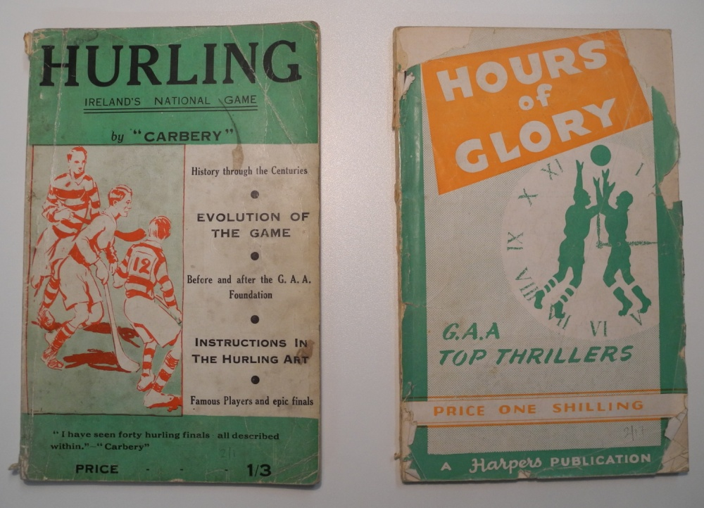The [Pádraig Puirséal Collection](http://www.ucd.ie/library/finding_information/special/printed/puirseal/) is comprised of sporting books and pamphlets formerly owned by Pádraig Puirséal (Patrick Purcell). Pádraig Puirséal (1914-79) was a novelist and a sports journalist writing for the *Kilkenny People*, *Gaelic Weekly* and the *Irish Press*, where he was the GAA correspondent from 1970 until his death in 1979. He attended University College Dublin from 1933-7, where he played hurling and football for the college and wrote for a number of university publications. He founded the *Gaelic Sportsman* which later became the *Gaelic Weekly* in 1950, and under the pen name “Moondharrig” contributed articles on the history of the early years of the GAA. *The GAA in its time,* which was based on his research, was published posthumously in 1982.

*Hurling: Ireland’s national game* by “Carbery” and *Hours of glory: recalling great moments in the story of the GAA* by Arthur McGahon both from the Pádraig Puirséal Collection

The majority of the Puirséal collection is comprised of GAA related publications dating from the 1920s to the 1970s. It includes books on the GAA and Irish athletics by “Carbery” and Séamus Ó Ceallaigh from the 1940s and Raymond Smith from the 1970s, many of which are signed by the authors; numerous GAA county yearbooks from the 1960s and 1970s; GAA club and parish histories many of which were issued to celebrate club anniversaries or victories; souvenir programmes dating from the 1940s which celebrate special games, club anniversaries or the opening of grounds. The collection reflects his interest not only in the GAA but all sports as it includes books on a wide range of other sports including soccer, tennis, golf, cricket, greyhound racing and coursing from both an Irish and international context. Many of the books and pamphlets contain inserts including cover notes to Puirséal, questions and letters from the public and handwritten notes on sporting events. UCD Library is working with UCD School of History's Dr. Paul Rouse to further promote this collection, to identify its future research uses and to select items for possible digitization.

The Pádraig Puirséal Sports Collection forms part of Store Special Collections and may be viewed by application to the Client Services Desk on level 1 in the James Joyce Library. Material will be available for consultation the next working day in the Special Collections Reading Room (Monday – Friday: 10am - 1pm; 2pm - 5pm).

For more information on Pádraig Puirséal please see his entry in the [Dictionary of Irish Biography](http://librarysearch.ucd.ie/V/QQ9E2MEAAEB3BKJQ3NNUT3XQYD9MB7LL7IPBA26YAFJHACAVGG-02378?func=find-db-1-title&mode=titles&azlist=N&scan_utf=&scan_start=dictionary+of+irish+biography&search_type=contains&restricted=all).